Artistic Representations of Suffering

Rights, Resistance, and Remembrance

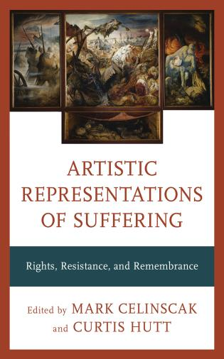

EDITED BY MARK CELINSCAK AND CURTIS HUTT

Artistic expression frequently engages with the question of suffering. In so doing, it confronts the gravity and complexity of the human condition. This volume investigates the relationship between art and suffering. In short, the contributors to this volume collectively demonstrate that suffering is an undisputed and shareable motivating experience.
This collection features original essays that focus on the subject of art and suffering, including topics such as the representation of violence and the intersections of art and human rights. Some of the key questions explored are as follows:
- How has suffering motivated artists around the world?
- How have artists used their platforms to call attention to human rights abuses?
- How can suffering be incorporated responsibly and ethically in works of art?
- What role does art play in the struggle against violations of human dignity and the promotion of building a more equitable world?
Each essay is complemented by full-color reproductions of artistic works that illustrate the concepts being discussed, including a graphic essay on the topic of “comfort women.”

Rowman & Littlefield Publishers
Pages: 242 • Trim: 7½ x 10
978-1-5381-5291-1 • Hardback • October 2021 • $75.00 • (£58.00)
978-1-5381-5292-8 • eBook • October 2021 • $71.50 • (£55.00)
Subjects: Art / General,

The special authority invested in the war artist and the image had become denuded by the mid-1980s. Although an independent artist working to commission, Peter Howson’s work in the Balkans was considered to have crossed the line that distinguished between impersonal witness and overzealous artist. Unlike William Orpen’s impartial rendition of gross personal violation, Howson was deemed to have become both judge and jury, an advocate not an artist, corrupted by circumstantial evidence rather than remaining vigilant as an uncorruptible viewer. For his part, Howson was clear that the terms of engagement had fundamentally changed since the Great War: it was no longer simply about what could be seen or not seen, but also what was known and could not be denied.

