For immediate release 01.04.2014

Back From the Front: Art, Memory and the Aftermath of War
Royal West of England Academy
19 July – 14 September 2014

The RWA announce the forthcoming launch of Back From the Front: Art, Memory and the Aftermath of War, a major programme of new exhibitions exploring the theme of conflict and memory in commemoration of the First World War centenary.
Featuring Paul Nash, an artist synonymous with British Modernism, and the work of his lesser known but no less highly regarded brother John Nash RA (both Official War Artists), alongside moving - and often challenging - responses to conflict from leading contemporary artists, including Tim Shaw RA, Xavier Pick, Emma Stibbon RA and Elizabeth Turrell, Back From the Front reflects on the legacy of conflict, both past and present.
Back From the Front: Art Memory and the Aftermath of War is supported by Arts Council England, the Bristol Cultural Development Partnership, Bristol Festival of Ideas and the University of the West of England.
It is part of Bristol 2014, an extensive programme of activity marking the centenary of the start of the First World War and looking at other conflicts that have had an impact on the city over the last century.
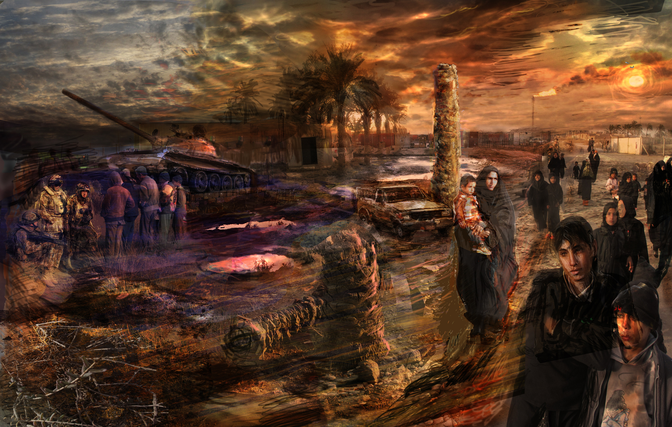

On Psychological Operations in the Garden of Eden, Basra, Iraq, Xavier Pick, 2009-10, mixed media drawing, pen and ink, digital print on Hahnemuhe German etching paper, photoshop digital manipulation and acrylic paint and glazes.
Full details for each exhibition are listed below in both short and long versions, including image credits. Images are available to download at www.flickr.com/photos/rwapress/sets
Exhibition Listings (short version)

Shock and Awe: Contemporary Artists at War and Peace
19 July – 17 September
An exhibition of work by contemporary artists recently exposed to the front-line of war in Iraq, Afghanistan and the Balkans. Creating a platform for artists who are fascinated by acts of remembrance, the show includes work from Tim Shaw RA, Xavier Pick, David Cotterell, Jill Gibbon, Mario Minichiello, Elizabeth Turrell RA and Paul Gough RWA amongst others.

Brothers in Art: John and Paul Nash
19 July – 14 September
Brothers in Art reunites the work of John and Paul Nash; brothers, Official War Artists and two of British art’s leading landscape painters. It features over forty landscapes from public and private collections, providing a unique opportunity to view the two siblings’ work side-by-side, explored within the powerful context of conflict and memory.

The Death of Nature
16 July – 8 August 2014
The Death of Nature is an ongoing series of work by leading contemporary artist Michael Porter RWA, providing a timely commentary on the environment and world around us.

Re-membering
10 August – 31 August and 4 – 25 September 2014
To coincide with the centenary of the start of the First World War, the RWA in partnership with the Bristol 2014 Project, has scheduled a series of thought-provoking and evocative exhibitions that demand the viewer’s attention and interaction, featuring responses from over 20 artists, writers, architects and composers to the themes of commemoration and memorialisation.

Exhibition Listings (long version)

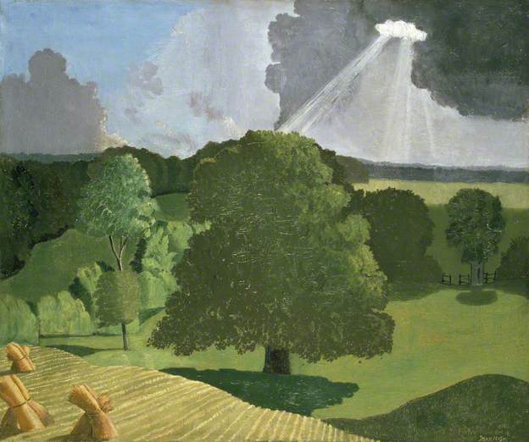
Brothers in Art: John and Paul Nash
19 July – 14 September
Brothers in Art: John and Paul Nash provides a unique opportunity to view the two siblings’ work side-by-side, explored within the powerful context of conflict and memory. Spanning each artist’s career, the exhibition features over forty works, including watercolours and drawings from public and private collections, creating a panoramic vision of the British countryside.

John and Paul Nash were landscape painters in the purest sense, depicting the fields and shorelines of their native land through a particularly English sense of Modernism. They shared a unique way of looking at the land, shaped by childhood pastimes; constant and close study, and a perception of the travesty of war. By interweaving the brothers’ two very different narratives, the exhibition explores the notion of memory through the haunting beauty of the English landscape, as prehistoric sites, waterways and ancient copses build upon one another like layered memories. Nestled between Paul’s monumental hilltops and John’s swaying corn sheaves, the landscape of southern England becomes the focus; a place for remembering and forgetting.

This will be the first significant exhibition of John’s work for a number of years and the first time the brothers’ work has been exhibited together on this scale.

As well as rarely seen works from private collections, the exhibition features some of their most familiar and iconic landscapes, such as The Cornfield, 1918, by John Nash and Druid Landscape, 1938, by Paul Nash.

Image credit above: A Gloucestershire Landscape, John Northcote Nash, 1914, oil on canvas, WA1978.67 © Ashmolean Museum, University of Oxford © The Estate of John Nash, All Rights Reserved 2014, Bridgeman Art Library

Shock and Awe: Contemporary Artists at War and Peace
19 July – 17 September

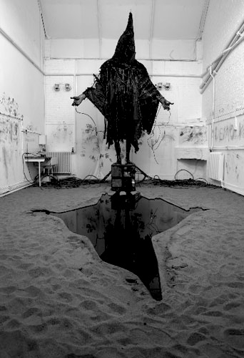
Shock and Awe is an exhibition of work by leading contemporary artists, recently exposed to the front-line of modern warfare in Iraq, Afghanistan and the Balkans. Fascinated by acts of remembrance or the notion of art as a warning or form of protest, each artist has created their own powerful response to conflict, building on personal and collective memories.

All of the artists in this exhibition have worked in highly demanding, often very stressful conditions: Tim Shaw RA uses modern industrial materials such as plastics and metal to create politically charged, larger than life sculptures inspired by the Iraq War; Jill Gibbon makes drawings at arms fairs all over the world; Mario Minichiello and Xavier Pick were commissioned to record British and US troops in the war zones of Iraq, and David Cotterrell was supported by the Wellcome Foundation to travel to Basra and Helmand Province to record the arduous work of the British Medical Corps.

Elizabeth Turrell RWA and the late Richard Hamilton both provide an alternative to the traditional operational medals issued by the Forces. Hamilton’s two faced ‘Medal of dishonour: The Hutton Award’ – depicting Tony Blair on one side and Alistair Campbell on the reverse – offers a critique of political handling of the Hutton Enquiry, whilst Turrell creates peace and anti-war medals.

The exhibition also includes a number of historic works contextualised by responses from contemporary artists, creating interesting juxtapositions: for example, between the work of Muirhead Bone, the first official British war artist, and Emma Stibbon RA RWA – both drawn to the epic, sublime theme of destruction.

Drawing on conflicts both past and present, Shock and Awe creates a moving contrast to the painterly memories residing in the Nash brothers’ landscapes. Between the two exhibitions, we are confronted by the aftermath of conflict, from both a time of peace and war.
Image credit above: Casting a Dark Democracy, Tim Shaw RA, 2008, steel, black polythene, oil and sand

The Death of Nature
16 July – 8 August 2014
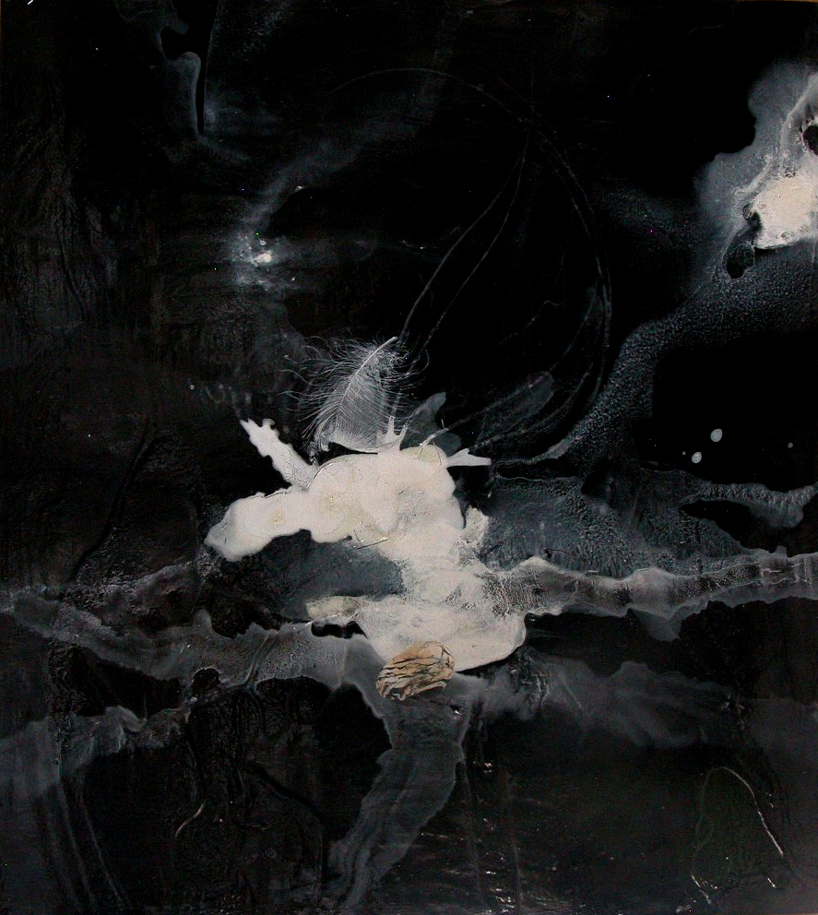
In The Death of Nature Michael Porter has created a cold, disturbing depiction of the natural landscape as a ravaged resource under attack from the human race, being systematically stripped of its assets with little regard for consequence – drawing on an environmental notion of conflict. For the past twenty years, Porter has worked exclusively from the landscape, using locations that he has been familiar with over long periods of time. His work incorporates both time past and time present, creating strata of memory that chart nature’s demise. Porter portrays discarded objects such as feathers, stones and lichen as a metaphor for his vision of the discord between humans and the environment.

Image credit above: Death of Nature series, 25-04-13, Michael Porter RWA oil and acrylic on paper, 2013

Accompanying Publications
Accompanying the exhibition Brothers in Art: John and Paul Nash is a fully illustrated book Brothers in Arms: John and Paul Nash, written by Paul Gough with an essay by Gemma Brace, published by Sansom & Company. The book is available from the RWA shop during the exhibition at a special price of £20 (RRP £25). Developing themes first explored in A Terrible Beauty, his book about British war artists, Paul Gough relates the fascinating story of the Nash brothers, illustrators, soldiers, and artists. For more information and to reserve your copy for review please contact Sansom and Company - info@sansomandcompany.co.uk

About the RWA
The RWA has eight galleries within a stunning, purpose-built 19th century building. The five upstairs galleries – Sharples, Winterstoke, Stancomb-Wills, Methuen, and Milner - host the main exhibition/s, alongside the Bristol Drawing School studio. Downstairs are three further gallery spaces. All gallery spaces are available for private hire for special events, such as conferences and meetings, wedding receptions and parties. The downstairs area has a shop selling a range of cards, prints, books and artistic gifts, and a café run by Papadeli http://news.papadeli.co.uk

The Royal West of England Academy (RWA) is England’s only regional Royal Academy of Art. It is a registered charity which has been self-supporting for over 150 years and is housed within an outstanding Grade II* listed building, boasting beautiful top-lit galleries and an extensive, permanent fine art collection. The RWA has HM Queen Elizabeth II as its patron and HRH The Prince of Wales is an honorary academician.

The RWA is an established venue for the fine arts and embraces an artistic awareness of the widest nature. The changing exhibition programme provides a showcase for one-person and mixed exhibitions in a variety of media, attracting large numbers of visitors nationwide. The Academy is situated in the academic heart of Bristol at the Clifton Triangle opposite the Victoria Rooms.

Opening hours:
Tuesday – Saturday 10am – 6pm
Sunday 11am – 5pm
Closed Mondays

Adults £5 (inc. 50p donation)
Concessions £3.50 (inc. 40p donation)
Under 16s, University of Bristol, UWE and SGS students FREE

Royal West of England Academy, Queen’s Road, Clifton, Bristol BS8 1PX / 0117 973 5129 / www.rwa.org.uk

NOTE TO EDITORS
For more information please contact Rebecca Clay, Marketing Manager
Rebecca.clay@rwa.org.uk / 0117 9735 129

Exhibition Supporters



