Title: The Micro Grasp and Macro Gestus Strategy as a facilitation of dyslexia in actor-training: reconstructing the written text when performing Shakespeare
Journal: Theatre, Dance and Performance Training
Author: Petronilla Whitfield
Acting Department
Arts University Bournemouth.
Email:pwhitfield@aub.ac.uk
Accepted for publication by editor Professor Jonothan Pitches on 17th January 2017. http://dx.doi.org/10.1080/19443927.2017.1284691 .

Abstract
This article discusses the challenges that dyslexic acting degree students can experience when engaging with classical text, offering a pedagogical strategy that facilitates the reading, and acting of Shakespeare. Calling attention to restrictions that dyslexic acting students can experience, the author considers how these difficulties might be overcome. It is re-iterated throughout the literature that those with dyslexia have problems with decoding, word recognition, working-memory and automatisation of skills. Shakespeare’s writing contributes additional challenges with idiosyncrasies of word-use. Describing her action-research trials with dyslexic acting students, the author shares her development of a teaching method, which supports identification of meaning and hierarchy within the text, interlinked with an appropriation of physical practice drawn from Brecht and Stanislavski. The final action-research cycle drew from Kintsch and Rawson’s Text-Base (2005) to enable a comprehension and memory of the text, underpinned by the Lexical Retrieval hypothesis (Krauss et al., 2000). The strategy was trialled in a performance of Shakespeare’s Venus and Adonis with dyslexic acting students. The participants’ modes of processing the text were encouraged as components of performance. Feedback supported the view that this method is effective in assisting dyslexic individuals in realisation of words, self-efficacy and enriched performance.
Key words: Dyslexia, Shakespeare, comprehension, memory, interdisciplinary performance

Introduction
How can our training processes take account of cognitive difference as the normative base, rather than ideas of inclusivity being perceived as specialist techniques? How might our methods break away from practices that support the dominant group whilst undermining those whose processes, learning styles and strengths lie outside of conventional models? I teach Voice and Acting on a university Acting degree course, with a specific interest in Shakespeare, voiced communication and the facilitation of dyslexia within actor-training environments. My research directions have been driven by the difficulties (and sometimes unrecognised strengths) I have observed in many acting students with dyslexia when struggling with the written word, and particularly in their accessing of Shakespeare’s writing. In this article, I argue that there is a need for further dissemination of research and ideas that focus on dyslexia-friendly practices integrated into curricula and teaching methods, to optimize equality of opportunity for all. To this end, I share my own experience and offer a practical strategy, generated through trial and research with dyslexic acting students, which has been shown to counter some of the barriers generated by dyslexia. It is hoped that these ideas might be explored, modified or developed by those who teach in similar contexts, stimulating reflection on existing practices.
I begin with a brief consideration of the socio-cultural values surrounding the concept of ability in contemporary education, and then describe the obstacles some acting students with dyslexia can encounter when interacting with Shakespeare’s writing. I proceed with a description of some adaptations of practice utilised by my dyslexic research participants, and finally detail the process and theory underpinning my devised method, wherein both dyslexic and non-dyslexic individuals can interact with Shakespeare’s text with freedom. My focus on the ‘Specific Learning Disability’ (or ‘Difference’) termed as ‘dyslexia’ and its impact on acting students within actor-training, places some critical attention on the recent arguments regarding selective education in the UK. The proposed revival of a system which endorses the ranking of individuals into a hierarchy of intelligences poses questions about the values and criteria used in assessing ability, what education is and what it aims to achieve, in both school years and actor-training in Higher Education. The selection of those with a prescribed model of ability and intelligence as worthy of prioritised opportunity over others, demonstrates how a specific learning disability (such as dyslexia), if masking abilities within conventional procedures, might contribute to the negligence of the individual’s attainment and potential. This raises further questions over the politics of difference, and the shifting arguments regarding the idea of multiple intelligences (Gardner 2003; Muijs & Reynolds 2005, p.20; White 2009, p. 241-259; Waring & Evans 2015, p. 89). Wishing to highlight the vulnerable status of those with a Specific Learning Disability (in this case dyslexia) in actor-training environments, this article draws attention to the prevalence of dyslexia, its complex nature and the accompanying barriers for acting students assessed as dyslexic. Although I am not dyslexic, I have been assessed by an educational psychologist as having dyscalculia. I therefore have a shared experience and empathy for those who might have abilities and disabilities that differ from the dominant group and this drives my call for changes in unexamined pedagogical approaches.
In my experience of teaching in actor-training institutions, every cohort of acting students invariably includes a number of individuals assessed as dyslexic. Although acknowledging that dyslexia remains a contested area (Elliott & Grigorenko 2014), it is recorded in much of the published literature on dyslexia (and I have observed in my dyslexic students) that those with dyslexia can face difficulties with: decoding and sounding letter symbols, word recognition, holding information in working-memory, making skills automatic, dual-tasking, articulation of multisyllabic words and overcoming the effects of negative learning experiences (Burden 2005, p.23-25; Bacon & Bennet 2012, p.20). Published research regarding the facilitation of dyslexic acting students through adaptation of curriculum content or teaching approaches remains sparse. However, actor-trainer and researcher Deborah Leveroy has discussed some of the issues surrounding the training of dyslexic actors in conservatoires, emphasising that practice should be informed by research into the lived experience of those with dyslexia. She imparts valuable information in describing her studies of dyslexic actors’ visual and multi-sensory approaches in entering, remembering and making sense of the text (Leveroy 2013, 2015). Although Leveroy and I have pursued independent research pathways, it is significant that my findings (originating from investigations with my dyslexic acting students) link directly in many ways with Leveroy’s studies. Some of these complementary findings are reported in other publications (see Whitfield 2009, 2015b, 2016; Leveroy 2013a, 2013b, 2015). In accordance with Leveroy’s recommendation that practical ideas of facilitation should be driven by research, I have also argued this necessity (Whitfield 2015b, p.22) and this article’s content is grounded in my six-year PhD study with acting degree students assessed as dyslexic.
The obstacles caused by dyslexia when reading Shakespeare
The ‘otherness’ of Shakespeare’s writing can generate additional hurdles for those with dyslexia. The unfamiliar language and multi-inferences of meanings can interfere with the guessing of words or meaning which is sometimes utilised as a tactic when reading, by dyslexic individuals. Established practical approaches to working on Shakespeare presented in the literature currently make little conscious provision for those with SpLD (dyslexia) (see Rodenburg 2002; Hall 2003; Noble, 2010; Block 2013). When rehearsing the reading and acting of Shakespeare, the teacher/director listens for those moments when the student actor might become fully ‘present’ in their voiced interaction with the words of the text, both psychologically and emotionally. As Rodenburg maintains, when acting Shakespeare, ‘you will think, speak and feel on the word… your existence is in the moment’ (2002, p. 5-6). Those with fluent reading skills can spontaneously engage with the sounds, images, rhythms and intricacies of Shakespeare, swiftly decoding, comprehending and articulating their individual response aloud. Although frequently possessing strong abilities, some acting students with dyslexia come to the reading of Shakespeare with an assortment of difficulties, which inhibit opportunities for such realisation of potential. Although those with dyslexia are often noted as possessing good comprehension skills, this comprehension can be undermined by a lack of automaticity in decoding skills, speed of processing, memory, organisation and identification of the main points in the text (Reid 2003, p. 246). In interview, my research participants have all referred to struggles with their memory and there is a recurrence on the subject of working-memory difficulties in the dyslexia literature (Smith-Spark and Fisk 2003, 2007; Mortimore 2008; Thomson 2009; Grant 2010; Nicolson and Fawcett 2010; McLoughlin & Leather, 2013; Leveroy 2015). Moreover, when endeavouring to read Shakespeare aloud, a feedback loop of critical self-judgment is commonly activated, accentuating disbelief in their abilities and fear of the written text. This is further exacerbated by anxiety when being observed by peers and teachers. In describing their reading experiences with Shakespeare, my dyslexic acting students have repeated statements such as: ‘I am overwhelmed…the more I panic the more I stumble … I need to practise it ten times before I am able to see the words…I cannot second guess this language… I can’t remember how to pronounce it…I have to watch someone else do it first so I can remember it…’ (participants’ interviews 2008- 2016). This insecurity with the word can impact beyond the act of reading and progress into the muscular articulation of the language.
In conjunction with utilising physical and vocal technique, it is an actor’s skilled practice to decipher the possible ‘clues’ buried within Shakespeare’s text so as to guide decisions on characterisation, motivation and speaking style. However, my aim in this study is not to investigate how the dyslexic acting student can adhere to the ‘rules of the text’ through scrutiny of its form as promulgated by Rodenburg (2002, p. 3), Hall, (2003, p.17) Noble (2010, p.5), although such detail is highly relevant to the study of Shakespeare. Much of my focus centres on exploring how individuals with dyslexia might discover an ability to comprehend, remember and articulate the words, leading to a free expression in their speaking and experiencing of Shakespeare’, when lifted from the printed page into performance.
Guide to the section structure
This section proceeds to focus on the research, trials, performance and findings underlying my proposed teaching strategy. To guide the reader, I have laid out the sequence of the work as it is presented. Firstly, I introduce my overarching methodology, and secondly, give an overview of my previous research, from which aspects have been gathered to form the teaching strategy presented here. Thirdly, I outline a textual analysis theory employed as a foundational base. Fourthly, I describe my preliminary study, involving the whole cohort of students, underpinned by theory, generating insight into how it might enable those with dyslexia. I then proceed to concentrate on the dyslexic participants in their work towards a performance of Shakespeare’s Venus and Adonis (2007). Finally, I share my findings and arrive at a conclusion.

Methodology
This section centres on the work of four acting students (assessed as dyslexic by an educational psychologist) in my final action-research cycle carried out during my PhD research. My research methodology was that of action-research integrated with case study. The nature of action-research, wherein a problem is identified, possible solutions are imagined and action taken with an evaluation of outcomes (McNiff 2013) provided an opportunity to explore practical changes in my teaching. Adoption of case study enabled me to capture the lived experience of individuals with dyslexia, recording their words and actions in a ‘thick description’ situated within the context (Winston 2006, p. 20).
Prior research informing the direction taken
The devised teaching strategy offered in this article is created from a culmination of ideas gathered from each stage of four action-research explorations with a variety of dyslexic participants throughout my six years of PhD study (Whitfield 2015a). So that the reader gains an understanding of the rationale behind the proposed teaching strategy, a brief summary of this research follows.
My first cycle studied the rationale for visual thinking demonstrated by the majority of my participants, and how their translation of the text into visually processed symbols, using drawings, photographs and colours, supplanted the written words of the text. These visual referents, placed onto a concrete surface (such as paper) were sometimes accompanied by physical movement. This method operated effectively as a process of interpretation and comprehension, enabling an embedding of mental models of constructed meaning and functioning as a mnemonic device. (For an additional teaching strategy using drawing and analysis, see Whitfield 2015b, and, for analogous findings, Leveroy 2015). My second cycle examined the creation of physical storyboards adopted by some participants, utilising a choreographed set of movements representing the words of the text. Although functioning as a mnemonic device, with the words directly transcribed through the body, some of the movements displayed misconceived meanings, or too literal a word representation, which did not capture the overall meaning of the text. This physical reference system also interfered with natural movements engendered through the acting of the text. My third cycle included a trial of Stanislavski’s Actions method in choosing verbs linked with physical actions to pinpoint meaning and intention in the language (Alfreds 2007, p.137-139). This was effective in gaining an overview of the narrative and characters’ feelings. However, the physical actions mapped to a chosen verb, sometimes representing a large chunk of text, camouflaged the fact that meanings in the language were often missed, affecting the spoken communication of the words. Furthermore, some participants experienced panic leading to a cognitive overload through attempting to multi-task in trying to memorise chosen verbs and accompanying actions, while also speaking and acting Shakespeare’s words.
Introduction of the Macro and Micro theory as a foundation for the teaching strategy
To address the sometimes convoluted meanings within Shakespeare’s language, (especially for my participants with dyslexia) I have drawn from Kintsch and Rawson’s analysis of levels within the text, to create a structure through which they might examine the words. Walter Kintsch and Katharine Rawson are psychologists who have a particular interest in how a reader achieves textual comprehension. They state that when automatic comprehension has broken down, an analytic reasoning about the details presented in the text might be necessary, or alternatively, the reader might be able to ‘see’ the meaning through a construction of mental images (2005, p. 209-2010). Kintsch and Rawson’s Text-base offers a framework wherein the process of deconstructing the text, analysing the pieces and then re-assembling them, arrives at a substantiated concept of meaningfulness. They designate four levels of focus that they define as the Text-base, however for clarity of aims for my participants I have utilised only two. These are:
- The Microstructure.

This is the linguistic level of processing; the individual words, such as decoding the symbols, recognising the whole word and analysing the grammatical roles of the words. In Shakespeare, the Microstructure would include recognition of unusual word meaning and use, rhetorical devices and the structural form, including the voiced sounding of the language activating an auditory and kinaesthetic memory.

- The Macrostructure.

This relates to larger units of text, wherein the overall ideas, themes or topics arising from the whole piece, can be identified. In Shakespeare, the Macrostructure would include the storyline, impressions about characterisation, and the characters’ emotional and psychological needs.

- Blending it all together

Here the reader actively constructs a mental model of the situation in the text, involving ‘imagery, emotion, personal experience’ (Kintsch & Rawson 2005, p. 211). It is not completely verbal, but can be built from pictures and diagrams interlinked with the words. An imprecise mental model is built from an amalgamation of both the Macro and the Micro structures. In the integration period, the model is strengthened by discarding irrelevant information, resulting in a secure mental model. This representation is then placed into long-term memory.

My devised teaching method: The Macro Gestus and Micro Grasp Strategy

As a preliminary exercise in a voice class, I divided the whole cohort of dyslexic and non-dyslexic acting students into small groups. At this early stage of the trial, group members were randomly selected. The dyslexic participants were not separated from the non-dyslexics, so the group’s mix of individuals represented the usual practice in a voice class. I gave each group a story, asked them to comb through the text carefully and define the Macro global topic ideas arising from their understanding of the text. To stimulate their imaginations, I merged the Macro with an acting technique they were familiar with. I aligned the Macrostructure of the text with Brecht’s idea of Gestus; meaning in German, ‘the gist, gesture and point’ (Willet 1977:173). The Gestus sums up in a physical gesture or image, an opinion, idea or message that the actor wishes to convey. Although Brecht had meant the Gestus to be used as a device of alienation, it was also used for presentation of perspective, which was my intention for the exercise (Mitter 1992, p. 48).
Firstly, I directed the students to sketch out some representations of their ideas for their Gestus Macros on paper, accompanied by a written title summing up the overall meaning. When their sketches were complete, they could then share their drawings with their group, so their various interpretations could be debated. The group members would then identify which Macros they wanted to use. The whole group would develop their ideas further by translating the drawings into physical frozen group images - Tableaux Vivants (living pictures) as meaning anchors. When in their Macro positions, they were to speak their Macro titles aloud with expression, so that they might deeply imprint their denotations.

Secondly, I directed them to isolate some key Micro words within the story; those that conjured up critical word meanings and images. I aligned the Micro with Stanislavski’s idea of Grasp (Merlin 2003, p. 66) where he wanted his actors to really ‘grasp’ the material. Stanislavski said: ‘…grasp is what a bulldog has in his jaw. We actors must have the same power to seize with our eyes, ears and all our senses’ (Stanislavski 1980, p. 217). I instructed the students to particularly ‘grasp’ the Micro key words in the text. As with the Macros, they were to explore their mental images in drawings, with the words written next to them. Having shared and discussed their Micro images, the group should build frozen physical images of their Micros, whilst they spoke the words aloud with expressive conviction, which could then be developed into movement.

These living images are available to be analysed by the group, and do not disadvantage those with difficulties with the written word. As a form of thinking-in and through-action, by the actors and the participating observers, the tableaux can be re-configured to encompass other interpretations, thereby providing an excellent learning and communication tool. The students were introduced to this method as a class exercise. The groups were then asked to develop their story performance with their Macro and Micro drawings and tableaux outside of class time and to present and perform their group interpretations at the next voice class. It is beyond the scope of my research to analyse the work of those students who are not dyslexic, however, this experiment was successful in extending inventive representations of the text. The content having been more thoroughly examined than usual, their interpretations were amplified through a transmission of modalities in merging physical actions with the expressive language of drawing. Furthermore, it was noteworthy that the dyslexic participants, within the mixed groups, were engaged in the exercise with some equality in their contributions, producing their distinctive drawings with enthusiasm, and performing with self-assurance.

The Lexical Retrieval theory underpinning the use of physical and visual device

In questioning how my Gestus and Grasp Elaboration Strategy might encourage an entrenched knowing of the text (especially for my participants with dyslexia) I am extrapolating from Krauss et al’s research, making crossover associations in how their theories might relate to my participants’ use of contrived gesture, related to language and speech. In psycholinguistic research investigations, Robert Krauss et al in their Lexical Retrieval Hypothesis (2000, p. 261) have studied the purpose of human gesture with speech. Their focus is on the lexical gesture (opposed to other types of gesture) which they define as ‘bear[ing] a meaningful relation to the semantic content of the speech they accompany’. Breaking the lexical identity down further into sub - categories, they state that metaphorical gestures and representational gestures are both lexical, i.e. linked to language (p. 263, 275- 276). Krauss et al assert that the implementation of these representational or metaphorical gestures help the speaker to find the words or vocabulary needed, by crossing modal channels. The spatio-dynamic aspects (such as mental images connected to the idea) are kept alive in memory through the gesture, while the appropriate language is found. In their theory, they emphasise that memory and knowledge are encoded in several different forms of representational formats and one can activate another. A concept might require more than one format to adequately express or realise it, so the verbal system might be translated into an image system, or the other way around. Making connections with my work, I surmise that the use of exaggerated, planned gestures will not only activate and cement the image with the word into long-term memory, but also enable an enhanced realisation of it, thus it will be embedded with more potency. In addition, as the articulators of speech are also connected with gesture and an auditory feedback loop, the Lexical Retrieval Hypothesis strongly supports the participants’ formation of the words.
Akin to gesturing, drawing utilises both the mental and physical in a motor action to keep a concept alive in working-memory. Artist Terry Rosenberg describes the act of drawing as a thinking space in action, between the not yet formed and the formed (2008, p. 109). Thinking is set into action as the pencil strokes are made on the surface in a feedback loop of doing, seeing and responding to what is seen. Significantly, Rosenberg uses the same verb that I have borrowed from Stanislavski for my title of the Micro exercise: ‘to grasp’; wherein, Rosenberg elucidates, the hand can grasp the pencil, but also, through the drawing, the mind can grasp the idea; ‘to grasp something is to know it’ (p.111- 112).
The Venus and Adonis Project; the fourth action-research cycle

To test the proficiency of my Macro Gestus and Micro Grasp Strategy for dyslexic acting students, I grouped my four dyslexic participants together for a voice performance, using a section of Shakespeare’s poem Venus and Adonis (2007) as working material. As I had previously trialled the strategy with the whole cohort, including dyslexics and non- dyslexics as in the usual working environment, it was now important to place my focus on those with dyslexia. I aimed to record their individual voices and experiences, while nurturing their idiosyncratic working methods. It was crucial at this stage to separate them from the non-dyslexics, to remove the pressure of trying to ‘keep up’ with the non-dyslexics, or the non-dyslexic methods influencing their choices. By drawing on student-centred constructivist teaching principles, in forming this small community of dyslexics with shared challenges, I aimed to offer a social learning space. By working with each other, they would be able to learn from each other’s (dis)-abilities and counteractions, while also developing a subjective understanding of their own processes, learning styles and strengths. This performance was self-directed by the participants. I asked the participants to utilise the Micro Grasp and Macro Gestus method in rehearsal and performance, Crucially, I asked the participants to include their personal modes of processing text as part of their devised performance. Specifically, for Sophia to incorporate her PowerPoint image storyboards (described in Whitfield 2016) Hollie to include her drawing (Whitfield 2015b) and James, his musical interpretations. By giving credence to the participants’ endeavours without fear of being criticised for breaking from conventional expectations of performance, I aimed to give them a sense of autonomy, using modes that enhanced rather than constrained their abilities.

The performance of Venus and Adonis
It is problematic to attempt to capture the ephemeral and corporal experience of live performance in written words; nor is this exposition meant to act as a review of the content of the performance. Huxley and Witts underline that live performance leaves only a ‘trace’ of itself, so searching for the roots, methods and reasons behind the creation is crucial. They stipulate:
[t]o understand the diversity of performance one must consider the practice and the practical concerns that have engaged its creators. Performance means process as well as final artefact, and an engagement with process is essential to any full understanding of the form. …it is easier … to consider the traces – the drawings, photographs… (Huxley & Witts, 1996, p.2).
Description of the performance
Although the text of Venus and Adonis is classical, the performance style was contemporary. To accommodate their interdisciplinary practice, the participants had set the stage with a large painting canvas, placed centrally up-stage, with painting utensils set at the base. Another large screen was placed stage left, for Sophie’s PowerPoint slide show. James played Adonis, and the three female participants (Sophie, Hollie and Elizabeth) all played Venus, speaking or re-acting together, or individually.
Their rendition of Venus and Adonis was rich in individual contribution, and performance ideas. The inclusion of live painting, the evocative PowerPoint images moving across the screen in tandem with the words, the employment of the Macro and Micro physical imagery, were underpinned by James’s composed music. The performance began with all participants taking up a physical Macro Gestus tableau, which they had titled, ‘you always want what you can’t get’, referring to Venus’s desire for Adonis. (Written permission to include their images in this article has been given by the participants).

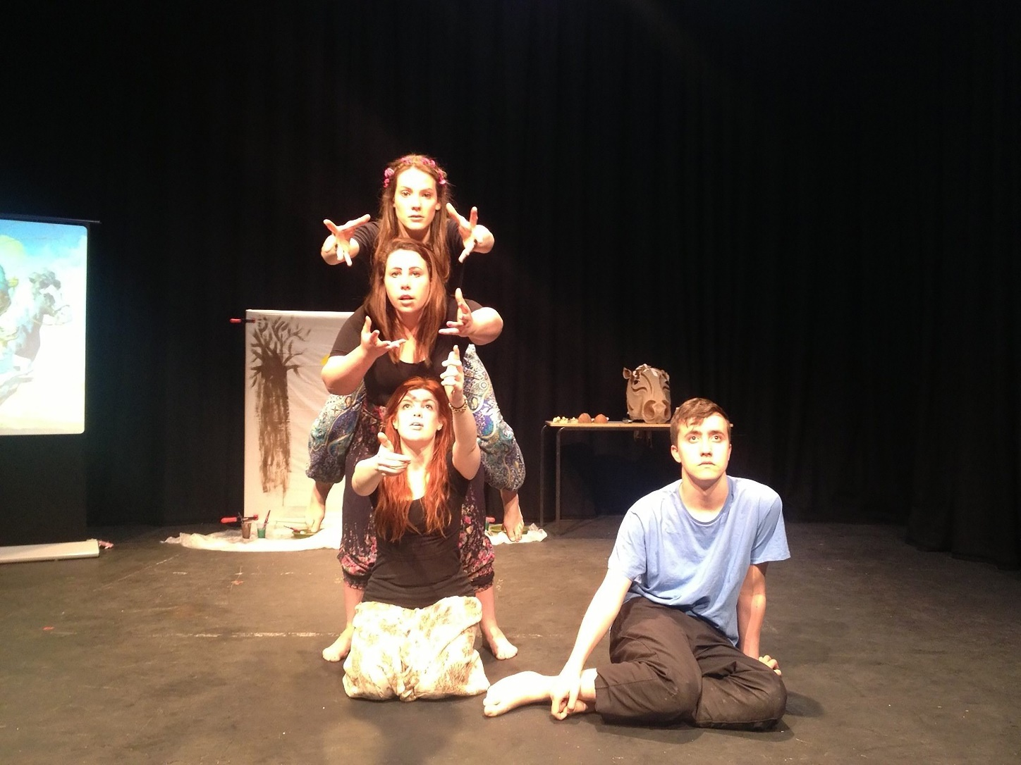

Figure 1 Macro Gestus Tableau: ‘You always want what you can’t get’
At the start of the performance, following their initial presentation of their first Macro tableau, they conjured up the world that Shakespeare describes at the beginning of the poem. Before speaking any lines, Elizabeth and James began a composed soundscape of imitative birdsong and atmospheric vocalisation, whilst playing the ukulele. Sophie set about painting a purple sky, the sun, green fields and trees on the backcloth. As Elizabeth spoke the first lines of the poem, Sophie’s PowerPoint images illustrating the text, echoing the words, began moving across the screen:
‘Even as the sun with purple coloured face
Had ta’en his last leave of the weeping morn…’
Hollie, embodying the horse that Adonis is riding, wearing a model of a horse’s head, appeared on the stage, galloping to the sound of horse’s hooves, created by Elizabeth and Sophie banging coconut shells together, as they spoke the lines:
‘Rose cheeked Adonis hied him to the chase,
Hunting he loved, but love he laughed to scorn…’

Throughout the highly physical performance, the participants utilised their Micro and Macro tableaux to underpin the words, communicating their interpretation of meaning and artistic expression. The poem proceeds, as Venus approaches Adonis:
‘Sick-thoughted Venus makes amain to him,
And like a bold-faced suitor ‘gins to woo him.
‘Thrice fairer than myself’, thus she began, ‘The field’s chief flower, …’

Figure 2 Hollie’s drawing of the Micro Grasp Tableau: ‘The field’s chief flower’
Here, Hollie’s drawing of the metaphor is a literal translation into picture form, creating a paired 'key word' mnemonic, as a memorable semantic elaboration (Sadoski & Paivio 2009, p. 167). This phrase was also given a physical Micro Grasp literal representation in performance.

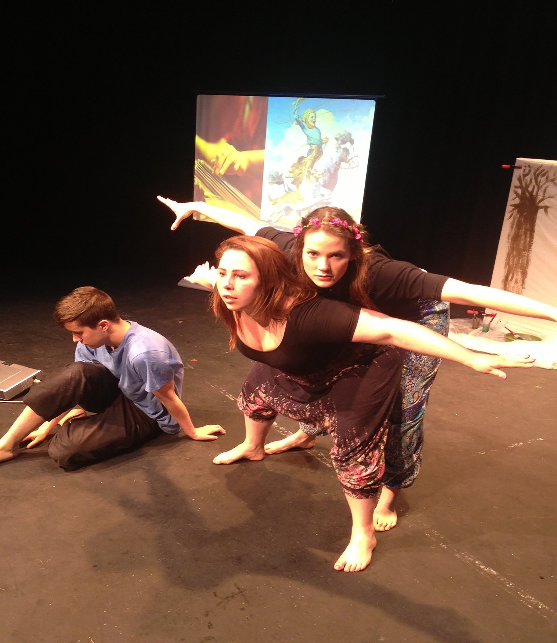

Figure 3 Micro Grasp Tableau: ‘She feedeth on the steam as if on a prey’

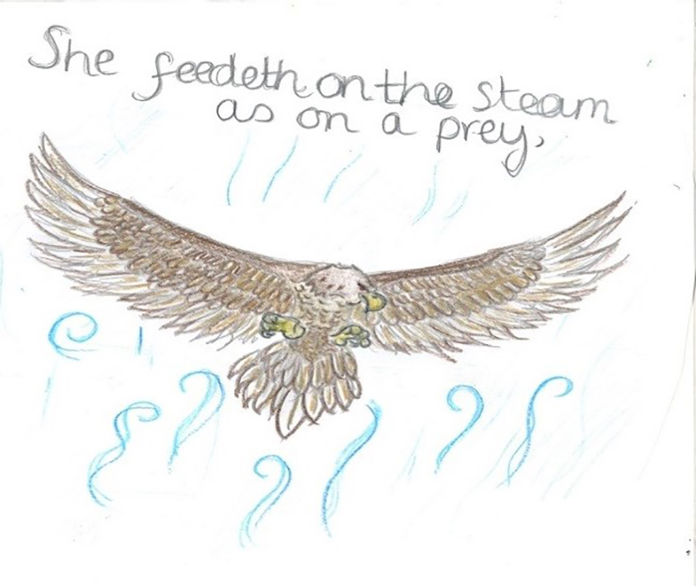

Figure 4 Hollie’s drawing of the Micro Grasp: ‘She feedeth on the steam as if on a prey’
In Figure 3, it can be noted how the physical image of the action in the Micro Grasp Tableau echoes the drawing of the bird of prey portrayed in Figure 4, while both genres capture the visceral content of Shakespeare’s metaphor.
A consideration of the function of the drawings as process towards performance
Below I report on some of the participants’ drawings produced as part of their experiencing of the text during their rehearsal period, and I consider their function as hermeneutic tools towards an immersion in the text.

Sophie
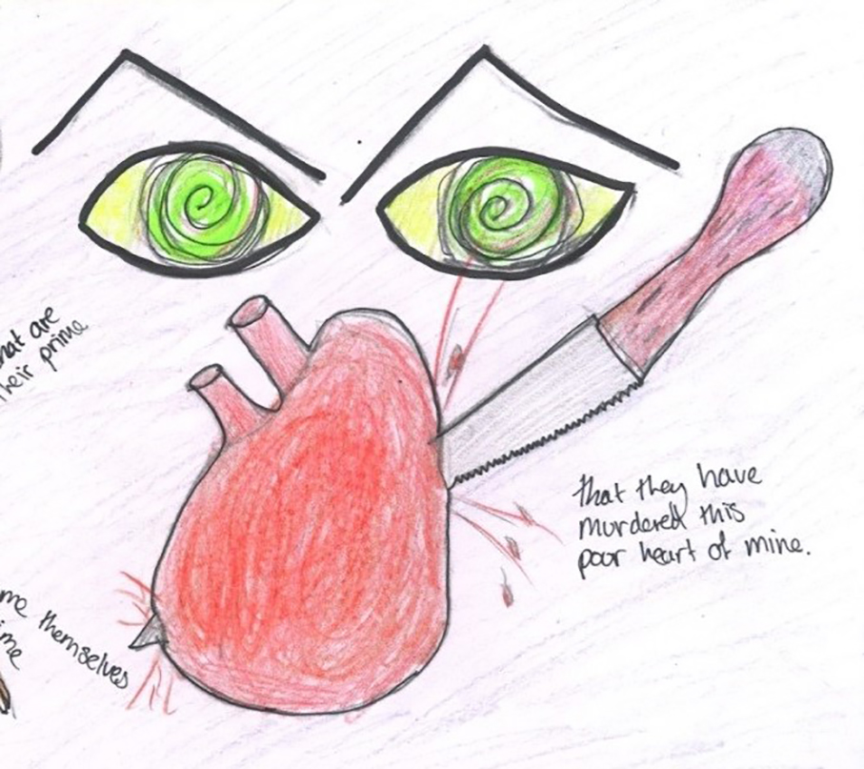
Figure 5 Sophie’s Micro Grasp: ‘that they have murdered this poor heart of mine’
Comment: This is an action-filled picture. In the eyes and the heart, the pencil strokes are swirling, full of movement. Lurid colours and strong black eyebrows add impact; the placement of the heart, as subject, is central, with the active verb murdered highlighted by the knife moving diagonally across the page, piercing the heart, the blood bursting from the wound. The graphics powerfully underpin the words and the pain that Venus is suffering. Sophie’s performance reflected all that is within this picture.

James

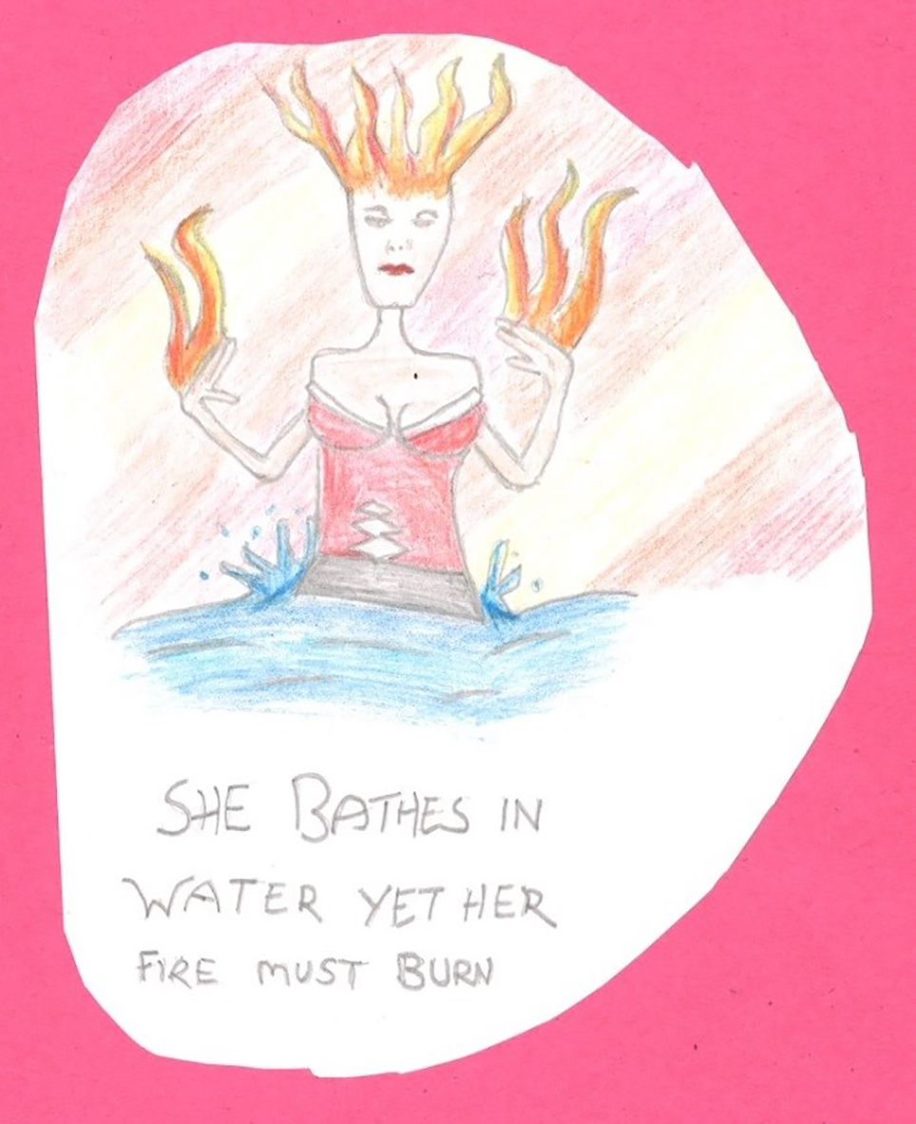

Figure 6 James’s Micro Grasp: ‘She bathes in water yet her fire must burn’
Comment: James’s picture has a naïve style, yet its design is dramatic. Venus, with voluptuous figure and flames of passion burning from her head and hands, cuts a spectacular figure. This representation amplifies her power, experienced by Adonis in Shakespeare’s narrative, and James when in the role of Adonis.

Hollie

Figure 7 Hollie’s Macro Gestus: ‘You can’t always get what you want’
Comment: Hollie’s drawing portrays Venus’s longing for Adonis. The drawing functioned as a Psychological Gesture for Hollie in her acting of Venus. Michael Chekhov’s technique for assisting actors in exploring their character - The Psychological Gesture acts as the ‘imaginary body’…‘calling up feelings,emotions and will impulses’ (Chekhov 1985,p.133).

Analysis of the effectiveness of the strategy
Following the performance, I collected feedback from the participants, using an interpretive phenomenological analysis, focusing on personal experience and emerging themes (Smith, Flowers & Larkin 2009). In semi-structured interview, I questioned whether working with the Macro and Macro exercises had assisted them with their dyslexia challenges or not. In my analysis, I re-read the interviews looking for identifiable themes. Their feedback affirmed that they believed that this exercise functions as a powerful tool to overcome, or by-pass some of their prevailing difficulties, whilst supporting their development in several areas. The themes have been divided into eight categories (see Figure 8). Due to their interconnecting relationship, where separation would have reduced their full meaning, I have merged them into four headings, which I have laid out below. I include a brief analytical comment under each heading, including a selection of participant feedback.

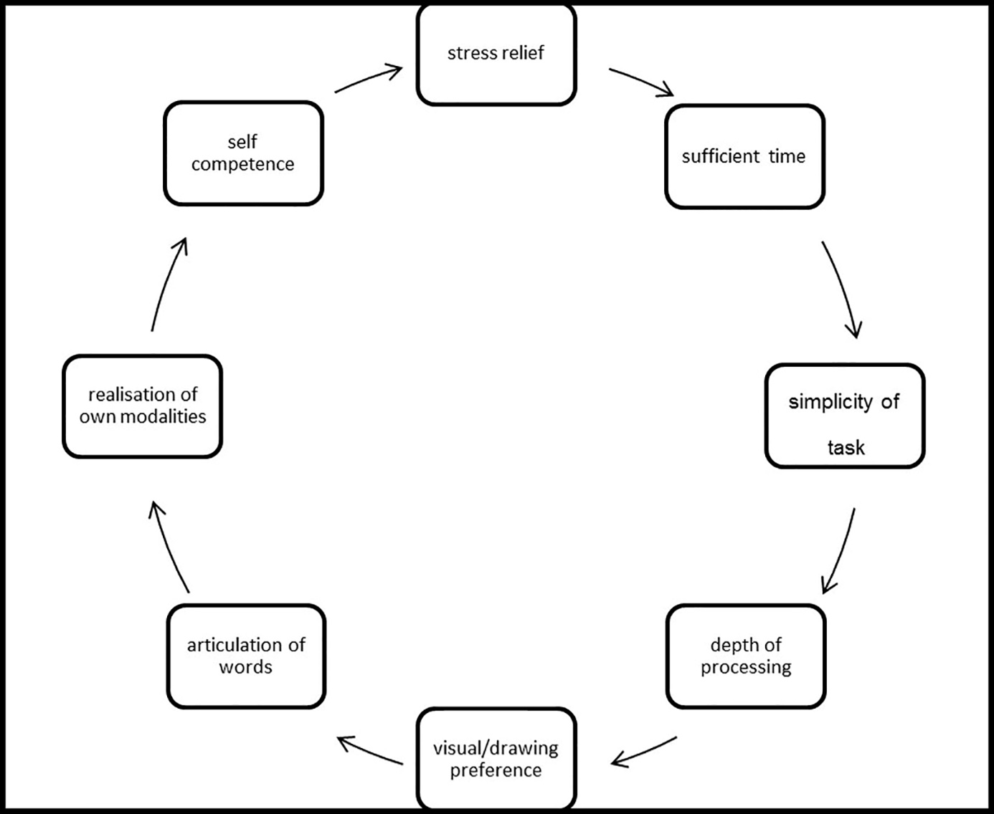
Figure 8 The Cycle of Themes
1) Theme: Stress Relief, Sufficient Time and Simplicity of Task
The Macro Gestus and Micro Grasp Strategy offers a structure that removes an initial confrontation with the text, eliminating the demand for an immediate ‘correct’ response. This reduces the risk of failure within the public arena of class/rehearsal. By approaching the text in a shared manner (with group discussion of meanings, interpretations and pronunciation of words before performance), the danger of exposure and humiliation is lessened. With a simplicity of instruction in identifying the Macro and the Micro, there is a clarity of goals, allowing time for the realisation of the words. Sophie explains, ‘I often panic when I know that I will be asked to read a big chunk of text, but if my mind was taken up by this - by looking at the meaning first and deciding on the Macros and Micros - and then creating the physical actions - it is very helpful’. Hollie tells us that, ‘I found this method easier to organise myself with the text and understand what the overall meaning is, what the characters are saying and how the language is expressing this, as I can place it all on the page in drawings rather than doing lots of different things at the same time, such as in the Stanislavski verbs and actions’.
2) Theme. Depth of Processing, Drawing and Visual Preference, Articulation
The strategy allows for multi-perspectives, abilities and cognitive learning styles optimizing a more complex, layered absorption of the text. The devising of images (both physical and visual) where meaning can be mapped directly to word and captured into concrete forms, facilitates the embedding of mental models, supporting working-memory and processing difficulties, while also developing creative interpretations. The process of separating the various strands of the text and then synthesising them back together, enhances depth of comprehension, influencing fluency of reading and ability to articulate the words. Hollie reports: ‘I found my own technique of drawing over the words of the text and the drawing of Micros help me memorise and express the text, as these were the images I mostly recalled when performing the text…the words no longer remain two dimensional when speaking the text or visually on the page, but instead they evolved to become interactive, exciting and rich’. Elizabeth agrees, saying, ‘I found this one of the most helpful exercises. It definitely helped me to understand the text but also made me look deeper into the meanings and feelings of all the detail and individual lines. When learning the text, I could also visualise the pictures I had drawn. When learning my lines, I could picture the drawings and automatically feel something and connect with it when I spoke it’.
3) Theme. Realisation of Own Modalities and Strategies
The action-research aspect of this investigation meant that the participants become co-participants in the investigation, through their examination of themselves, reflecting on their dyslexia and compensatory methods. Considering her rationale for translating the text into illustrative PowerPoint slideshows, Sophie commented, ‘I realised that most of my PowerPoint slides are Micros - picking out iconic details from the text…helping me to grasp what is going on and finding overall and individual meaning’. James made some sense of his desire to interweave the text with music, clarifying: ‘if I give a piece of music to a scene or a speech, and then I add the text into the lyrics of the music and then get the feeling from that, I then take away the music, take away the singing, I feel that becomes a lot more fluid and free… I can hear a piece of music and in my mind there will be a certain picture – an image - music is one way I can really express myself in the text ...to give it a sense of me’. In recognising her dominantly visual approach, Hollie said, ‘the encouragement of drawing has really helped me when understanding or reading texts, also helped me learn the qualities of myself that I am a visual learner. I think this is one of the exercises I will take with me throughout my acting career when exploring future texts. It really helped me get into the text and I loved discovering the sounds, textures, imagery and colours within the language’.
4) Theme: Self-competence
The utilisation and presentation of the participants’ personal modalities as valuable contributors to the performance encouraged a sense of competence and self-actualization (Maslow n.d). In his model of human needs and motivation, Abraham Maslow’s proposition of self-actualization is placed at the top of the pyramid of human needs, referring to ‘a self-fulfilment…to become everything that one is capable of becoming’ (Maslow n.d, p.19). Having removed many of the barriers that blocks those with dyslexia during this process, the individual is able to develop their abilities. Sophie underlines: ‘I have learnt so much about myself. I found that half the challenge is about self-confidence...I have learnt that it is better to take your time with the text rather than panicking and rushing over it and to make sure that I am understanding what I am saying...now I can pick up a text and understand most of the language and... if I think about it, can work out most of the double meanings. I never thought that dyslexia and Shakespeare could go together but now I could see myself performing Shakespeare with confidence, which for me is an achievement’.

Conclusion
In her dissemination of dyslexic actors’ visual and multi-sensory ways of making meaning, Leveroy encourages actor-trainers and industry professionals to develop inclusive strategies for rehearsals, although highlighting that this work can be complicated and time consuming (2015, p. 319- 320). Here I offer a strategy for studio teaching that is not too demanding of time, underpinned by research into dyslexia, psychology, textual comprehension and educational theory. Although I acknowledge there is no typical dyslexic learner, and therefore no ‘one size fits all’ in facilitation, this is a method which can involve a wide range of individuals, including dyslexic and non-dyslexics learners. It provides equality of opportunity that can be developed using a multiplicity of texts beyond Shakespeare. Maryanne Wolf (director at a Centre of Reading and Language Research) has labelled dyslexia as ‘a mystery of the century’ (2008:192). Dyslexia (and its accompanying spectrum of characteristics) is observed in individuals across social class, levels of education, and languages. There is a continuing debate amongst some educational and dyslexic specialists who question the existence and label of dyslexia (Elliott & Grigorenko 2014; Elliott & Nicolson 2016). However, despite the arguments, it is agreed by all involved that those who suffer difficulties with reading and decoding, and the resulting emotional effects, should receive appropriate support driven by ‘high-quality research’ (Elliott 2016:149). This article and its study attempts to contribute to those aims and discussions.

Reference List

Alfreds, M., 2007. Different Every Night. London: Nick Hern.
Bacon, A.M. and Bennett, S., 2012. Dyslexia in Higher Education: The Decision to Study Art. European Journal of Special Needs Education, 28 (1), 19-32.
Block, G., 2013. Speaking the Speech: An Actors Guide to Shakespeare. London: Nick Hern.
Brunswick, N., 2012. Supporting Dyslexic Adults in Higher Education and the Workplace. Oxford. Wiley-Blackwell.
Burden, R., 2005. Dyslexia and Self-Concept. London: Whurr Publishers.
Carey, D. and Clark Carey, R., 2010. The Verbal Arts Workbook. London: Methuen Drama.
Carey, D. and Clark Carey, R., 2015. The Shakespeare Workbook. London: Methuen Drama.
Chekhov, M., 1985. Lessons for the Professional Actor. New York: Performing Arts Journal Publications.
Department for Education and Skills., 2004. A Framework for Understanding Dyslexia. London: Department of Education and Skills.
Elliott, J., and Grigorenko, E., 2014. The Dyslexia Debate. New York: Cambridge University Press.
Elliott, J., & Nicolson, R., 2016. Dyslexia: Developing the Debate. London: Bloomsbury Academic.
Gardner, H., 2003. Frames of Mind. The Theory of Multiple Intelligences. New York: Basic Books.
Grant, D., 2010., That’s the Way I Think. 2nd ed. Oxon: David Fulton.
Hall, P., 2003., Shakespeare’s Advice to the Players. London: Oberon Books.
Huxley, M., and Witts, N., 1996. The Twentieth-Century Performance Reader. London: Routledge, 1996, 1-11.
Kintsch, W., and Rawson, K., 2005. Comprehension. In: M. Snowling, and C. Hulme, eds. The Science of Reading. Oxford: Blackwell Publishing, 209 -226.
Krauss, R., Chen, Y., and Gottesman, R. 2000. Lexical Gestures and Lexical Access: A Process Model. In: D. McNeill., ed. Language and Gesture. Cambridge: Cambridge University Press, 261-283.
Leveroy, D., 2013a. Enabling Performance: Dyslexia, (Dis)ability and ‘Reasonable Adjustment’. Theatre, Dance and Performance Training, 4 (1), 87–101.

Leveroy, D., 2013b. Locating Dyslexic Performance: Text, Identity and Creativity. Research in Drama Education. The Journal of Applied Theatre and Performance, 18 (4): 374–387.

Leveroy, D., 2015. A Date with the Script: Exploring the Learning Strategies of Actors Who Are Dyslexic. Theatre, Dance and Performance Training, 6 (3): 307–322.

Linklater, K., 1992. Freeing Shakespeare’s Voice. New York: Theatre Communications Group.
Maslow, A.H., n.d. A Theory of Human Motivation. Floyd VA: Wilder Publications.
McLoughlin, D. and Leather, C., 2013. The Dyslexic Adult. 2nd ed. Chichester: Whurr Publications.
McNiff, J., 2013. Action Research.3rd ed. London: Routledge.
Merlin, B., 2003. Konstantin Stanislavsky. Oxon: Routledge.
Mitter, S., 1992. Systems of Rehearsal. London: Routledge.
Mortimore, T., 2008. Dyslexia and Learning Style. 2nd ed. Chichester: John Wiley and Sons.
Muijs, D. and Reynolds, D., 2005. Effective Teaching. 2nd ed. London: Sage.
Nicolson, R. and Fawcett, A., 2010. Dyslexia, Learning and the Brain. London: MIT Press.
Nicolson, R., 2015. Positive Dyslexia. Sheffield: Rodin Books.
Noble, A., 2010. How to do Shakespeare. London: Routledge.
Pollak, D., 2012. Supporting Higher Education Students Who Are Dyslexic. In: N. Brunswick., ed. Supporting Dyslexic Adults in Higher Education and the Workplace. Oxford: Wiley-Blackwell, 59-73.
Reid, G., 2003. Dyslexia: A Practitioner’s Handbook. 3rd ed. Chichester: John Wiley.
Rodenburg, P., 2002. Speaking Shakespeare. London: Methuen Drama.
Rosenberg, T., 2008. New Beginnings and Monstrous Births: Notes Towards an Appreciation of Ideational Drawing. In Garner, S., ed. Writing On Drawing. Bristol: Intellect Books, 109-124.
Sadoski, M. and Paivio, A., 2009. Imagery and Text. New York: Routledge.
Shakespeare, W., 2007. Venus and Adonis. In: K. Duncan-Jones, H.R. Woudhuysen, eds. Shakespeare’s Poems. London: Bloomsbury Publishing.
Smith, J. A., Flowers, P. and Larkin, M. 2009. Interpretative Phenomenological Analysis: Theory, Method & Research. London: Sage.
Smith-Spark, J. and Fisk, J., 2003. Investigating the Central Executive in Adult Dyslexics: Evidence from Phonological and Visuospatial Working Memory Performance. European Journal of Cognitive Psychology, 15 (4), 567-587.
Smith-Spark, J. and Fisk, J., 2007. Working Memory Functioning in Developmental Dyslexia. Memory, 12 (2), 174-182.
Stanislavski, C., 1980. My Life in Art. London: Methuen.
The Quality Assurance Agency for Higher Education., 1999. Code of Practice for the Assurance of Academic Quality and Standards in Higher Education, Section 3 Students with Disabilities. Author Gloucester.
Thomson, M., 2009. The Psychology of Dyslexia. 2nd ed. Chichester: Wiley-Blackwell.
Waring, M. & Evans, C. 2015. Understanding Pedagogy. London: Routledge.
Willet, J., 1977. The Theatre of Bertolt Brecht. London: Eyre Methuen.
White, J., 2009. Illusory Intelligences? In: R. Cigman, R., & A. Davis, A., eds. New Philosophies of Learning. Chichester: Wiley-Blackwell, 241-259.
Whitfield, P., 2009. Shakespeare, Pedagogy and Dyslexia. In: R. Cooke., ed. The Moving Voice: The Integration of Voice and Movement. The Voice and Speech Trainer’s Review. USA: University Readers. 6, 254-262.
Republished on-line, 25th Nov 2013. Voice and Speech Trainer’s Review http://dx.doi.org/10.1080/23268263.2009.10767576
Whitfield, P., 2015a. Towards Accessing Shakespeare’s Text for Those with SpLD (Dyslexia): An Investigation into the Rationale for Building Visual Constructs. Thesis (PHD). University of Warwick.
Whitfield, P., 2015b. Towards an Emancipatory Praxis of Pedagogy: Supporting Acting Students with Dyslexia When Working On Shakespeare. Voice and Speech Review. 9 (2/3), 113-138.
Whitfield, P., 2016. A Facilitation of Dyslexia through a Remediation of Shakespeare’s Text. Research in Drama Education. The Journal of Applied Theatre and Performance. 21 (3), 385-400.
Winston, J., 2006. Researching Through Case Study. In: J. Ackroyd., ed. Research Methodologies for Drama Education. Stoke: Trentham Books.
Wolf, M., 2008. Proust and the Squid: The Story and Science of the Reading Brain. Cambridge: Icon Books.

For information regarding the various theories of dyslexia, see DFES 2004, Nicolson and Fawcett 2010.
Terminology is a contested area. ‘Learning difficulty/disability’ is said by some to place the responsibility within the student, while ‘difference’ indicates that teaching must be adjusted (Pollak 2012:60). The UK Equality Act (2010) labels dyslexia definitely as a learning disability (Brunswick 2012:4).
Dyscalculia is a difficulty with understanding numbers, counting and matters of ‘numerosity’ (DFS 2004 p 20).
In the UK, the Code of Practice for the Assurance of Academic Quality and Standards in higher education requires that: ‘The delivery of the programmes should take into account the needs of disabled people or, where appropriate, be adapted to accommodate their individual requirements…’ (The Quality Assurance Agency for Higher Education, 1999, Section 3, Precept 10).
At British drama institutions, dyslexia is included under a general title of ‘Specific Learning Difficulty’ in student records, making exact statistical numbers of students assessed as dyslexic unclear. In conversation with the Student and Academic Service departments in four major drama schools, they reported that every year there are a number of dyslexic students in each cohort.
An exception to this is the voice practitioners David Carey and Rebecca Clark Carey who include generic information about assisting dyslexic learners in their Shakespeare workbooks (2015, p.12, 2010, p. xviii) and Kristin Linklater’s methods which explore the text in sequences of sounds, words, phrases and sentences. In my research trials, it has shown that these methods can be helpful for those with dyslexia (Linklater 1992, p.11-52).
My PhD research comprised of case study observation and four action research cycles with twelve participants who were second year Acting degree students (assessed as dyslexic by an educational psychologist) carried out during my teaching of the nine-week Voice unit and Shakespeare Acting unit, progressing into the Story-telling unit over a 6-year period.
All the participants involved in this work have given written permission for their work and images to be included in this article.
Nicolson argues that mnemonics are helpful as a learning approach for dyslexics as many dyslexics have strong Declarative Learning skills (The Declarative Memory System stores knowledge of facts and events) (2015, p. 55-57).
For ideas about using computer technology to assist dyslexic learners, see Whitfield 2016
For more on my participants’ activation of the Psychological Gesture see Whitfield 2015a, p 99-102. Leveroy also refers to it as a possible teaching method for those with dyslexia (Leveroy 2013, p. 94, 2015, p.320).

