© [Keeley, A. 2019]. The definitive, peer reviewed and edited version of this article is published in [Scene, 7 (1+2), pp. 5 - 16, 2019, doi: https://doi.org/10.1386/scene_00002_1]

Adele Keeley, Arts University Bournemouth
Anthropomorphizing nature through costume design: A visual essay
Abstract
The United Nations Sustainable Development Goals 14 and 15 outline a broad concern for us to take better care for our lands and oceans and act on the negative anthropogenic impact that we, as humans, are having on this planet. However, I propose that many of us see ourselves as separate from nature and lack a connection with it. This, in turn, affects the way we treat it. In this research I explore how we can frame our futures by telling visual stories about the land and sea and the geological foundation of the world we live in. This is achieved by exploring the relationship between natural landscapes, earth sciences and the ‘bodily’ canvas. By presenting examples of costume and textile design in response to a specific brief this visual essay introduces the notion that by anthropomorphizing nature through costume design a sense of connectivity between humans and nature can be bridged. Although there are many examples of how nature has been used as a springboard for garment design this article draws attention to theories explored in social science that claim if we attribute human characteristics to natural forms we feel greater connectivity towards it. I present ideas that using the visual detail of the landscape and by exploring the opportunities of how these can be embedded into costume design we can create a playful public engagement performance tool. This approach has the potential to, not only investigate new ways of interpreting landscape and geology through a costume-design-led performance model, but also challenge the way people think about the natural world with the potential to foster pro-environmental behaviour.
Keywords
Anthropomorphizing, environmental practice, costume design, nature, connectivity, design-led performance

Introduction
This issue of Scene calls for us to consider the United Nations Sustainable Development Goals. It is helpful to remind ourselves that, at times, these goals can seem overwhelming to the individual. Sustainable Development Goals 14 and 15 call for us to protect our lands and oceans and take action to improve their natural biosystems by taking better care of them (United Nations n.d.a). More specifically Goal 14 states ‘sustainable land and marine-based human activities’ are one of the issues to be addressed to reduce ‘negative anthropogenic impact’ (United Nations n.d.b). These broad statements are a heavy responsibility on us as humans but as we get on with our busy daily lives, we can often feel removed from the effects we are having on the environment around us. I feel this disconnect is because we feel separate from nature in some way rather than seeing ourselves as part of the World’s ecosystem. As William’s comments in her response to the Fashioned from Nature exhibition at the V&A in 2019. ‘We humans are, of course, part of nature. We are one of many species living on earth, but our actions imply that we see nature as separate from us because we act on it with apparent impunity’ (Williams 2018: 151).

This visual essay presents a model of practice that highlights how the intervention of performance, or more specifically costume design, can be used as a method to connect us to the environment and think about the natural world. It outlines how costume design can play a role in helping individuals to connect to their local natural landscapes by anthropomorphizing natural forms in the design of fabric and textiles. Drawing on the somatic costume work by Dean (2014, 2016) I explore how the body can be used as a somatic landscape to promote connectivity with nature through performance. It will draw on theories explored by social scientists and present a visual diary of a case study that implements these ideas.

The bodily canvas of costume forces a designer to explore artistic interpretation in human form. In recent years research relevant to this study has come from the field of social sciences. Tam et al. (2013), Beery & Wolf-Waltz (2014) and Lumber, R. and Sheffield, D. (2017) all suggest that by presenting nature in human form we can encourage a connection with nature and promote positive environmental behaviour. I suggest that costume design is the perfect medium to explore this notion further. The body gives the designer a canvas to explore the notion of environmental interpretation that is automatically humanized. As Bugg succinctly puts it ‘clothing and the body are inextricably interconnected’ (2014: 68). The practice of designing a garment inspired by nature is not a new phenomenon and has, in fact, been a preoccupation of fashion designers for hundreds of years. The recent exhibition Fashioned from Nature at the V&A in 2019 showcased and celebrated many garments that humanize the natural environment, including fashion collections such as Alexander McQueen’s Plato’s Atlantis (2010). McQueen’s famous Darwin-inspired collection is a classic example of how nature can be staged on the human body (McQueen cited in Mower 2009). However, what costume design does through its performative nature is to help tell a story and, when specifically designed in response to nature, creates a ‘gateway into the environment’ (Dean 2014: 84). The relevance of research such as Tam et al. (2013), Beery and Wolf-Waltz (2014) and Lumber et al. (2017) stems from their focuses on the natural form and more abstract concepts. Tam et al. research claims that when an entity is anthropomorphized it becomes a source of social connection. They hypothesize that there is stronger connectivity to nature from these experiences (2013: 515). The Oxford Dictionary description to anthropomorphize something is to attribute human characteristics or behaviour to a god, animal or object (The Oxford Dictionary of English, 2010). Often when costume designers anthropomorphize, they commonly do so by humanizing or attributing human characteristics to animals. Characters such as Colleen Atwood’s design of the Wolf in the film Into the Woods (Marshall, 214) demonstrates how animalistic features are reimagined in an upright anthropoid form. This article specifically considers how landscape and the natural environments can be anthropomorphized on the body. Following on from Beery and Wolf-Waltz’s (2014) claim that the topic of environmental connectedness has found a growing scholarly concern I present that this concern can be actively explored in the area of performance design research too. Kershaw’s performance experiment at Bristol Zoological Gardens in 2005 presented a group of actors, using the movement traits of animals, to successfully draw attention to the behavioural connection between humans and primates (2012: 9). Though this work is of great value, I feel costume can also have significance in bridging a human/nature connection through the visual representation of natural formations in the landscape. Through this research project I wanted to explore if by humanizing landscape through costume design I could see an emotional connection between the audience and a specific location. I was lucky enough to be presented with an opportunity to do just that. The next section of this article presents a visual diary of a creative costume-design-led research project inspired by the Jurassic Coast in the South of England.

Case study: Mesozoic!
In 2017, together with research partner Lorna Rees from Gobbledegook Theatre, we were asked by the Jurassic Coast Trust to work with them on a creative project that presented the Jurassic Coast in a new and innovative way. The outcome of which would conclude in a costume-design-led theatrical performance inspired by the 95 miles of UNESCO Jurassic Coast World Heritage Site in Dorset and East Devon. Although commonly known as the Jurassic Coast the coastline comprises a near-continuous sequence of rock exposures representing the period of geological time known as the Mesozoic Era between 285–65 million years ago (Khatwa Ford 2018: 2). The performance was to accompany the Natural History Museum’s Dippy on Tour in which the iconic Diplodocus skeleton cast travelled to the Dorset Country Museum in February 2018. The museum received approximately 153,000 visitors through its doors during ‘Dippys’ visit and the Jurassic Coast Trust saw this as an opportunity to promote the Jurassic Coast and encourage a sense of identity and connectivity to the natural environment along the south west of England. In 2006, preceding the commission of this project, the Jurassic Coast Trust developed what was seen at the time as, as an innovative arts strategy by being the first World Heritage Site to invest in an approach that placed the importance of creative expression alongside scientific and historical facts. The performance Mesozoic! was part of the concluding element of the strategy’s application. As theatre-makers commissioned to make a unique and bespoke piece of theatre we were guided by the key objectives of the Dippy on Tour project as outlined by the Jurassic Coast Trust (2017). These were to:
- Inspire the next generation of scientists.
- Challenge the way people think about the natural world, past, present and future.
- Provide the opportunity to celebrate UK collections and natural history.

Research aim
Our role as theatre-makers and designers was to encourage a connection with the Jurassic Coast and in turn get audiences to question the world around them by promoting curiosity about nature (Jurassic Coast Trust 2017). We were very interested in using a costume-design-led methodology to lead the project development. This meant that we worked primarily from the visual exploration of the site before considering the narrative or dialogue of the performance. Our main aim for the project was to explore the notion of anthropomorphizing nature through the design process and create a costume design that presented opportunities for learning through playful interaction during the performance. We outlined a set of secondary aims that we considered as we developed the research. These were:
- To explore the opportunity of embedding the site into the costume design by using details in the landscape.
- To enable the performer to not only perform in the original location that inspired the costume but more importantly to take the landscape to an audience that might not be able to visit the actual site.
- To explore broader issues of deep time and encourage our audience to make sense of their everyday world and care for it by reflecting on past events.

We hoped that by using these aims we could create a playful interactive performance tool to promote communication and environmental connectedness. Rogers claims in her research as a cultural geographer that ‘performing arts […] have become established means through which […] people experience and make sense of their everyday worlds’. She goes on to say ‘the performing arts are playful, creative and experimental, they draw attention to the poetics of being in the world’ (Rogers 2012: 60). We hoped that by creating a costume which anthropomorphized nature that we would present the Jurassic Coastline in a new, innovative and exciting way. By embedding images of the landscape into the design of the costume we intended to create a walking accessory to share factual information about the landscape and its history and encourage connectedness by using a visually stimulating and scientific artefact.
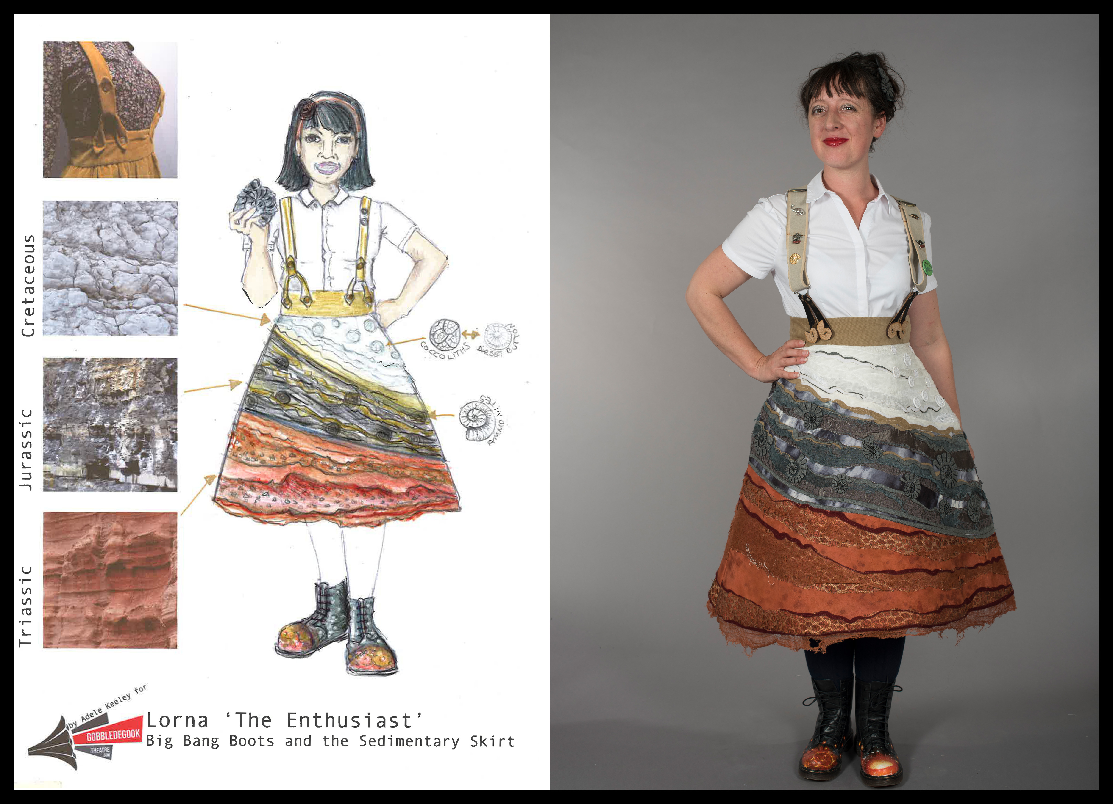
Figure 1: Design by Adele Keeley and modelled by Lorna Rees, The Sedimentary Costume, 2017–18, mixed media. Photograph by Maggie McGuire. Dorset.

Methods
The costume-design-led approach was developed through theoretical and empirical research that explored the connectivity between the landscape and the body. Field trips and visual hands-on research included rock rubbing, sketching, fossil hunting, archival research and investigative walking as shown in Figure 2. As artists that reside in the Dorset region we also extended our own geological knowledge which had developed empirically over years of informal visits and holiday excursions to the coast. By having this focus to our activities the project brought an awareness of the way we viewed the landscape. Most significant was the dialogue with the earth scientists from the Jurassic Coast. We used the research process as a platform to share practice and explore how design and science can converge to create work that is aesthetically pleasing as well as factually correct.
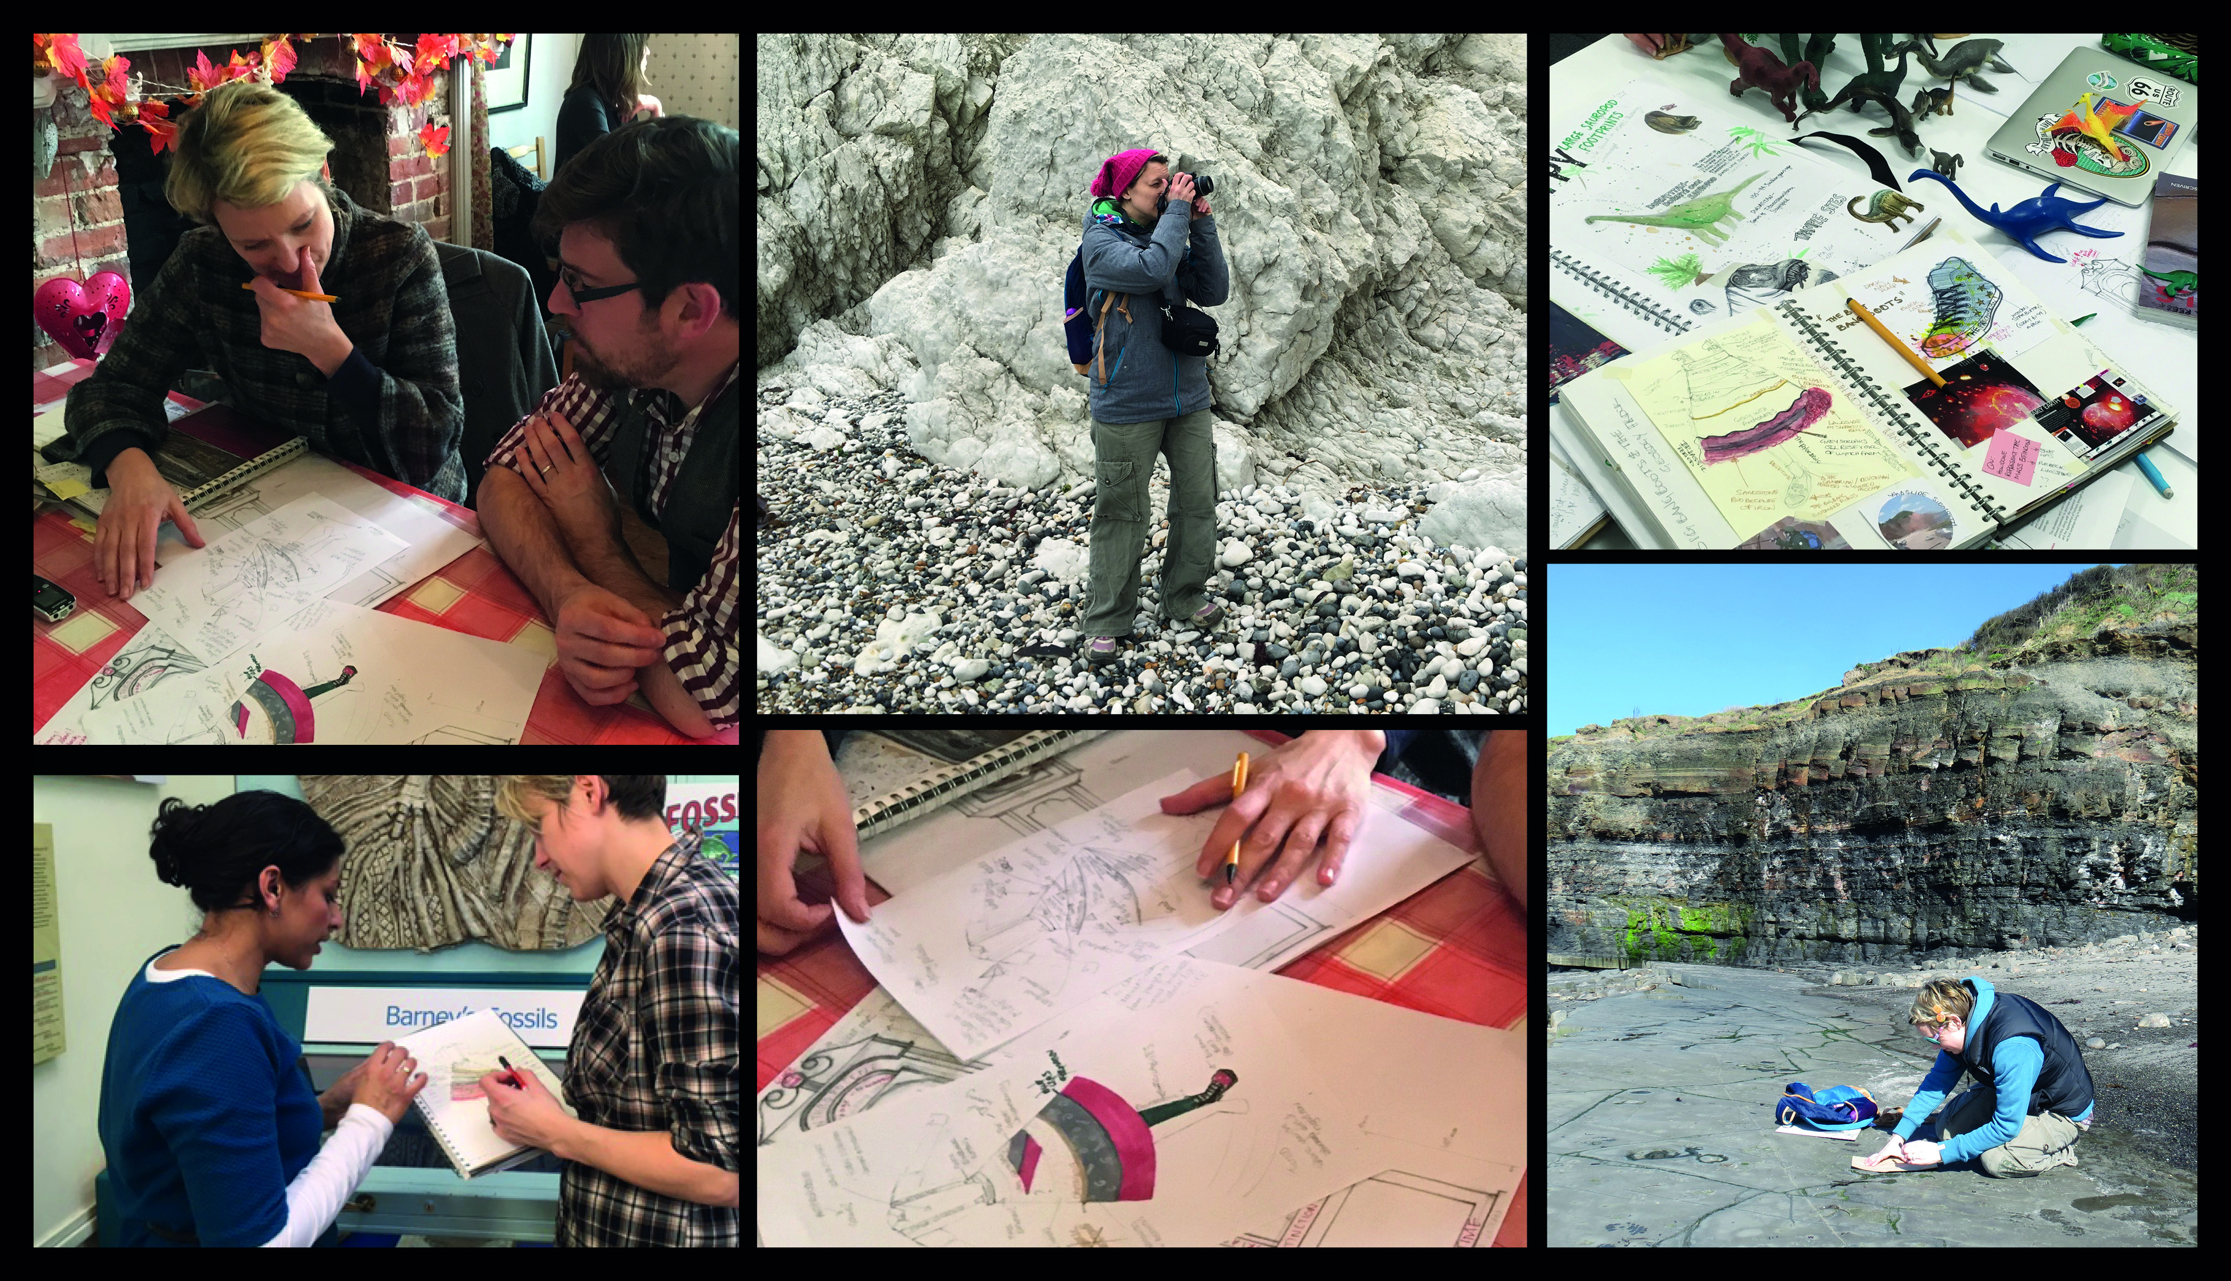
Figure 2: Adele Keeley, Collage of Methodologies, 2017–18, featured scientist Sam Scriven and Dr Anjana Khatwa Ford from the Jurassic Coast Trust. Dorset.

The series of design development images shown in Figure 3 demonstrates an example of the visual conversations that took place between us, as designers, and the scientists. An initial design was drafted in simple human form almost as a static map of the intended costume. This was then presented to the experts who imparted their extensive knowledge. The design was then revised and represented in a circular process of action style research. From the scientists point of view, these revisions took into consideration the geological nuances and detailed scientific facts. For us, as designers, we considered the aesthetics of the natural form and the placement of these on the body. We also considered the fabrics and materials to create an artistic interpretation that also was true enough to be factual and inspiring at the same time. This circular dialogue enabled a design development process to evolve that embedded facts into a garment in a fluid and creative way. As the design evolved so did ideas of how the performer would present these facts through performance. At this stage the body was seen as a ‘design tool to generate performative clothing design’ (Bugg 2014: 72), which could be translated into actions performed in a manner that shared cognitive information to its audience. The final costume illustration seen in Figure 1 was used as the initial prompt for narrative development. Following on from Dean (2014) we wanted the somatic experience of wearing the costume, together with the visuals of the landscape embedded in the costume, to inform and drive the dramaturgy.
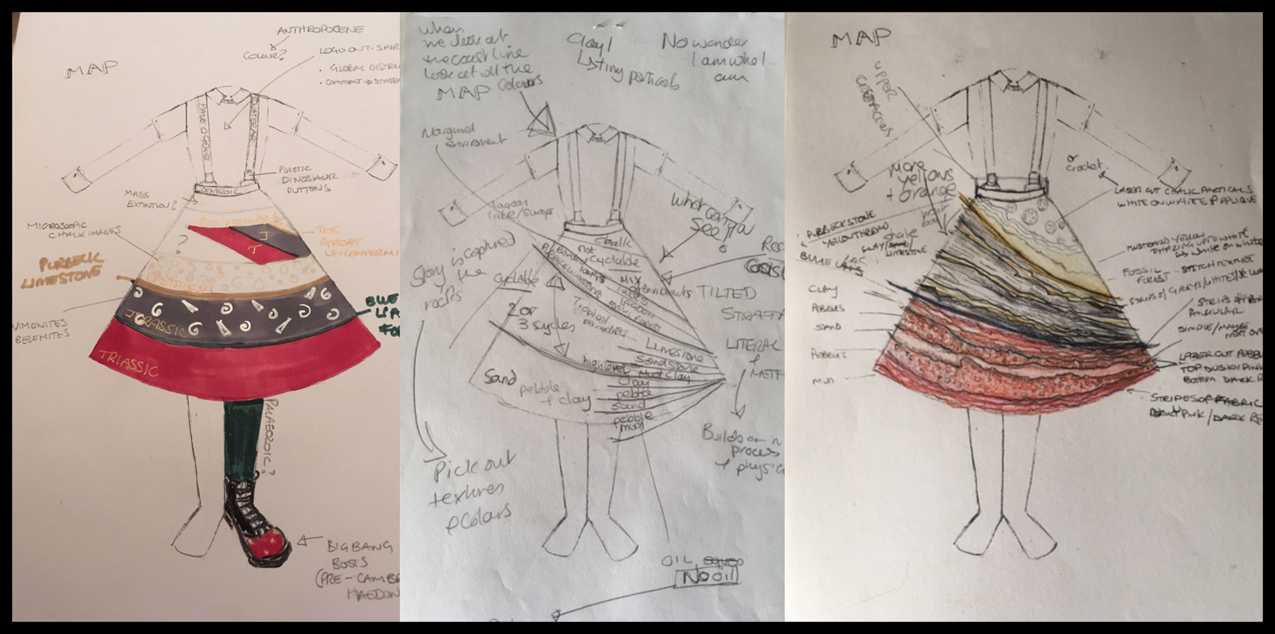
Figure 3: Drawings by Adele Keeley, Design Development Drawings for the Sedimentary Costume, 2017, watercolour, pencil and ink, Dorset.

Crafting the coast
The geographical timeline of the coast was presented chronologically up the body. Starting with the feet we represented the beginning of time with the big bang boots. The main inspiration for the project, the geomorphic strata of the Jurassic Coast, was crafted onto the flat surface of an A-line skirt. The width of the skirt gave us a large open backdrop to explore textiles that were inspired by the geology of the site. We also went on to discover that the skirt canvas becomes a usable visual point for the performer to refer to throughout the performance. The top half of the body was kept simple. In discussions, we tentatively saw this as the time period known as the Cenozoic, the time of mammals and eventually humans. We did explore a variety of different graphical representations of what this may look like and even printed some of these on T-shirts, but in the end, we decided to keep this to a simple white shirt. This kept the main focus on the textured skirt representing the sedimentary layers along the Jurassic Coast. While constructing the placement of landscape onto the body we also started to get an identity of the wearer. The amateur palaeontology enthusiast was born and additional accessories such as the explorer style braces and fossil hunter badges were added.

The tri-layered Sedimentary Skirt was crafted to represent the three time periods of the Mesozoic era (Cretaceous [145mya–66mya], Jurassic [201mya–145mya] and Triassic (252mya–201mya]). For the white Cretaceous layer, we commissioned a local button maker to craft Dorset Buttons. These represented the microfossils found in the chalk beds, known as Coccolithophores. Dorset buttons traditionally known for their detailed crochet-like presentation not only replicated the Coccolithophores in tacit form but presented a story of locality, history and place which became part of the narrative in the performance. In the grey Jurassic layer, we created artistic representations of ammonite fossils which were laser-cut from recycled felt. Being the most prolific strata where fossils have been discovered, and can still be found today, it seemed appropriate to create a visual dialogue around fossils and how they present themselves in the coastal rock. In the red Triassic layer at the bottom of the skirt a red mesh fabric, with spotted oval textures, represented the Budleigh Salterton pebble beds located in East Dorset. The skirt was designed so all the sedimentary layers were tilted down to the right mirroring the geological structure of the coast shown in Figure 4.
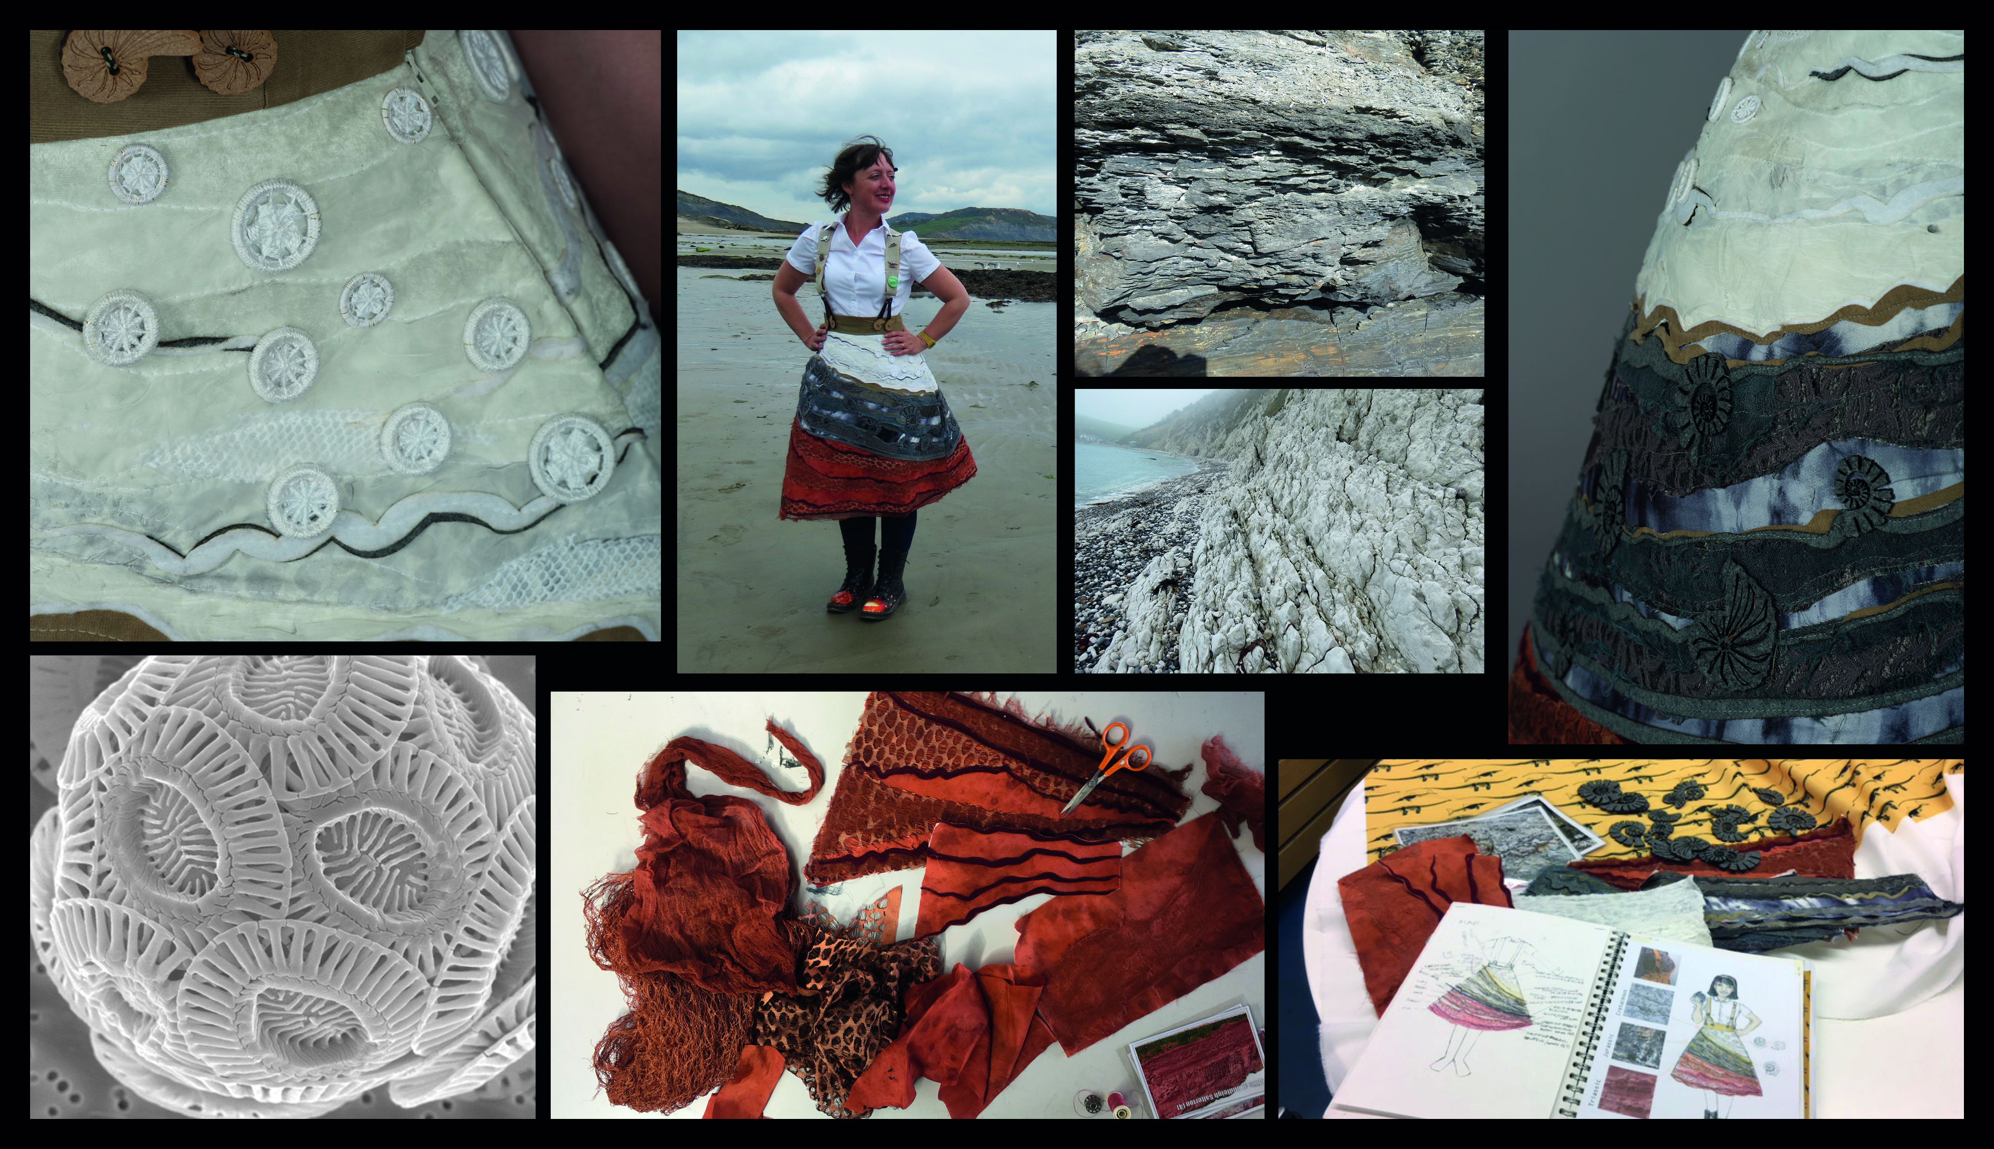
Figure 4: Textile construction Adele Keeley and modelled by Lorna Rees, Montage of Textile Development inspired by the Rock Formation Present in the Sediment and Close-up Detail of the Costume Supported by Visual Influences, 2017–18, mixed media, Dorset

During the research we looked for opportunities for further experimentation in presenting landscape and nature on garments. One of these creative investigations explored how we could present other artists interpretations of landscape on the human form. The Duria Antiquior (‘A more ancient Dorset’) a watercolour by Henry De La Beche (1830) was the first portrayal of prehistoric marine life. An example of early Paleoart, the picture was based on evidence from fossils found by Dorset’s treasured amateur palaeontologist Mary Anning (Seaton Jurassic 2019). The design process involved manipulating the painting to fit onto a shirt pattern. This was then digitally printed onto the fabric before the final shirt was constructed shown in (Figure 5). The painting seamlessly wrapped the body with no obvious breaks in the painting. This costume, which dressed a second performer in the performance, gave a platform for further discussion about how the Jurassic landscape has been represented over time. Another example of anthropomorphizing nature was through the creation of the Ichthyosaur inspired button that featured on the duffle coat worn by the performer during some outdoor performances (such as at the Lyme Regis Fossil Festival). The Ichthyosaur is a pre-historical marine reptile that thrived during the Mesozoic era. Indigenous to Dorset the Ichthyosaur was the first full fossil skeleton found by the Anning family in 1811. By creating a replica of the tooth as an everyday item such as a button we hoped to generate conversation, inspire curiosity and promote inquiry.
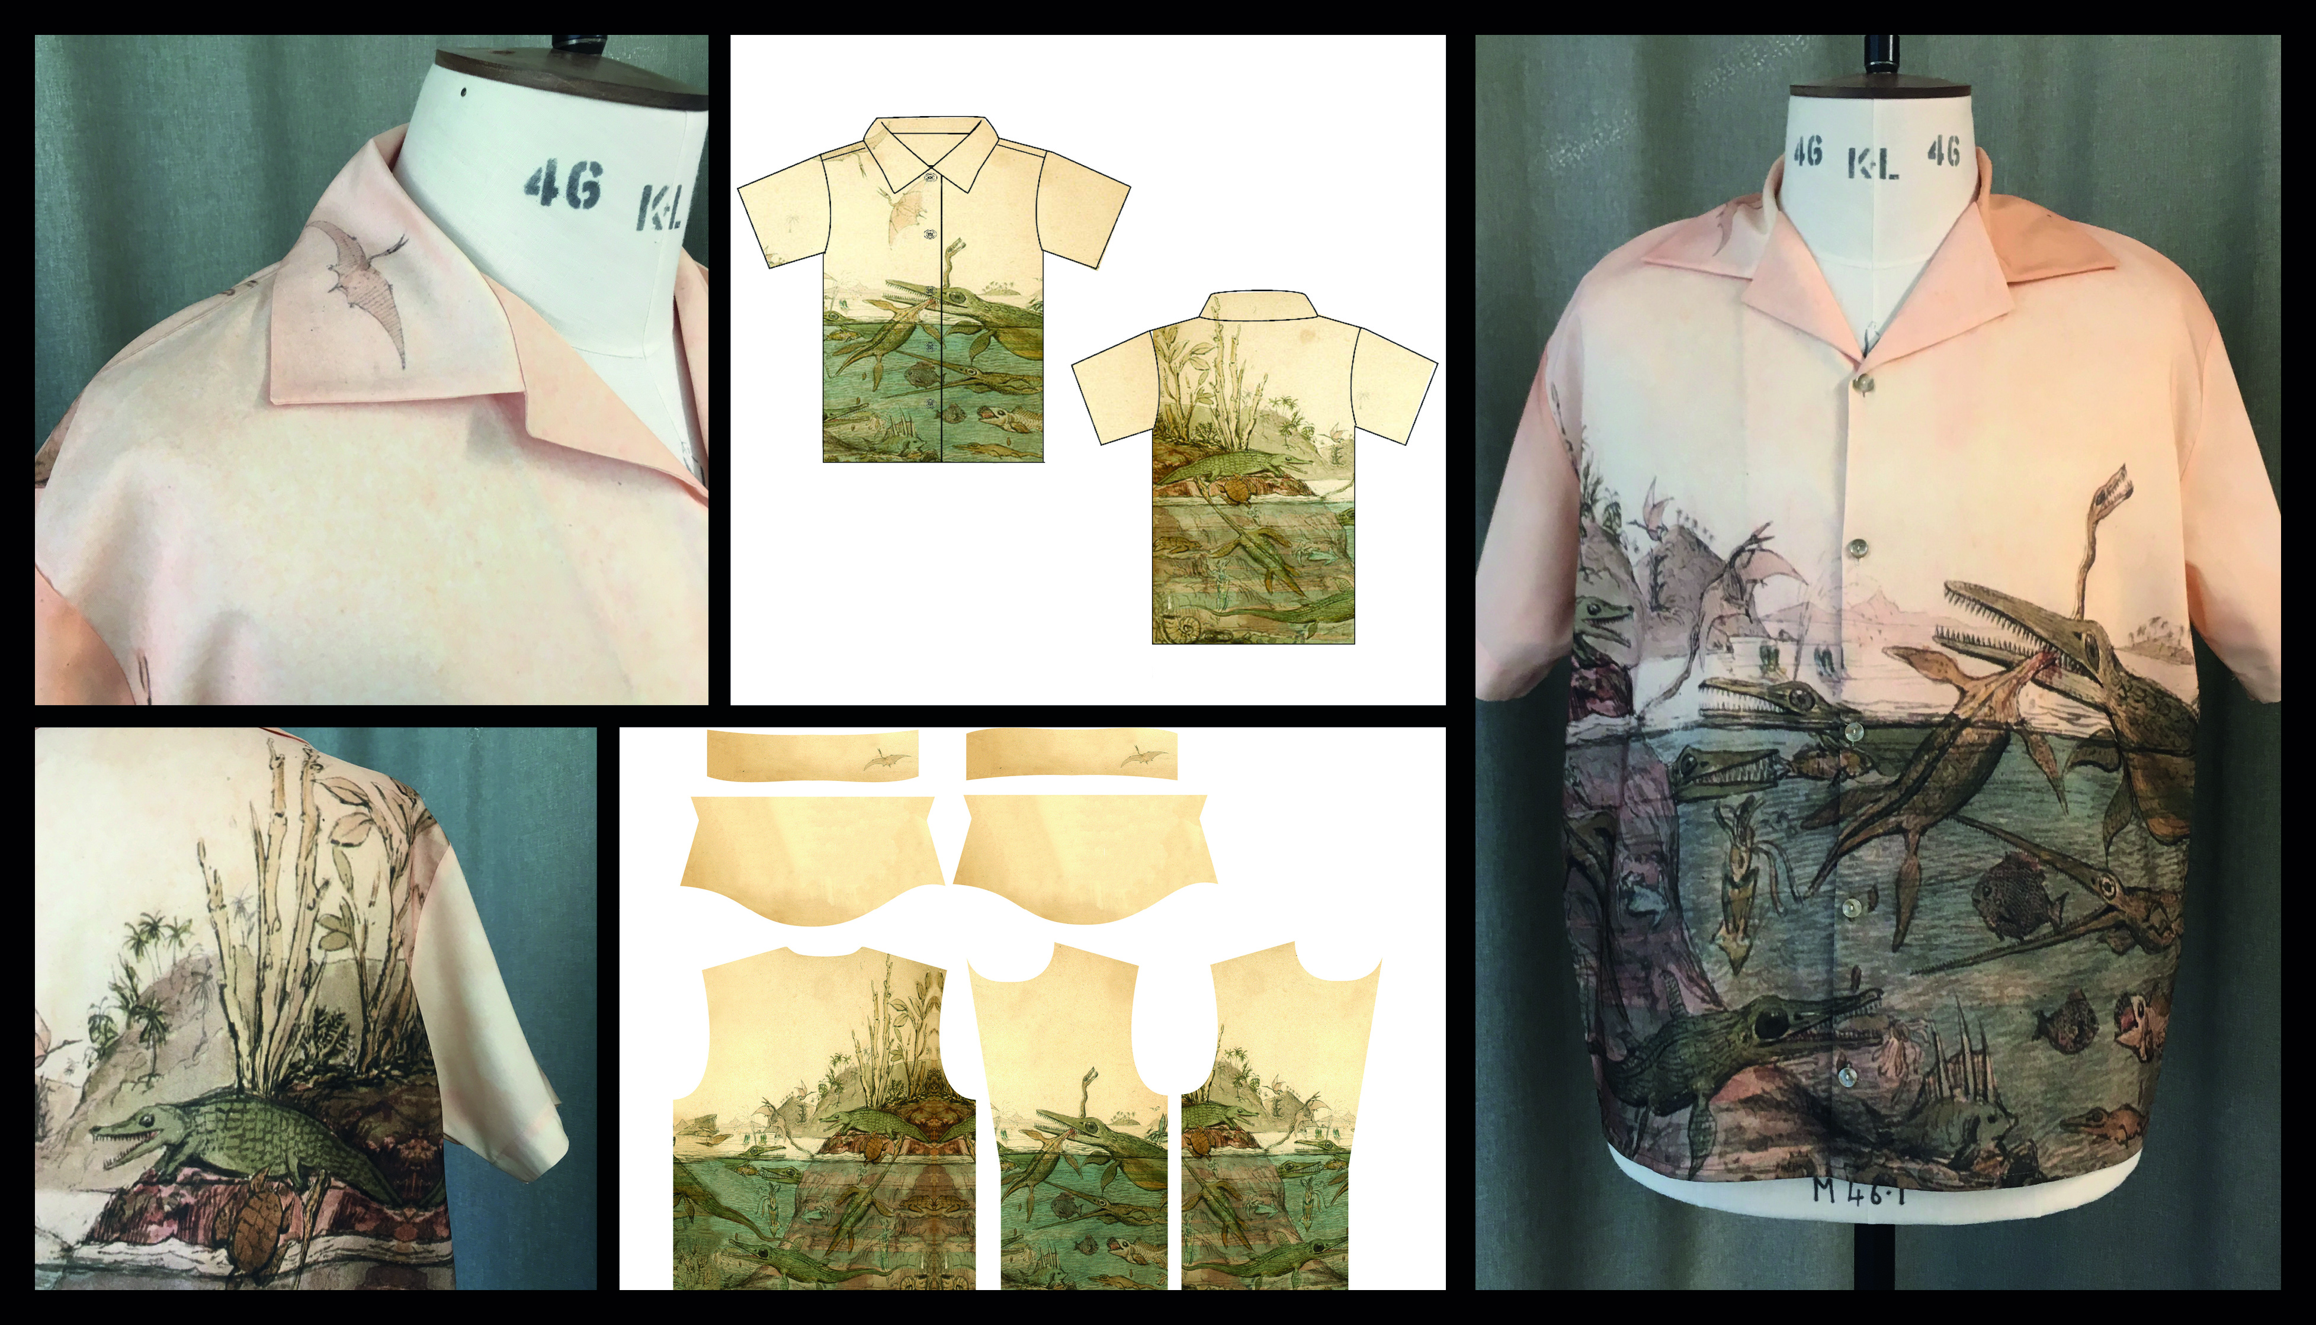
Figure 5: Original painting by Henry De La Beche (1830), edited interpretation by Adele Keeley (2018), Montage of Costume Design Development Work Inspired by the Painting Duria Antiquior, digital manipulation and digital print on to fabric, 2018, Dorset.

In performance
While working on Mesozoic! we considered how we were using the body as a ‘site for the development of clothing and performance’ and how this somatic canvas allowed an alternative representation of landscape (Bugg 2014: 76). Our intention was to create a costume that anthropomorphized nature to evoke an effective response from an audience but we also wanted to impart factual knowledge as well. Carter and Master write in their ground breaking Arts and Natural Heritage Review in 1998 ‘if the aim of interpretation is to encourage a conservation ethic, and a sense of caring about a place, it must touch its audience emotionally as well as developing their factual understanding’ (1998: 4). The performances took place at various locations around Dorset, rarely on the actual coast beaches. The majority of the showings resided at Dorset County Museum in February, April and May 2018 shown in Figure 6. The format of the performances took the shape of a performed conversation, as opposed to fully scripted dialogue. Observations were made throughout the performances and audiences were asked informal post-show questions to capture their thoughts and reaction. Though the performance was not specifically commissioned for a younger audience, many of the audience members were families with children, school groups and children centre groups. The reaction from the performance definitely highlighted the emotional response we had hoped for. Many commented on how the performance had made them more curious about the Jurassic Coast. One young female who had come to see the performance with a school group commented on how thrilled she was to see such a stylish skirt. She said ‘I never knew science could be so cool’. Another audience member said ‘It makes me think about our place on the Earth and how long the Earth was here before us’. The response from the Jurassic Coast Trust was also positive and outlined the more cognitive aspect of the project. In 2018 Dr Khatwa Ford claimed the project was a ‘remarkable piece of interpretation’ when reviewing the sedimentary costume in her article ‘Resonance in Rocks: Building a Sustainable Learning and Engagement Programme for the Jurassic Coast’ (2019: 519). An image of the costume has since been added to the Jurassic Coast Story Book (Jurassic Coast 2018: 37) as an example of an innovative interpretation of the coast. This evidence helps us to see the significance of using the costume as a platform to communicate complex ideas to audiences and promote an emotional response to the landscape being presented to them.
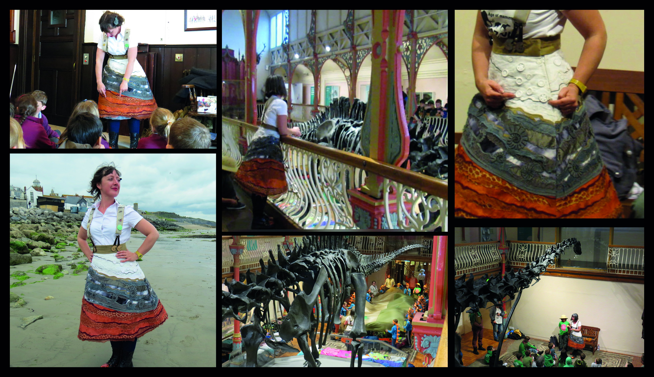
Figure 6: Gobbledegook Theatre, Montage of Performance Images, 2018, Dorset County Museum, Dorset.

Conclusion
In coming to a conclusion I am reminded of the Sustainable Development Goals. Specifically, I draw on a comment outlined in Goal 14, which reminds us that ‘oceans, seas and marine resources are increasingly threatened, degraded or destroyed by human activity’ (United Nations n.d.b). Much of the theorist views outlined in this article suggest the most positive way to counteract the forces of such human action on the environment is to change social behaviour and increase individual levels of concern (Beery and Wolf-Waltz 2014: 198). This article has highlighted the need for us, as humans, to connect to nature in a hope that by doing so we might look after it better. The case study explored the notion of anthropomorphizing nature through a costume-design led process with an aim to create a costume that presented opportunities for learning through playful interaction during the performance. We have explored the notion of embedding facts into a costume design while exploring artistic interpretation and generating a public engagement tool which promoted appreciation for the environment. The outcome of which is evidenced in an interpretation of the Jurassic Coast crafted in the costume. This has had positive results. Both audience members and commissioners responded in a way which suggested that the aims of the project were reached to a successful level. The artist performed in different locations and was able to take a visual representation of the Jurassic Coast with her imparting factual information and inspiring curiosity about the natural world. All this gives an example of how costume design can be used to promote connectedness to nature. However, it is not without its flaws. Though the research aims in the case study were achieved, what we did not explore as researchers was if this experience made a difference to the audience’s environmental behaviour, as was suggested by some of the social science.

Theatre is such an ephemeral experience and to be able to follow the actions of audience members post-performance is almost impossible. Lumber et al. state that ‘Researchers and practitioners interested in facilitating nature connectedness […] should focus specifically on activities that involve contact, meaning, emotional attachment, or a compassionate relationship […] that includes engaging with nature’s beauty’ (2017: 21).

Further research in post-performance audience activity could be investigated to establish if there is a change in behavioural patterns as a result of the experience. I believe that performance can heighten an audience’s awareness and create debate about environmental issues. I hope that by exploring landscape through the tangible medium of textile and clothing, combined with a highly refined process of artistic and scientific collaboration, people will feel a greater connection to the natural world. Revisiting the concerns of Williams (2018) (quoted earlier in this article) we, as theatre makers, should encourage our audiences to see themselves as part of nature rather than separate from it.

References
‘Anthropomorphism’ (2010). Oxford Dictionary of English, 3rd edition, Oxford: Oxford University Press.https://www.oxfordreference.com/view/10.1093/acref/9780199571123.001.0001/m_en_gb0031270. Accessed 26 November 2019.

Beery, T. and Wolf-Waltz, D. (2014), ‘Nature to place: Rethinking the environmental connectedness perspective’, Journal of Environmental Psychology, 40:2014, pp. 198–205.

Beche, H. de la (1830), ‘Duria Antiquior (A More Ancient Dorset), Watercolour, Wales: National Museum Wales, in: Sharp, T. (2017) “The De La Beche Archive at Amgueddfa Cymru”’, National Museum Wales, 28th June, https://museum.wales/articles/2009-04-20/The-De-la-Beche-archive-at-Amgueddfa-Cymru/. Accessed 2 February 2019.

Bugg, J. (2014), ‘Dancing dress: Experiencing and perceiving dress in movement’, Scene, 2:1&2, pp. 67–80.

Carter, J. and Masters, D. (1998), Arts and the Natural Heritage, 109, Edinburgh: Scottish Natural Heritage.

Dean, S. E. (2014), ‘Somatic costumes™: Traversing multi-sensorial landscapes’, Scene, 2:1&2, pp. 81–87.

Dean, S.E. (2016), ‘Where is the body in the costume design process?’, Studies in Costume and Performance, 1:1, pp. 97–111.

Jurassic Coast (2018), ‘The Jurassic Coast story book: Interpretation framework for the Dorset and East Devon Coast World Heritage Site’, Jurassic Coast Trust, April, Bridport, https://jurassiccoast.org/wp-content/uploads/2018/05/Jurassic-Coast-Story-Book_WEB.pdf. Accessed 12 January 2019.

Jurassic Coast Trust (2017), ‘Dippy on tour: Premier host venue January–May 2018’, PowerPoint presentation, Charmouth, Jurassic Coast Trust. Accessed 10 January 2017.

Kershaw, B. (2012), ‘“This is the Way the World Ends, Not…?”: On performance compulsion and climate change’, Performance Research, 17:4, pp. 5–17.

Khatwa Ford, A. (2018), ‘Resonance in rocks: Building a sustainable learning and engagement programme for the Jurassic Coast’, Proceedings of Geologists’ Association, 726: 130:3-4, pp. 507-21

Lumber, R. and Sheffield, D. (2017), ‘Beyond knowing nature: Contact, emotion, compassion, meaning, and beauty are pathways to nature connection’, PLOS ONE, 12:5, pp. 1–24.

Marshall, R. (2014), Into the Woods (DVD), USA: Walt Disney Pictures.

Mower, S. (2009), ‘Spring 2010 ready-to-wear Alexandar McQueen’, Vogue, 6 October, https://www.vogue.com/fashion-shows/spring-2010-ready-to-wear/alexander-mcqueen. Accessed 19 April 2019.

Rogers, A. (2012), ‘Geographies of the performing arts: Landscapes, places and cities’, Geography Compass, 6: 2014, pp. 60–75.

Seaton Jurassic (2019), ‘“Duria Antiquior” – a more ancient Dorset’, Seaton Jurassic, March, https://seatonjurassic.org/blog/duria-antiquior-a-more-ancient-dorset/. Accessed 25 March 2019.

Tam, K. P. and Lee, S. L. and Chao, M. M. (2013), ‘Saving Mr. nature: Anthropomorphism enhances connectedness to and protectiveness toward nature’, Journal of Experimental Social Psychology, 49:3, pp. 514–21.

United Nations (n.d.a), ‘Sustainable development Goal 15’, United Nations Sustainable Development Goals Knowledge Platform, Sustainable Development Goal 15, https://sustainabledevelopment.un.org/sdg15. Accessed 12 April 2019.

United Nations (n.d.b), ‘Sustainable development knowledge platform, oceans and seas’, United Nations Sustainable Development Goals Knowledge, Platform Oceans and Seas, https://sustainabledevelopment.un.org/topics/oceanandseas. Accessed 12 April 2019.

Williams, D. (2018), ‘Chapter 4: 1990 – present’, in E. Ehrman (ed.), Fashion from Nature, London: V&A, pp. 151–73.

Contributors details
Adele Keeley is a costume designer, theatre collaborator and senior academic in costume and performance design at the Arts University Bournemouth. Adele has a MA in theatre arts from Nottingham Trent University. Over the past five years Adele has worked as practitioner-academic on a range of landscape-inspired outdoor theatre projects in collaboration with research partner Gobbledegook Theatre. Adele’s work has been seen at various national and international performance festivals including Seoul Street Arts Festival in 2018. She is one of the founder members of Environmental Arts Practice Research Collective (https://eapresearchcollective.wordpress.com). Adele’s practice-led research is highly informed by environmental issues, landscape, nature and outdoor theatre. See more of her work at www.site33.co.uk/design.

Contact:
Faculty of Media and Performance, Arts University Bournemouth, Fern barrow, Wallisdown, Poole BH12 5HH
E-mail: akeeley@aub.ac.uk

