Paul Gough’s UPAS series
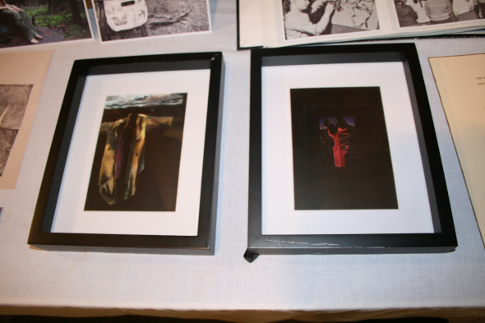
Paul Gough, drawings as part of the UPAS series. ‘This fabulous tree was said to grow on the island of Java, in the midst of a desert formed by its own pestiferous exhalations.’
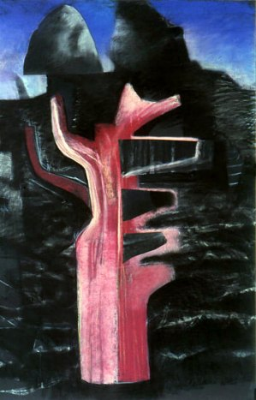
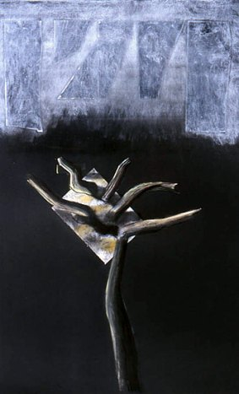
Paul Gough: The Upas Enigma
I never lost this tree sense: to me half the war is a memory of trees; fallen and tortured trees; trees untouched in summer moonlight, torn and shattered winter trees, trees green and brown, grey and white, living and dead. They gave their names to roads and trenches, strong points and areas. Beneath their branches I found the best and the worst of war. (Talbot Kelly 1980, 5)

War artist Paul Nash shared similar sentiments, here expressed eloquently by fellow painter and front-line officer Richard Talbot Kelly. In the Ypres Salient Nash was aghast at the sight of splintered copses and dismembered trees, seeing in their shattered limbs an equivalent for the human carnage that lay all around or even hung in shreds from the eviscerated treetops. In so many of his war pictures, the trees remain inert and gaunt, failing to respond to the shafts of sunlight; their branches dangle lifelessly ‘like melancholy tresses of hair’, mourning the death of the world and its values that Nash held so dear. (Cork 1994, 201)
Was Nash aware that a century earlier, another young British painter had devised an extraordinary image of an equally poisoned and murderous landscape? At its centre was the notorious ‘Upas Tree’.
This fabulous tree was said to grow on the island of Java, in the midst of a desert formed by its own pestiferous exhalations. These destroyed all vegetable life in the immediate neighbourhood of the tree, and all animal life that approached it. Its poison was considered precious, and was to be obtained by piercing the bark, when it flowed forth from the wound. So hopeless, however, and so perilous was the endeavour to obtain it, that only criminals sentenced to death could be induced to make the attempt, and as numbers of them perished, the place became a valley of the shadow of death, a charnel-field of bones. (Regrave 1886, 483)
The fable of the dreaded Upas Tree is based on the tale of the poisonous anchar tree, first revealed by the 18th century botanist Erasmus Darwin. During the Romantic era it became a familiar and potent image adopted by such poets as Samuel Taylor Coleridge, occurring in Lord Byron’s Childe Harolde’s Pilgrimage and in Robert Southey’s epic poem Thalaba. But probably the most significant evocation of this bizarre plant is in the vast canvas painted by the Bristol-based painter Francis Danby. He painted The Upas, or Poison Tree, in the Island of Java in 1819, when he was just 26; a year later it heralded his triumphal arrival on the London art scene. By the standards of its time it is not a huge painting – some 5 feet by 7 – but its sense of scale is striking. A cowering figure is dwarfed by the landscape, the tree – little but a vertical stalk – dominates the surrounding terrain; and the rocky valley – said to have been modelled on the Avon Gorge – is a hazardous, leafless place of crags and fissures, surrounded by the wasted corpses of fated men. (Greenacre 1988, 89-91)
The painting was equally doomed. After mixed reviews it sold for £150, but the fee went straight to a host of creditors, Danby having worked up an impressive debt during his stay in Bristol. Within years the picture had declined in quality: sloppy technique and thick varnish had rendered the image almost unreadable. By 1857 the picture was barely visible: it was as if the poisonous exhalations of the motif had spread to the very paint surface. Extensive cleaning and removal of layers of dark varnish have since revived the painting, but even after laborious conservation it still catches the light and is difficult to see. Like the eponymous tree itself one approaches the vast canvas with squinting eyes and a cautious tread.
Ninety-nine years after Danby finished his painting, Paul Nash – also in his late twenties – was struggling with his own ‘magnum opus’, the huge canvas now known as The Menin Road, the painters’ first foray into oil paint, an act – as he put it – of ‘great audacity’. (Abbot and Bertram 1955, 98) Like Danby’s image it describes a blighted land – the dystopian wilderness of the Western Front, a pestilent waste of shattered trees, toxic soils and scattered bones. (Gough, 2011) Perhaps here, for the first time since Danby depicted the corrupted ‘poison anchar of Java’, might be found the Upas in its modern incarnation.
Abbot, C.C and Bertram, A. (eds), (1955) Poet and Painter: Being the Correspondence between Gordon Bottomley and Paul Nash, 1910-1946, London: Oxford University Press.
Cork, R. (1994), A Bitter Truth: Avant-Garde Art and the Great War, New Haven: Yale University Press.

