Title: Towards an emancipatory praxis of pedagogy: supporting acting students with dyslexia when working on Shakespeare
Author: Dr Petronilla Whitfield
Acting Department, The Arts University at Bournemouth, Poole, UK
Email:pwhitfield@aub.ac.uk

Abstract
The presence of students with SpLD (dyslexia) in actor-training institutions is an increasingly common occurrence. This article argues that there is an urgent need to develop inclusive strategies of support in the voice and acting studio that can effectively enable those with dyslexia, while promoting equality of opportunity for realization of potential. Focusing on the author’s research concerning the facilitation of acting students with dyslexia in the areas of reading, speaking and acting of Shakespeare, this article begins by highlighting specific difficulties presented by dyslexia. It goes on to describe a case-study of two acting students with dyslexia and their visually led methods employed in entering Shakespeare’s text. The second workshop section offers a pedagogical strategy for the inclusive voice class when working on Shakespeare, while the third section dedicated to participant three demonstrates how a dyslexic acting student uses a visually led approach in enhancing her articulation of speech and extrapolation of meaning in the text. Underpinning the investigations with analysis and theory, the author concludes by sharing her research findings, seeking to stimulate further discussion within the community of voice and actor- training.

Key words: dyslexia; inclusive pedagogy; Shakespeare; visual approaches; mnemonics

Introduction
How might voice trainers effectively meet the needs of student-actors with specific learning differences (dyslexia) especially when accessing Shakespeare’s text? I am a senior lecturer in Voice and Acting on a university Acting degree course. In my teaching role in both drama schools and universities, I have regularly encountered acting students with dyslexia who, in observations and in shared discussion, profess to experience serious challenges if situated within the boundaries of conventional teaching methods when engaging with the written text. Although recognising that each individual with dyslexia differs from another in their diverse talents and needs, it is notable that in recounting their learning experiences to me, many of my dyslexic acting students have used words such as ‘panic’, ‘fear’, ‘embarrassment’, ‘anger’, ‘humiliation’ and ‘frustration’ to communicate their emotions when required to read aloud. Some of these words are echoed by Thomson when discussing the psychological impact of dyslexia (Thomson 2009, 215) while matters of low self-esteem can be an ongoing factor (, Burden 2005; McLoughlin & Leather 2013; Pollack 2012; Reid 2003). Pollack has highlighted that a lack of self-esteem can arise from the medical label of being described as ‘disabled’, which suggests the ‘problem’ lies within the individual as having a ‘disability’ rather than the concept of a ‘learning difference’; a perspective which places the responsibility on the teacher to provide teaching methods which can facilitate these differences (Pollack 2012, 59-60). Although not dyslexic myself, I have an assessed learning disability of dyscalculia and therefore have a shared experience and empathy for those who might have abilities and disabilities which differ from the dominant group.
Specifically, my annual teaching of the Shakespeare unit with second year Acting degree students highlighted for me the difficulties many dyslexic individuals were having in my classes when interacting with the text and the gaps in pedagogical knowledge in supporting their complex differences in learning styles and strengths - (see Whitfield 2009; wherein I recount my experiences with three dyslexic acting students when working on Shakespeare, their challenges and successes in performance, and my embryonic ideas in helping them). More recently there have been research contributions published in the area of actor-training and dyslexia by actor trainer and researcher Deborah Leveroy, some of which, although independently conceived, correlate strongly with my own research findings, which I reference further on (Leveroy 2013a, 2013b, 2015). Rebeca Clark Carey (Voice and Text Director at the Oregon Shakespeare Festival Theatre) is investigating how she might create a more dyslexia-friendly working environment for professional actors. She states:
I do believe there is a need for research and strategies of facilitation in the interest of equity and optimizing potential, so I can better support the excellent work our dyslexic actors are already doing. I see them often having to work harder to get there and feel it would be desirable to give them more support so that they can get the job done with less stress and anxiety. R. Clark-Carey (personal communication, April 2016) Email to: Petronilla Whitfield
The premise of this article is that there is a limited body of research from which voice trainers in particular might draw, which offers explicit teaching strategies for dyslexic actors-in-training specifically within voice pedagogy and the acting of Shakespeare. As a result, many voice trainers, like me, have difficulty finding ideas to integrate into a Voice or Shakespeare curriculum to explicitly address the needs of SpLD learners.
An investigation into visually led processes
Seven years ago, my experiences in working with dyslexic acting students and the scarcity of disseminated research concerning dyslexia in these specialised areas motivated my pursuit of a part-time six year PhD study which explored the premise that some acting students assessed as dyslexic show a preference for processing the written text through non-verbal, primarily visually led and kinaesthetic mediums. I have sought to develop, and test pedagogical strategies that might cultivate these preferences. My teaching of Shakespeare has revealed evidence that for some of those with dyslexia, a confrontation with Shakespeare’s written text can block access to meaning and inhibit cognition, yet can also evoke a unique blossoming of creative talents and modalities. There is a widely-held opinion amongst researchers that many of those with dyslexia have poor working and short-term memory (especially verbal rather than visual) which might be a contributory factor in their inability to read fluently (Gathercole & Packiam Alloway 2008, 29; McLoughlin & Leather 2013,19; Mortimore 2008,102; Smith-Spark & Fisk 2007,51). My research investigations revealed that visual memory aids were instrumental in assisting my participants in processing and performing Shakespeare’s text. This construction of image-based texts provides a working-memory scaffold and as Reid maintains ‘… visual skills and strategies in remembering and retention are important and should be developed with those who have dyslexia’ (Reid 2003, 208).
This article centres on my study of three second year acting degree students assessed as dyslexic, their methods of accessing the text and my emerging strategies of facilitation during my teaching of the Shakespeare acting unit and the accompanying Voice syllabus. Using an action research methodology of practice, I critically analyse key aspects of the learning process within a case study observation; capturing the lived experience of the individual with dyslexia, recorded through ‘thick description,’ and context (Geertz 1973, 9; Winston 2006, 20). When engaging with the research about dyslexia, it has become necessary for me to step outside of performance discourse into areas such as psychology and educational theory. This harvesting of theories from cross-disciplinary sources has generated ideas for innovation in my own practice underpinned by theoretical concepts. From this I propose that a visually led approach to teaching can be utilized and exploited within the teaching of Shakespearian texts for SpLD actors in training. By imparting an account of some of my PhD journey, I hope to stimulate a larger discussion about inclusivity in the voice classroom and offer ideas for studio practice.
Towards an emancipatory praxis
Initially, my methods of teaching Shakespeare replicated the procedures of those who had taught me, and whose books I had read. Using a teacher- centred system, each student was expected to fit into conventional practices that served the able majority. As Carr & Kemmis point out, ‘...much teacher action is the product of custom, habit ...which constrain action in ways that the teachers themselves do not recognise...’ (1986,189). I had little conception about how I might adjust my practice based on an accommodation of learning differences or that other ways of working might have cogency.(Appendix One).
Underlining that dyslexic people are not a homogenous group where one method will suit all, dyslexia consultants McLoughlin and Leather have called for an ‘idiographic’ approach, so as to meet the specific needs of the individual, based upon professional knowledge of the cognitive, affective and language processes that influence different types of learning (McLoughlin & Leather 2013, 8-9). Action research philosophers Cotton and Griffiths argue that the articulation of ‘little stories’ can foster an understanding of individual worlds, stimulating questions about how those worlds may be changed, challenging existing structures and working practices, including in educational settings (Cotton & Griffiths 2007, 548). It is hoped that by sharing my own ‘little stories’ other teachers will be stimulated into examining, evaluating and adjusting their own pedagogical directions, generating emancipatory strategies for those with SpLD who are currently restricted by conventional practices. Through my research, my teaching approach has transformed in several ways beyond the singular aim of ‘supporting the visual learning strengths’. I now have a deeper understanding about how a visual dominance and reliance can act as both an indicator and facilitator of dyslexia, and how, why and where this visually-led approach can be utilised and exploited in my teaching of Shakespeare.

The problem
It has become evident to me that in actor training environments, there are some individuals who possess a range of abilities and yet have challenges in reading without effort, and physically articulating and processing language and speech sounds. My dyslexic acting students have variously explained that this is because they have forgotten how to pronounce a word, do not recognise the word, do not understand the meaning of the word, have to process the word letter by letter, the small words seem to move about, they have forgotten the content, or the print appears as meaningless marks on the page. In some cases, they cannot explain why they cannot read the words. This can be in conjunction with other characteristics, such as distractibility, disorganisation, anxiety, poor short-term memory and physical awkwardness, despite their possession of literacy, intrinsic motivation, athletic movement skills, intelligence and acting talent.
At British drama institutions, dyslexia is included under a generalised label of ‘Specific Learning Difficulty’ in student records, making exact statistical numbers of students assessed as dyslexic unclear. Julie Crofts (Director of Student and Academic Services at the Royal Academy of Dramatic Art) reports that in each year ‘… we have seven or eight students disclosing a disability. Generally, there will be about six students out of every twenty-eight who will be dyslexic’ (communication 17.12.2015). Tanya Zybutz (Dyslexia Co-ordinator at the Royal Central School of Speech and Drama) states,
… there is general acknowledgement across the school that 25% of our students are registered with the Disabilities & Dyslexia Service … in the BA Acting cohort … we have noticed a specific increase with roughly 60% of the year having a specific learning difference’. (Communication December 4 2015)
Amy Barbour (Programme Manager at Mountview Academy of Theatre Arts) reports ‘… the vast majority of our students with a SpLD have dyslexia. I'd say that 20% of them have dyslexia (communication 3.12.2015). Elspeth Morrison (Student Disability Officer at Arts Educational Schools) declares that in each cohort of thirty acting students there are approximately six students with dyslexia (communication December 212015).
This sample taken from four leading British actor training institutions demonstrates that dyslexia is not an unusual phenomenon amongst acting students but something that voice and actor trainers can increasingly expect to encounter in their classes of students year after year. Thus, providing an adequate curriculum-based adjustment to effectively support those with dyslexia is essential.
Reading Shakespeare
The readability of Shakespeare for the modern young person can present unfamiliar territory. Amongst my acting students there are some that can read effortlessly but still find Shakespeare’s meaning hard to grasp. Psychologist James L. Keidal, literature scholar Philip Davis et al (Keidal et al. 2013) have labelled Shakespeare’s language as a ‘neurological tempest’ because of his surprising idiosyncrasies in idiom, syntax, ellipsis, word omissions, contractions and word order. Davis emphasises how Shakespeare’s frequent shifts of grammatical function can excite the imagination, but also deviate from expectation; for example, where the adjective is utilised as a verb, such as: ‘him have you madded’ (Quarto 4.2. 40-44) or there is a change of a noun into a verb: ‘Nay godded me indeed’ (Coriolanus 5.3, 10-11 in Davis 2008,267-268). Davis suggests that such functional shifts produce ‘a sudden electrical charge in the brain … getting closer to the very roots of sudden mental-verbal formation…more primal in meaning-making’ (267). Although such language adaptation is ‘electrical’ for some, for others who are less used to reading in the Shakespearean style, it can become nonsensical.
Additionally, many of the voice and actor-training books concerning the speaking of Shakespeare centre on a meticulous observation of the literary form and language, promulgating the notion that there is a ‘correct way’ to speak Shakespeare through a grasp of the ‘rules ‘which have to be reproduced. For many acting students with dyslexia, not only does Shakespeare’s text contain an abundance of baffling words which are occasionally placed in unusual grammatical sequences, but these books’ instructions about Shakespeare’s ‘rules’ can trigger a cognitive overload and anxiety in those that struggle with reading. Furthermore, traditional studio practice generally assumes a competence in reading fluency with an ability to dual task, analyse meaning, remember matters of technique, read aloud when playing textual games and deliver an embodied interpretation of the text while being observed by peers and teachers.

What is meant by the term dyslexia?
The word ‘dyslexia’ comes from the Greek. ‘Dys’ means difficulty and ‘lexia’ refers to words or language. Labelling an individual as ‘dyslexic’ is a contentious area. There is an unbounded discourse of theories for and against the concept and label. Despite extensive research, the suggested causes, identification and approaches of support for those identified as dyslexic remain diverse and sometimes conflicting (Nicolson & Fawcett: 2010, 1). The very existence of dyslexia as an identifiable construct is questioned by some professionals. Professor of education Julian G. Elliott and educational psychologist Simon Gibbs go so far as to describe the assessment of dyslexia as akin to reading one’s horoscope as ‘there will be some elements that seem to fit’ (Elliott & Gibbs 2012). They suggest that dyslexia could be a social construction – the individual becomes disabled through the social construction of dyslexia as a disability and the educators can deny accountability for their own poor teaching (Elliott & Gibbs in Cigman & Davis 2009, 124). According to Mortimore, there are over forty definitions of dyslexia (2008, 51). Many are complex in explanation requiring study of the dyslexia specialist literature. Some of the underlying causal hypotheses which are pertinent to the voice teacher’s work with dyslexic students are here very basically explained: the phonological hypothesis (problems with processing, remembering and recognising sounds in words), the cerebellar theory, originating from the automaticity hypothesis (difficulties in motor skill, organisation, process and pronouncing unfamiliar words), the articulatory deficit (not recognising how words are formed by the articulators and having difficulty with speaking multi-syllabic words) and the working memory hypothesis. There are also several accounts of those with dyslexia possessing distinct abilities which are a component of their dyslexic characteristics, especially in the visuospatial areas, although McLoughlin & Leather underline this is anecdotal rather than evidenced (2013; 14; Davis 1997; West 1997). Within my own teaching domain, I have sometimes been puzzled by the shadowy line drawn between the (dis)-abilities of acting students who have been assessed by an educational psychologist as ‘definitely dyslexic’ or tell me that they have been told that they are ‘border-line dyslexics’ or ‘not dyslexic enough’. That apparent division is not evidenced in voice classes when they are all grappling with delivering a fluent reading of the text.
Working memory challenges
In interview my research participants have all referred to their struggles with memory and there is a recurrence on the subject of memory difficulties (both working and long- term) in the dyslexia literature (Gathercole & Packiam Alloway 2008; Grant 2010; Mortimore 2008, Morgan & Klein 2000; Nicolson & Fawcett 2010; Reid 2009; Smith-Spark et al 2003; Smith-Spark & Fiske 2007; Thomson 2009). Working-memory is said to be responsible for the temporary acquisition, storage and manipulation of information, and also acts as a ‘...translator between sensory input and long-term memory’ (Fletcher-Janzen, cited in Dehn 2008, xiii). Baddeley’s model of working memory (2007) is relevant to this study because of the demands of reading the words, making meaning, holding the information in the memory, processing it and responding, as in the acting of Shakespeare. The phonological loop - (the ‘inner voice’, articulatory rehearsal and processing of phonemes) in tandem with the visuospatial sketch pad - (the ‘inner eye’ and arising mental images) are both involved in the reading and acting of a text. Understanding the role of these two working memory pathways and perceiving how those with dyslexia might habitually utilise one system over another can provide a guide as to how the teacher might support certain strengths and weaknesses through devised strategies.

How might references to ‘images’ be understood
The definition of the word ‘image’ can be ambiguous. For the actor engaging with Shakespeare’s text, Cicely Berry refers to two types of images: an image that ‘paints an external picture’, and those images that emanate from the ‘inner landscape’ (Berry: 1993, 111). To be clear about the use of the word ‘image’ in this article, I am guided by Shepherd’s terminology, who distinguishes between types (1978, 160-161) which support Berry’s classifications.
- A Perceptual image is an internal image created by the view of an external object. Shepherd maintains that these types of images, although reflecting the external, remain subjective as they are ‘internally generated’. For example, we might ‘see’ a table, but it is in the brain that we actually perceive it. Thus everyone’s conception of that table will be individually represented. (This correlates with Berry’s description of an ‘external picture’).
- An Entencephalic Image originates spontaneously within the brain. Phenomenally experienced, complex and diverse in nature, such images arise from memory, imagination and dreams. These types of images play a significant role in creative thinking. (This runs in parallel with Berry’s idea of the ‘inner landscape’).
In my interviews with my research participants, it is apparent that both types of visual images are a primary component of their process.
The case study report and my action research intervention
Guide to section structure
This section focuses on three of my case studies drawn from my PhD study, one of my action research trials, analysis and findings. The structure is as follows:
- Firstly, I describe two participants’ approaches (Jimmy and Richard) and analyse their personalised methods of accessing the text.

- Secondly, in an action research trial, I present a teaching strategy incorporating ideas generated from my studies of Jimmy and Richard and their visually led representational systems, underpinned by theory. I report on the outcomes of this workshop and the comments made by an observer of the workshop.

- Thirdly, through a consideration of scientific research about some dyslexic brains and how they process information, I arrive at a deeper understanding of the participants’ visual preferences and their effectiveness.

- Fourthly, I introduce another participant (Hollie) who not only struggles with reading but demonstrates an additional feature of dyslexia; that of having difficulty with attaining a precise articulation of the sounds within the words. Although participant Richard sometimes gets confused with grasping the sequences of the syllables in a word (as I point out further on below) Hollie’s overall articulation in her speech is indistinct. In interview, she reported that as a child, she could not understand how certain clusters of alphabetic letters were translated into particular sounds (e.g. phonological mapping) and may be the reason for her ongoing unclear formation of words. This created an additional obstacle in her communication of classical text in an emotional acting scene. I describe what specific methods we used to overcome her insecurity with achieving an accurate pronunciation, recognition and comprehension of the words, offering this as another teaching strategy.

- Finally, I share my overall findings from my study and future recommendations.

- Case studies Jimmy and Richard
Before I could decide on any remedial action I needed to gain insight into how the participants approached a text, and what pathways might be more accessible to them therefore it was imperative that I listened to what my participants said and recorded their words and actions. Further I needed to question my own actions in teaching them and reflect on how I might improve the situation. I therefore asked the participants what methods they used and recorded their answers. Some of these details follow below:
Jimmy explained that when he is acting:
it’s purely images I have – always images, it’s never words… it’s just thoughts, feelings and images ... the image acts for an anchor for the word, the more … detailed and specific to myself the image created, the more I am able to discover things about that word and then use my voice to put in what I have discovered about that word… just seeing something apart from the dreaded format of what I have been afraid of for years – just simply letters – it helps… I would rather do an image than a word. (December 14 2010)
Like Jimmy, Richard also describes a visual reliance saying, ‘I think that nearly every word I know I remember as a picture, not as a word’. He describes having no phonological record of a word, ‘I just have a picture of the word with no sound’, and ‘…until I’ve got a picture of what the word looks like in my head…ways of spelling just don’t make sense to me’ (December 6 2010).
The participants’ methods of trans-mediation; working between the language of pictures and the language of words
Jimmy’s and Richard’s descriptions of their experience of language as image supports Shepard’s theory of perceptual and entencephalic image-making as a phenomenological experience (Shepherd 1978, 160). In translating the meaning from one sign system to another, the participants’ use of drawing is not about achieving a high level of skill in art. The visual journey acts as a cognitive cipher towards encapsulating the words, engendering layers of thoughts and feelings, expressed through their spoken acting performance.
Participant One - Jimmy: His approach used on Aaron’s monologue (Titus Andronicus, Act V Scene i)
Firstly, Jimmy stated he divided the text up into thoughts, to which he allotted different colours. Associating colours with feelings, he elaborates, ‘anger filled chunks of text would be red’ or ‘I’ll get a sort of blue in my head… it’s a change of thought for the character, so from yellow to blue’. Jimmy explains:
When I think of text it is really hard for me to remember words and … visualise letters … I need to grab hold of the text and transform it into something I can understand by breaking it down into colours … I remember almost like a film in my head of what’s happening and the colour, and that film’s awash with the colour I have learnt it in.
Secondly, Jimmy drew small pictures he associated with the text, ‘a strong symbolist picture …to help me remember that picture, I will always base it around something red …a lot of the time it is the eyes…so I just build the picture around the red part. The use of red throughout helps me to pinpoint the main points’. He reflects that, ‘the benefit from … spending time with the pictures is you spend longer thinking about the lines you are going to associate with that picture… I couldn’t imagine any other way of working – only through pictures’ (June 15 2011).
The passage of text (Shakespeare 1995) in the excerpt from Jimmy’s story board:
Aaron:
Ay that I had not done a thousand more.
Even now I curse the day, and yet, I think,
Few come within the compass of my curse,
Wherein I did not some notorious ill:
As kill a man, or else devise his death:
Ravish a maid or plot the way to do it;
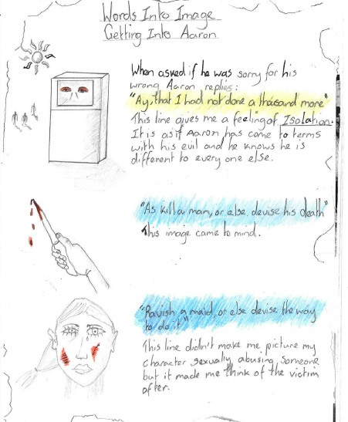
Figure 1 Clip from Jimmy’s storyboard for Aaron’s speech

Comment on the function of the symbols:
Jimmy’s drawings remain deliberately naïve. He emphasises, ‘the rougher and …simpler you can make it the better’. In trying to understand how Jimmy uses his drawings to access the words of the text, but also to encourage a deeper self- analysis of his personalised learning processes, I drew Jimmy’s attention to the fact that he used a mix of types of images in his interpretation of Aaron’s speech. The symbols seem to work concurrently as inner enactments and third person external narratives. Jimmy replied that he does not think about the kind of images he uses, saying, ‘it just comes, so that is the image I will use….and then I start to add the text …it just runs like a film in my head’.
- For the line, ‘Ay that I had not done a thousand more’ Jimmy’s drawing is of a man trapped within a box, with only his eyes revealed. This is a metaphorical drawing, which is an external description of the character, although it might stimulate internal feelings, if arising from Aaron’s experience of isolation.
- His second drawing for the line, ‘As kill a man, or else devise his death’ is depicted through metonymy; signifying a knife dripping with blood, as a murder weapon. This could be Aaron’s perception of his own knife, or an external descriptive representation.
- The third picture of the injured female is external, descriptive and literal.
Participant Two - Richard: His approach used on Sonnet 147.
Firstly, Richard said he colour-coded the different themes within the sonnet. All the words that are to do with love, he highlighted in a red colour, blue for medical and green for diseases. He explains that the colour is important to him because:
…the words are pictures in my head and if I give them this colour that means the picture in my head will be in that colour and …helps me to realise what that word and meaning is, through the colour. I will remember the whole sonnet as a picture … I’ll know exactly where each word is on the page and what each word looks like and what font it is written in. This colour coding process infuses it a lot more.
Richard then moved on, ‘to try to excite my imagination a bit more’ with the use of pictures. As he spoke, Richard drew his examples on the white-board, breaking down the sonnet into symbolic images, saying, ‘the first thing that comes into my head is usually the best - if I think about it too much it becomes over complicated’. He drew a heart for the word love, and fever was represented by a thermometer in someone’s mouth, saying, ‘my drawing’s atrocious but it doesn’t really matter how it looks as long as I know what it means and for longing… – I have drawn a clock that is melting…I thought of time melting’ (May 5 2011)
Next, when speaking Shakespeare’s word ‘nurseth’, Richard muddles the sequence of the syllables. Instead of ‘nurseth’, he said, ‘Nurthes is really simple, just a woman with a stereotype nurse’s bonnet on’. Richard sketched the figure of a man on the board explaining:
…it is someone who is quite strong with broad shoulders, … but he is getting smaller and smaller to almost nothing, as the love is draining him and because he is so ill and is on his knees because his love – this fever has bought him to his knees and this woman has taken everything from him – he is becoming nothing and he is going down and down …
On the board he drew two kneeling figures. One has a chain around his ankles and wrists and kneels on a melting clock, (the clock representing the word longing).
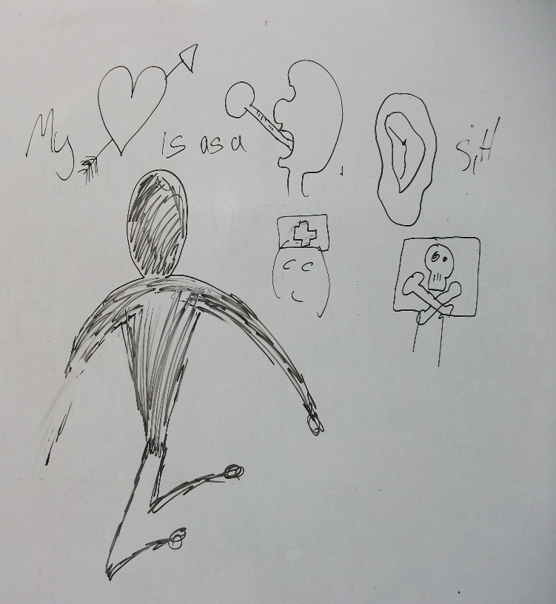
Figure 2a
Clip from Richard’s storyboard for Sonnet 147. ‘My love is as a fever longing still for that which longer nurseth the disease'

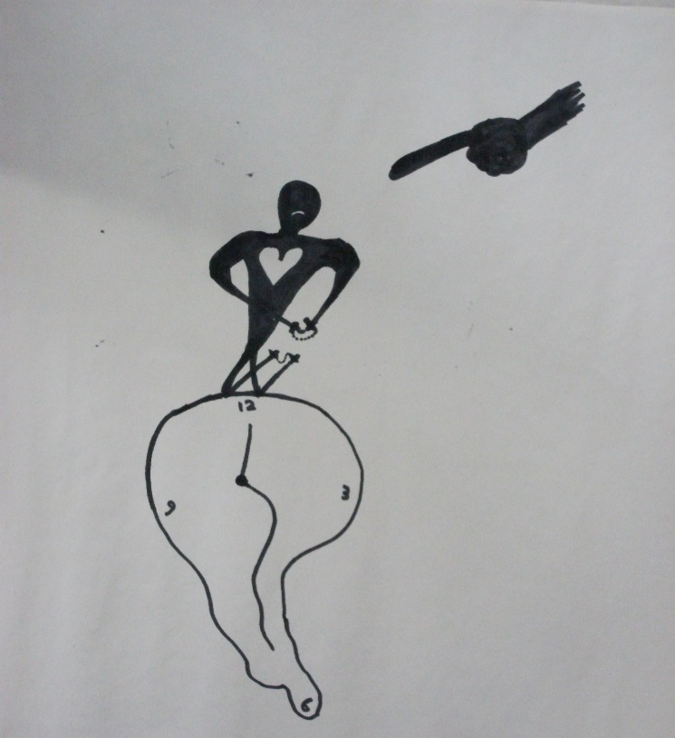

Figure 2b
These figures show examples of Richard’s use of the Psychological Gesture (Chekhov 1985).

Comment on the function of the symbols:
- Richard’s symbols are literal, acting as direct prompts for the words. ‘Longing still’ is an ideograph – represented by the metaphor of a melting clock, as time is passing, with the chained man upon it, being controlled by the commanding huge pointed finger of the subject of the sonnet.
- When writing the word ‘still’, Richard has written sitl, muddling the letter sequence, as he did when speaking the words nurseth, (‘nurthes’) and remedial, (‘ermenial’).
- Richard said that his drawings of the kneeling man became his physical actions when he performed the sonnet. Having observed his physical performance of the sonnet, I recognised the drawn figure. I realised that Richard, through his drawing, was employing a version of Michael Chekov’s Psychological Gesture.
In explaining his Psychological Gesture, Michael Chekhov used the example of the phrase, ‘to draw a conclusion’, illustrating how the human action is revealed within the words in language (1985, 107). He said ‘…the hidden gesture slipped into the word, is the true driving force of the spoken word’ (1991, 74). Chekhov explored how the doing of a physical gesture which is embedded within the language of the text, can activate the psychology and emotion, experienced internally. Directly related to Richard’s process, Chekhov used a drawing analogy to explain his rationale, saying, ‘[t]he Psychological Gesture becomes …a kind of first, rough charcoal draft for the future picture, after which all the details will gradually emerge and cover the initial sketch (1991, 62).
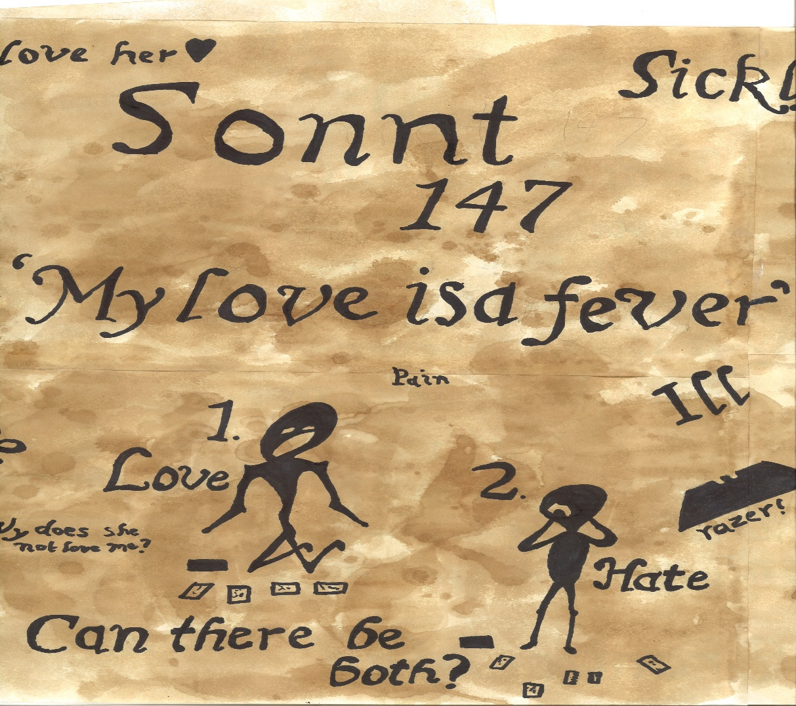
Figure 3. A clip from Richard’s storyboard for his sonnet presentation, showing the Psychological Gesture physical positions that he assumed in his performance. Despite his care in the drawing, note the assimilation of the words ‘is’, ‘as’ and ‘a’ in the line ‘my love is as a fever’; the word ‘as’ is possibly represented backwards, thereby dual - tasking the letter ‘a’; the omission of the letter ‘e’ in the word Sonnet (Sonnt) and the incorrect spelling of the word ‘razor’.
- My action research workshop using Sonnet 57; an inclusive teaching strategy
Following my examination of my participants’ personalised methods, I devised an approach for entering and processing the content of Shakespeare’s text which circumvents an initial ‘confrontation with the text’ for those with dyslexia. Although aimed particularly at those with dyslexia, this method which activates auditory, visual, haptic and kinaesthetic learning styles can be used for teaching across abilities. I offer this workshop’s sequences and underlying theory as a template for others to use or adapt for their own teaching.
The workshop
Present: Myself, the participants and my ‘critical friend’ to give feedback (Senior Lecturer in Acting, Ken Robertson). The workshops were filmed and lasted sixty to ninety minutes. For the focus of this article I am reporting on Jimmy and Richard’s work only.
Rationale: I chose Sonnet 57 as a working tool because the language is not obscure. It does not contain difficult words which are out of modern use, rely on clever puns and double meanings of words, nor the necessity of a dictionary before one begins to read. The thoughts and feelings in the sonnet, although passionate, are simply expressed and easily identified with. Having studied my participants’ visually led thinking procedures and their utilisation of semiotic sign systems as an anchor of their thoughts and construction of meanings, I planned an imagistic/aural approach rather than the traditional method of reading the words. Through this work I am exploring ways of ‘flowing’ into the text for those with dyslexia, entering through open channels, rather than persisting with a mode of ‘banging into’, being ‘stalled’ or ‘blocked’ by the text (these are the forceful verbs used by a dyslexic individual when describing reading) (Essley 2008, 21, 29).
Aim: Through this sequence of work my aim is that the participant will achieve a phonological, visual and semantic deep coding of the text. According to Baddeley, an auditory presentation ensures an access to the phonological store (2007, 51). My goal is to activate the phonological loop through the hearing and vocalised repetition of the words, to activate the visuospatial sketch pad through the drawing, and embed in memory the phonological/grapheme relationship through the writing of the words. Baddeley states that integrated information is bound within the episodic buffer (a component of working memory) and then the information is moved into long term memory (Baddeley 2007, 148, Baddeley personal communication 2009).

Method
Materials: a large pad of paper and a mix of oil pastels, felt tips, crayons, board pens.
Stage One. Warm-up. The participant begins by working on the pad with a pencil; let their breath release outwards as they make free pencil marks onto the page. Let the whole body and breath move and flow with the sketching strokes. Then introduce the use of colours, and with the colour, introduce voice; let expressive vocal sounds be released, responding to the warmth of the colours, rhythms and shapes of the pencil strokes made onto the paper.
Stage Two. Working through the sonnet line by line, I speak aloud key words from the sonnet. The participant repeats the word aloud at the same time as drawing a response to the word. Consideration must be given as to what colour and type of utensil is used in its expressive quality related to the word. When the drawing is completed, the word is written alphabetically underneath the drawing.
Stage Three. Then I introduce short key phrases of sonnet. Symbols representing the phrases are rapidly drawn by the participant, while speaking the phrase aloud, and then they write the phrase next to the picture.
Stage Four. I speak short phrases from the sonnet, and the participant physicalizes them while repeating them aloud, creating a motor – sensory image of their concept within the space.
Stage Five. The participant is given the text, reads aloud four of the lines of the sonnet, then paraphrases them into contemporary language, and discusses the meaning.
Stage Six. The participant works through the whole sonnet using the same process, chunk by chunk.
Stage Seven. The participant reads the whole sonnet aloud from the printed text.
Stage Eight. The participant returns to their drawings, explaining the meaning of their storyboard drawings to the observer. This post - reading act assists in their further re- interpretation, assimilation, and comprehension of the words and their meaning.
Stage Nine. The participant gives a performed reading of the sonnet from the printed text.
Outcome of the workshop
Although each individual differed in their acting style, and drawing/image methods, their combined enthusiasm for the approach was evident in observation of their behaviour, the energy with which they tackled their drawings, and in what they said. When the participants finally read the whole sonnet from the printed text, after working through the sequence, they had a much improved fluency, comprehension, and confidence in their performed interpretation. As the sequence included repetition and deconstruction, this fluency is not surprising, but their expressed pleasure in their immersion of the drawing exercise method revealed a deeper cause for their enjoyment.
The critical friend observations
Robertson commented that he noted the participants expressed a sense of vindication after finishing the exercise. He noted that when talking about their participation in the drawing, they all spoke of a feeling of relief and pleasure that their method of learning was recognised, given credence and encouraged.
Robertson noted that when reading the phrases of the sonnet to the participants, I spoke the text with little attempt to offer a personal interpretation through vocal expression, however my speech was carefully articulated. This was an intentional strategy. I was aware that any vocal presentation might have some influence on their own interpretive choices, however, as I needed to impart the text to them aurally, this approach aimed to minimize an imposed aesthetic style.
Having already gained a perspective of the participants’ reading prowess from prior observations, Robertson deliberated that if they had sight - read the text without this process, they would have misread and misunderstood many of the words and the overall meanings. Robertson commented he thought my defined articulation of the spoken word was beneficial to them in gaining a precise auditory image of the text to hold in working memory as they drew their interpretations and repeated the words aloud in their own vocal explorations. He proposed that this method engendered an expressive freedom in their speaking of the text hitherto not experienced when they read the words themselves without this process.
Examination of the participant drawings of the text
Example of the piece of text shown, from Sonnet 57 (Shakespeare 1997).
Being your slave, what should I do but tend
Upon the hours and times of your desire?
I have no precious time at all to spend
Nor services to do till you require
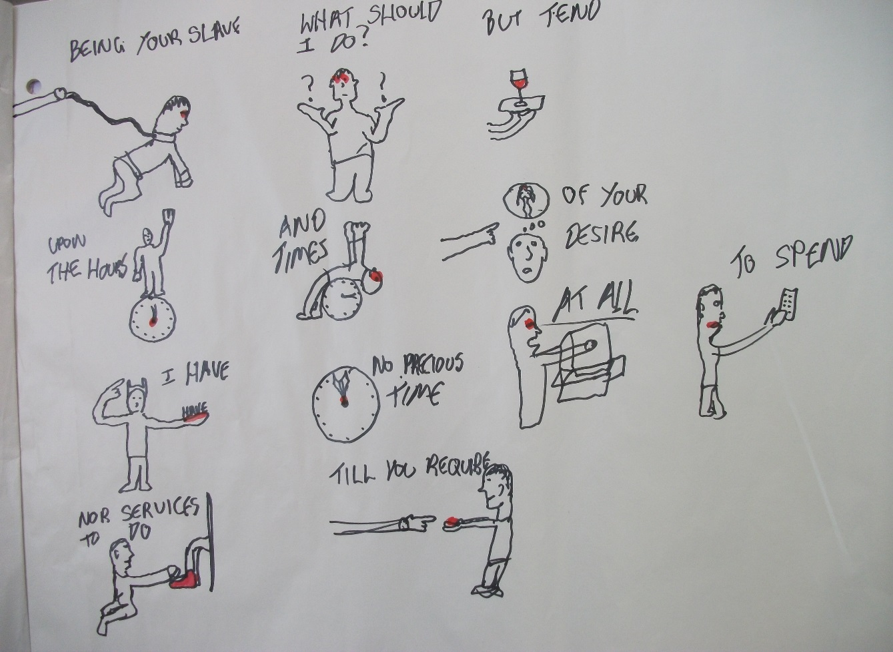
Jimmy
Figure 4 Clip from Jimmy’s storyboard for Sonnet 57
Comments on the function of the symbols:
Jimmy’s ideas for his images came to him immediately that he heard the words, demonstrating a fluency in drawing, linked to thought.
- All the images (save the clock which is literally denoted), represent the enactment of the speaker of the sonnet, in first person perspective and their physical actions.
- ‘I have’. Depicting a bodily action, Jimmy has made a concrete embodiment of the abstract idea of ‘I have’, by drawing a person holding the word ‘have’ as an object on his hand, whilst pointing to himself.
- Similarly, the phrase ‘at all’ has been made into a concrete physical action through placing the hand into the spatial capacity within a box – the space being ‘all’.
- ‘Time’. Jimmy has created a physical metaphor for the word ‘time’, depicting a man bent backwards over the clock. This uncomfortable effortful physical position reveals the emotional state of the speaker within the sonnet. This could a Psychological Gesture for the sonnet.
- ‘Upon the hours’ is a literal translation of the words; a man standing upon a clock.
- The colour red is mostly centrally placed within the picture, to ‘set’ the image in Jimmy’s memory.
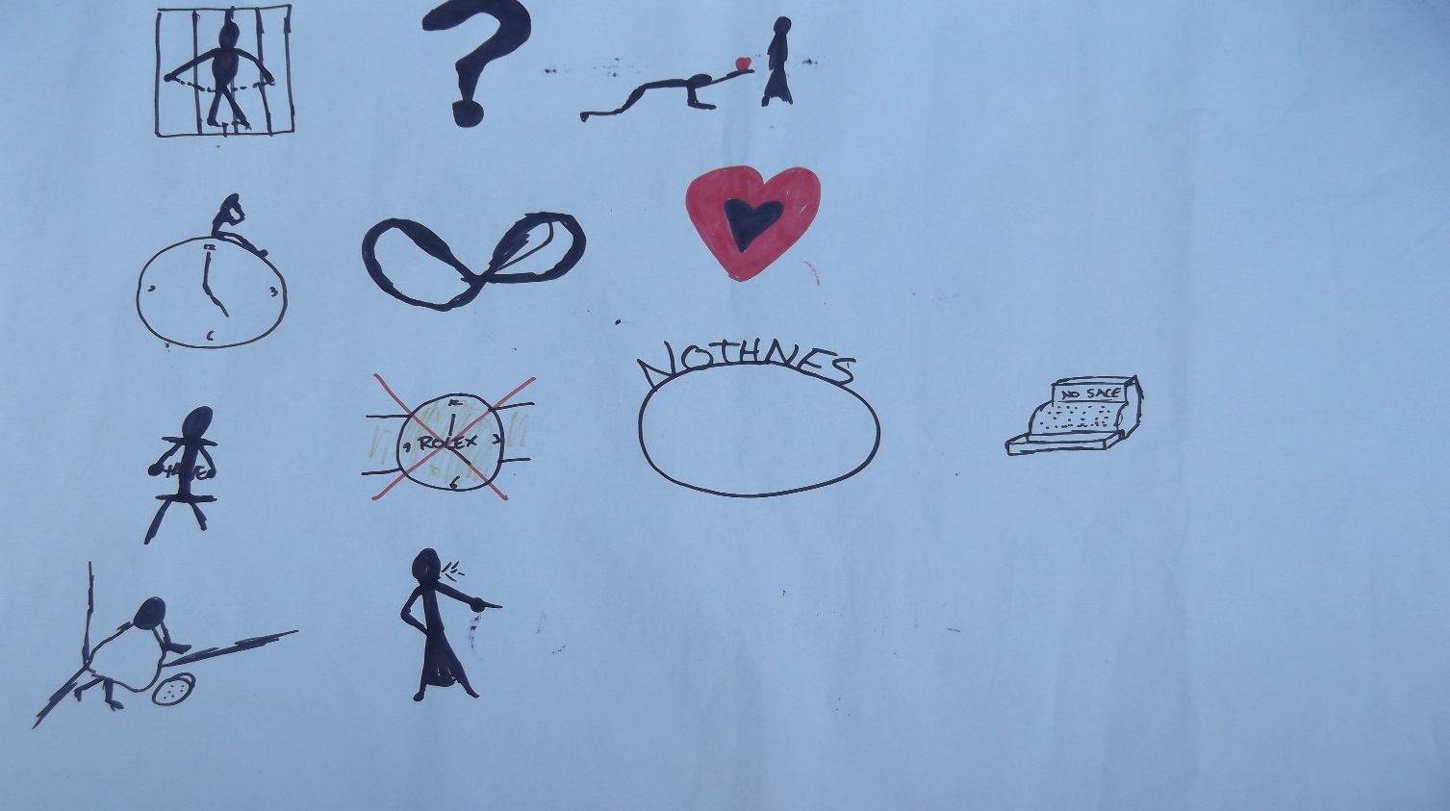
Richard
Figure 5 Clip from Richard’s storyboard for Sonnet 57
Comment on the function of the symbols:
Richard was quick in the translation, from hearing the word to devising the picture, his ideas translating into drawing almost instantaneously.
- Some images are from an embodied first person perspective, and some represent descriptive ideas from an exterior perspective.
- ‘At all’ is a metaphorical concept represented by an empty circle, (note Richard’s spelling nothness, missing a syllable, for the word nothingness).
- ‘Have’ is comparable to Jimmy’s idea, being made concrete by being held as an object.
- It is interesting to note that Richard’s representation for ‘upon the hours’ replicates Jimmy’s conception of a figure on top of a clock, although independently conceived.
- ‘no precious time’ is made into a concrete graphic representation. It is neatly summed up by a Rolex watch with a cross through it which captures the words precious/time/no in one image.
- ‘and times’ is an interesting spatial configuration of two circular shapes intertwined into a figure of eight, or could be a singular twisted circle, thereby representing the idea of the plurality of the word times.
2. Analysis
When considering the teacher’s challenge to enable an individual to achieve their potential, university SpLD specialist Geraldine Price argues that they should capitalize on the individuals’ strengths, adapting to ‘the dyslexic way of working and mind-set’ (2012,54). She warns against using a ‘let’s try this and see if it works’ approach to teaching those with dyslexia, generated with a lack of knowledge about individuals with dyslexia and their needs. This experimentation can further frustrate and undermine the individual’s self-esteem and progress if ineffectual. Price specifies a need for the teacher to provide a reliable teaching approach for the dyslexic learner in an environment where dyslexic students can learn how they learn. She stresses that the teacher must make educated decisions about what techniques are best to carry out the task and to assist the dyslexic learner to achieve a self-understanding and autonomy over their learning methods (51-57). Working from the context-specific experience of my participants I have examined some of the theories about reading and dyslexia to gather evidence which underpins my specification of visually led methods (backed by the kinaesthetic) as advantageous for those with dyslexia.

A consideration of the principle areas of the brain used in reading
Maryanne Wolfe (director of the Centre for Reading and Language Research at Tufts University) accentuates how widely distributed and complicated the brain networks are when we read, stating that there is ‘an almost instantaneous fusion of cognitive, linguistic and affective processes; multiple brain regions; and billions of neurons that are the sum of all that goes into reading’ (2010, 145). The science writer Rita Carter stipulates that the intricate interaction between the two hemispheres of the brain makes it difficult to identify exactly what is happening when we read; that the brain is plastic and influenced by environmental aspects. However, (although advising that there are atypical examples in individuals) Carter asserts that brain imaging studies have confirmed the particular functions of the hemispheres (Carter 1998, 50). It is of note that the left hemisphere of the brain holds Wernicke’s Area which is thought to be involved in the recognition and comprehension of spoken and written language and Broca’s Area which is responsible for the motor organisation of speech, breaking words into segments, and forming a mental image of their sound (Carter 1998, 246-7; DFES 2004, 79; Perkins & Kent 1986, 424). Baddeley refers to the phonological loop as dependent on the left hemisphere (Baddeley personal correspondence 2009). The right hemisphere recognises visual patterns, spatial orientation, pictures, intuition, rhythm, intonation of poetic structure and emotional expression (McLoughlin & Leather 2013, 117; Perkins & Kent 1986, 441). The visuospatial sketchpad relies mostly on the right side of the brain (Baddeley 2007, 8).

Some apparent differences in the hemispheric use in those with dyslexia
In the current literature there is an ongoing debate about the reliability of claims which argue that those with dyslexia utilise one side of the brain more readily than the other (see Mortimore 2008, 86-94 for discussion on the argument). Mortimore states that to regard each hemisphere as dealing with only specific functions is an over-simplification (2008, 88) and McLoughlin and Leather, when referring to the visual strengths of some dyslexics, caution against regarding the hemispheres of the brain as separate entities, stressing that it is the interactions between the hemispheres that are important. Moreover, after re-iterating that the right hemisphere can generate mental maps, images and visual conceptions, they propose that ‘those with a strong preference for right hemisphere functioning are ‘at a disadvantage’ in academic settings which places a demand on ‘left hemisphere activities’ (2013, 117). Reporting on brain imaging findings Wolfe states that ’the dyslexic brain consistently employs more right brain structures then left brain structures, beginning with visual association areas…’ (2008, 186), however she also describes the possibility of a right-hemisphere-dominated reading circuit for dyslexics as unresolved (2008, 196). Although I am aware that some might consider it problematic to definitively attribute specific hemispheres to specific skills, as a practitioner working from a non-scientific perspective, I posit that, when engaging with the spoken and written word, my participants appear most comfortable when working from what are termed as right hemisphere tendencies, displaying a predilection for visuospatial processing and physical action, while struggling with the proposed left hemisphere specialisations of analysing, decoding and articulating aspects of language. There is research that seems to verify this supposition, and some of the theories underpinning this are presented below.

Neurocognitive scientist Dr Zvia Breznitz explains that, in order to read, the brain has to synchronize information coming from distinct areas, processed in different ways and time speeds. Reading involves moving information from the back of the brain to the front, and from one side of the brain to the other, transferred through the corpus callosum (Breznitz 2008, 12). By using Electromagnetic Tomography, Breznitz identified that for non-dyslexics, written information arrives in the left side of the brain first and then is transferred into the right side of the brain within a certain time measure. Her Asynchrony Theory of Dyslexia (2008) is based on her findings that in dyslexics, when reading text, the information goes into the right side of the brain first, is then transferred into the left side of the brain before going back into the right hand side, therefore taking longer than the non-dyslexic in the speed of processing. Because the information arrives in the right side of the brain first, (which Breznitz describes as the ‘wrong side’) this slows down the inter-hemisphere transfer. According to Breznitz, this impairment travels through the sequence of brain processing and synchronization, leading to reading dysfluency.
Morgan and Klein have labelled perceived right brain dominance in those with dyslexia as The Difference Model. They give examples of several individuals with dyslexia using graphic drawings instead of writing, and a preference for visual representations (2000, 10-19, 170). Bacon and Handley (2010) have investigated the primary use of visual strategies in dyslexics, in a test which presented a reasoning task to both dyslexics and non-dyslexics. They found that most of those with dyslexia adopted visuospatial strategies to work out their answers, using:
…vivid pictorial presentations of the specific properties described by the problems. Even the less imitable properties…presented little problem, being creatively illustrated by depictions such as pound signs, halos/horns, smiley/sad/angry faces or starts and dunce hats…the majority of dyslexic participants (75%) used this type of visual-spatial strategy (2010, 33).
The generation of picto / ideographs correlates with Paivio and Sadoski’s Conceptual Peg Hypothesis, wherein the forming of a concrete image acts as a mental peg on which to hook the information into memory. Sadoski and Paivio purport that a concrete verbal phrase that can be easily imaged acts as a mnemonic aid, to be remembered more easily than an abstract phrase. The image peg then acts as a trigger to retrieve a large amount of stored information (2001, 63, 110). Images that are attached to emotional states are also better recalled (Paivio 1983,15) This use of image as a psychological and emotional prompt correlates with Stanislavski’s writings about the actor employing an ‘inner stream of images’ that function as ‘lures’ to our feelings when using words (Stanislavski 1968,126). In analysing Shakespeare’s writing, Berry stresses that ‘the image is always expressing some kind of need or self-image of the character’ (Berry 1993, 111).
- Participant Three - Hollie as Dorotea in Cardenio; constructing and integrating global and micro understanding, improving her articulation of words
Hollie has poor articulation, often skimming over the muscular formation of the words so they remain indistinct, possibly reflecting a weak mapping of the phonological sounds to the alphabetic letters in the words. Before the Shakespeare unit began, I knew that a key goal for me would be to improve Hollie’s communication of language and reading fluency. It is important for voice teachers who work regularly with articulation and text to note that there are several theories that link weak articulation with dyslexia. Nicolson and Fawcett identify in dyslexics an articulatory deficit. They contend that, ‘there is considerable evidence that dyslexic children are impaired in articulatory skill, though it is not clear whether this is caused primarily by a phonological deficit or by a motor skill deficit arising from the cerebellar (Nicolson and Fawcett 2010, 97). Griffiths and Frith carried out a controlled trial and asked adults with dyslexia to repeat phonemes aloud and then to identify a picture which represented the physical position the articulators formed in making the sound of the phoneme. They found that the dyslexics struggled to relate the sound to the articulators’ shape and that, ‘dyslexics were significantly impaired in articulatory awareness’ (Griffiths & Frith 2002). Grant and Thomson accentuate that those with dyslexia can have overlapping challenges such as dyspraxia (difficulties with motor co-ordination, clumsiness and significant neurocognitive variations such as weak visual processing and memory processing) (Grant 2005, 48, 52; Thomson 2009, 17). Articulation difficulties are often a factor of dyslexia which may or may not be linked to dyspraxia.

Similarly to participants Jimmy and Richard, Hollie related that when learning text, she breaks it into sections, giving each ‘little pinpoint’ an imagined picture, and then she highlights each ‘pinpoint’ with a different colour (October 8 .2012). She uses this approach to make things ‘more prominent in my head when I’d go back to it’. In lectures she explained that she would:

…be thinking about it and listening but I would be drawing the whole time. I’d understand all the things and I’d write a sentence down and I’d doodle all over the sentence... I’d make certain characters different…It allows me to focus on that sentence a lot more – like a separate entity and I’d think, ‘ah, now I understand it a lot more’.

Hollies’ Acting Scene

Hollie played Dorotea in Cardenio Act I, scene vi. Cardenio is cited as the ‘lost re-imagined’ play, compiled by director Gregory Doran, and Spanish author Antonio Alamo, sourced from various play texts and possibly originally written by Shakespeare and John Fletcher (Doran and Alamo 2011,5).

Some of the language in the scene is fairly cryptic, not only for the listener, but also for the actor reading and speaking it. A short example of the complex meaning and word use, and long sentences in a speech within the scene is given below. Here Dorotea finds that she is being forced to give up her virginity by an over- ardent suitor.

Dorotea:

If I were now between a lion’s paws

And were made certain sure of liberty

If only I’d forsake my honour here,

'Twould prove all as impossible for me

As for the lion to give his essence o’er.

Then even as you have engirt me round

So likewise have I binded fast my mind

With virtuous and forcible desires

(All of which are wholly different from yours),

As you shall find if force you seek to use.
I am your vassal, not your slave my lord;

Nor ought the nobleness of your high blood

Have the power to stain the humbleness of mine,

I do esteem myself (though but a girl,

A farmer’s daughter, but a country wench),

As much as you yourself, though noble born.

During rehearsals I continually drew Hollie’s attention to her pronunciation of consonants, vowels and syllables. Although always in a state of flux, her diction improved tremendously. Gradually she began to give value to every word rather than delivering slurred clumps of indistinct meaning. As Berry stipulates, the weight given to the whole word not only communicates the literal meaning, but ‘…the meaning which is transmitted by the very sound of the words’ (1993, 30). Berry advises that to achieve the ‘dynamic of the word’, the actor needs to consider how they might ‘give themselves to the vowels’ as carriers of ‘instinctive, primitive meanings’ and that there can be a lack of clarity in communication if the consonants and syllables are not given enough space and time. If aiming to make the language ‘interesting and alive’, ‘…the words themselves are the journey to be lived through’ (30, 98,101). When working with Hollie on articulation exercises, I reminded her of her drawing techniques when customising important information by doodling over the words, when listening to lectures or learning texts (October 8 2012). I suggested to her that she might achieve a deeper assimilation with the language and her articulation of it, if she developed her drawing techniques on her Cardenio text.

At the end of the Shakespeare unit, Hollie handed in her customised Cardenio text (November 30.2012). In a written evaluation of her work Hollie commented:

As I was still struggling with the disjointed language of the piece during rehearsals I began to explore ways to allow the language to become more flowing…. I began illustrating the text visually to help celebrate each word in its own separate entirety, allowing me to feel, see and experience the word and it was during this exercise it allowed [me] to uncover the extent of how important the word ‘honor’ was to Dorotea…. She is a determined, strong woman with the power to fight him with her formidable language, and this for me was only discovered as I began to illustrate and embrace her words.

Hollie’s Cardenio text is interwoven with visual symbols. Adjacent to the customised text, she has drawn four larger images capturing whole phrases and encapsulated meanings. In interview (May 14 2013, August 15 2013), Hollie explained her drawings to me.

Figure 6 Hollie’s Cardenio text
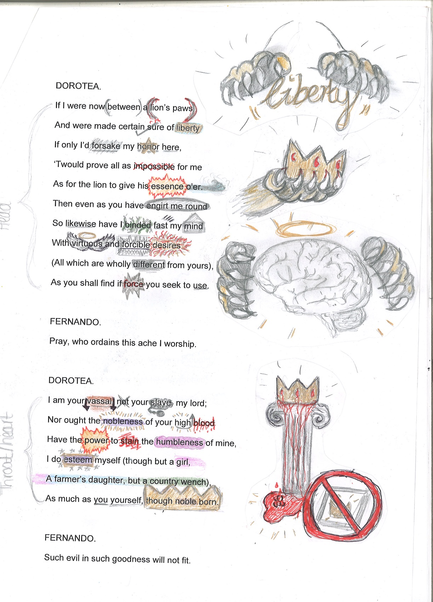

Description and analysis of the first large picture:

Picture one. ‘If I were now between a lion’s paws

And were made certain sure of liberty,

If only I’d forsake my honour here’

Hollie’s explanation: ‘I drew a picture of two lion’s paws (which represents Fernando) grabbing the word ‘liberty’ written in gold. Firstly, it’s written in gold to highlight how important and precious her freedom is to Dorotea. Secondly, it represents her body being physically grabbed by Fernando’ (all communications here and below made on August 15 2013).

My comment: These larger pictures have broken the text up into four units of action, capturing several lines within each image. They represent the action as described in the text, while also containing an overall psychological understanding of what is happening to Dorotea from the actor’s perspective.

Hollie’s explanation about four of her drawings which customise the words of the text:
- forsake is coloured with grey strokes to illustrate the fast carelessness of her honour being thrown away
- honour is starred with gold colour to highlight its importance, and here is underlined to further reinforce how significant it is to Dorotea
- binded has green vines interweaving round the letters as Fernando physically does to Dorotea
- desires is in the centre of gold and red- like flames of passion

Hollie explained the role of her drawing onto the words of the text in assisting her articulation, saying (August 15 2013):

The customised words on the text are for a different purpose than my drawings at the side of the text. When I draw onto the words, that’s what the words look like and feel like in my head, making it also easier to articulate as I can see how the word feels or is meant to feel like. The drawing onto the words is more to help with the pronunciation of the word and feeling, flow and energy of the language. When I draw on the words it helps me visualise the meaning of that word.

Conclusion

My participants’ drawings function primarily as a decoder of the meaning and phonological sounds of the words within the text. When receiving the words aurally, the verbal system is evoked and then anchored through the creation of overt images. These denotations act as referential prompts, setting in motion a chain of connotations. Unlike the written word, wherein information is imparted progressively, the pictorial form allows a holistic rendition of several meanings within one illustration.

My overall findings

- When reading Shakespeare’s text, internal mental models of information arising from the text are created through the medium of mental images. For those with dyslexia difficulties, the transmutation of these internal mental images into external models (interpreted through the body or onto a surface) can provide stable, concrete representations of individual schema structures, or simulations, which are constructed and mapped from the text. These external representations support both memory weaknesses and difficulties with reading, overcoming the need to engage with the text through a re- reading of the words. This apparently automatic default used by some individuals with dyslexia, can be further developed into methodologies of practice in voice and acting exercises.

- I have invented the term Interpretive Mnemonics to encapsulate the devising of images (both physical and visual) which capture a subjective representation of meaning and expression. The exploitation of Interpretive Mnemonics can aid the individual’s comprehension, utterances, memory and performance of Shakespeare. This mnemonic approach to the text can also serve as an acting method, not only as an aid to thinking and memory, but also in unlocking creative forms of exposition.

- Working memory and processing difficulties can severely affect the processes and outcomes of the participants’ work, having as much detrimental impact on class work and performance, as the reading difficulties connected to dyslexia. Teaching strategies, therefore, when working on Shakespeare’s text, must consciously support the faculty of memory, and reduce processing demands.

- When working on the text, the content should be organised into small units of focus in order to reduce cognitive overload, and then processed through structured frameworks which guide the recognition of the hierarchical significance of the word and meaning.

- Humanistic approaches of pedagogy, which emphasise a nurturing of the individual and their differences, an empathetic understanding for their experience and a fostering of their distinctive strengths are necessary, in order to adequately enable and promote the potential of those with dyslexia, and accompanying features.

- There is a need for the acting and voice teacher to possess not only a deep knowledge of their specialised subject, including a broad knowledge of pedagogical theory in practice, but crucially, an informed knowledge about the concept of dyslexia, and its multifarious manifestations. Pedagogical provision and support can be significantly improved if the teacher has studied the theories about dyslexia.

Notes
1. Although some people challenge the view of dyslexia as a disability rather than a learning difference, the UK Equality Act (2010) describes dyslexia as a “mental impairment which has a substantial and long-term adverse effect on a person’s ability to carry out normal day-to-day activities” (Ofﬁce for Disability Issues 2010, Chapter 1, Section 6, cited in Brunskill 2012).
2. In the UK the Code of Practice for the Assurance of Academic Quality and Standards in higher education requires that: “The delivery of the programmes should take into account the needs of disabled people or, where appropriate, be adapted to accommodate their individual requirements …” (The Quality Assurance Agency for Higher Education 1999, Section 3, Precept 10).
3. A learning style is a general term to describe factors that can inﬂuence learning incorporating cognitive, affective and physiological aspects. Multi-sensory approaches are often recommended for teaching those with dyslexia as effective in supporting a range of styles. For information about dyslexia and learning styles see Reid (2003, 209–224) and Mortimore (2008).
4. This sample is drawn from my PhD study which involved 12 participants assessed as dyslexic. All of them were second year acting degree students studied during the 9 week Shakespeare unit and accompanying Voice units from 2009–2014.
5. For more information about the theories of dyslexia see DFES (2004), Thomson (2009), Nicolson and Fawcett (2010), Reid (2003) and for a critique of dyslexia Elliot and Grigorenko (2014).
6. Also refer Leveroy (2015).
7. Also refer Leveroy (2015, 320).
8. This method was trialled on 12 second year acting student dyslexic participants as part of the action research investigations during the Shakespeare unit from 2009–2014.
9. Semiotics is the study of signs and what they signify. This can include words, images, sounds, gestures, objects and the meaning, value and interpretations which have been given to them.
10. For more information please refer to: Berry (1993), The actor & the text, pages 110–115; Stanislavski (1968), Building a character, pages 124–126; Stanislavski (1980), An actor prepares, pages 63–71.
11. Also see Leveroy (2015) for a connecting relationship in her case-studies.
12. Also refer Leveroy (2015).
13. This approach is also supported by Zybutz and Leveroy, refer Leveroy (2013a)

Notes on contributor
Dr Petronilla Whitfield is associate professor and senior lecturer in Voice and Acting on the Acting degree course at the Arts University Bournemouth UK. She has a PhD in Arts Pedagogy (focusing on the support of acting students with dyslexia) from Warwick University and a Masters degree in Voice Studies from the Royal Central School of Speech and Drama. Petronilla was a professional actress for twenty years appearing with leading theatre companies such as the Royal Shakespeare Company, and in film and TV. Petronilla has taught voice and acting at several of the major British drama schools and has presented her research at conferences and in academic publications.

Reference List
Bacon, A. & Handley, S. (2010). Dyslexia, reasoning and the importance of visual-spatial processes. In: Alexander- Passe, N., ed. Dyslexia and creativity. New York: Nova Science Publishers. pp 25-49.
Baddeley, A. (2007). Working memory, thought, and action. Oxford: Oxford University Press.
Baddeley, A. (2009). Answers to your questions. 17th March. Email to: Petronilla Whitfield.
Berry, C. (1993). The actor and the text. London: Virgin Books.
Breznitz, Z. (2008) The origin of dyslexia: the asynchrony phenomenon. In: Reid, G., Fawcett, A., Manus, F., & Siegal, L., eds. The Sage book of dyslexia. London: Sage Publications. pp 11-30

Burden, R. (2005). Dyslexia & self –concept. London: Whurr Publishers.

Carr, W. & Kemmis, S. (1986). Becoming critical. London: RoutledgeFarmer.
Carter, R. (1998). Mapping the mind. London: Phoenix Books.
Chekhov, M. (1985). Lessons for the professional actor. New York: Performing Arts Journal Publications
Chekhov, M. (1991). On the technique of acting. New York: Harper Collins.
Clark-Carey, R. (2016). Personal communication. 2nd April. Email to: Petronilla Whitfield.
Cotton, T., & Griffiths, M. (2007). Action research, stories and practical philosophy. Educational action research, 15(4), pp.545-560.
Davis, R. (1997). The gift of dyslexia. London: Souvenir Press.
Davis, P. 2008. Syntax and pathways. Interdisciplinary Science Reviews,33 (4): 265- 277.
Dehn, M. (2008). Working memory and academic learning. Hoboken, New Jersey: John Wiley & Sons.

Department for Education & Skills. (2004). A framework for understanding dyslexia. London: DFS.
Doran, G. & Alamo, A. (2011) Cardenio. London: Nick Hern Books

Elliott, J.G. & Gibbs, S. (2009). Does dyslexia exist? In: Cigman, R. & Davis, A., eds. New philosophies of learning. Chichester: Wiley Blackwell, pp. 115-130.
Elliott, J.G. & Gibbs, S. (2012). The dyslexia debate. In: Adey, P. & Dillon, J., eds. Bad education: debunking myths in education. London: Open University Press, pp.263-278.
Elliott, J. G. & Grigorenko, E. (2014). The dyslexia debate. New York: Cambridge University Press.
Essley, R. (2008). Visual tools for differentiating reading and writing instruction. New York: Scholastic.
Gathercole, S. & Packiam Alloway, T. (2008). Working memory and learning. London: Sage Publications.
Geertz, C. (1973). The interpretation of cultures. New York: Basic Books.
Grant, D. (2010). That’s the way I think: Dyslexia, dyspraxia and ADHD explained. Oxon, David Fulton Books.
Griffiths, S. and Frith, U. (2002), Evidence for an articulatory awareness deficit in adult dyslexics. Dyslexia, 8, pp. 14–21.

Keidal, J.L., Davis, P., Gonzalez-Diaz, V., Martin, C.D., & Thierry, G. (2013). How Shakespeare tempests the brain: neuroimaging insights. Cortex, 49, pp. 913 – 919.
Leveroy, D., 2013a. Enabling performance: dyslexia, (dis) ability and ‘reasonable Adjustment’. Theatre, Dance and Performance Training, 4 (1), 87–101.
Leveroy, D., 2013b. Locating dyslexic performance: text, identity and creativity. Research in Drama Education: The Journal of Applied Theatre and Performance, 18 (4), 374–387
Leveroy, D., (2015) ‘A date with the script’: exploring the learning strategies of actors who are dyslexic. Theatre, Dance and Performance Training, 6:3, 307-322.
McLoughlin, D. & Leather, C. (2013). The dyslexic adult. 2nd ed. Chichester: Whurr Publications
Morgan, E. & Klein, C. (2000). The dyslexic adult. London: Whurr Publishers.
Mortimore, T. (2008) Dyslexia and learning style, 2nd ed. Chichester: John Wiley and Sons
Nicolson, R. & Fawcett, A. (2010). Dyslexia, learning and the brain. London: MIT Press.
Office for Disability Issues, (2010) Equality Act 2010, London: Office for Disability Issues.
Paivio, A. (1983). The mind’s eye in arts and science. Poetics, 12: 1-18
Perkins, W. H. & Kent, D.R. (1986). Functional anatomy of speech, language and hearing. USA: Allyn & Bacon.
Pollak, D. (2012). Supporting higher education students who are dyslexic. In: Brunswick, N., ed. Supporting dyslexic adults in higher education and the workplace. Chichester: John Wiley & Sons, Ch.7. pp.59-73.
Price, G. 2012. Why can’t I learn? Metacognitive strategy instruction. In: Brunswick, N., ed. Supporting dyslexic adults in higher education and the workplace. Chichester: Wiley-Blackwell. Chapt.6.
Reid, G. (2003). Dyslexia a practitioner’s handbook 3rd ed. Chichester: John Wiley
Reid, G. (2009). The Routledge companion to dyslexia. Oxon: Routledge.
Sadoski, M. & Paivio, A. (2001). Imagery and text. New York: Routledge.
Shakespeare, W. (1997). Shakespeare sonnets. Ed. Duncan- Jones, K. London: Arden Shakespeare.
Shakespeare, W. (1995). Titus Andronicus. Ed. Bate, J. London: Arden Shakespeare.
Shepherd, R. N. (1978). Externalization of mental images and the act of creation. In: Rhandhawa, B.S., & Coffman, W.E., ed. Visual learning, thinking, and communication, 133-189.London.: Academic Press, pp 133-189.
Smith-Spark, J. & Fisk, J. (2003). Investigating the central executive in adult dyslexics: Evidence from phonological and visiospatial working memory performance. European journal of cognitive psychology, 15, (4), pp. 567-587.
Smith-Spark. & Fisk, J. (2007). Working memory functioning in developmental dyslexia. Memory, 12, (2), pp. 174-182.
Stanislavski, C. (1968). Building a character. London: Methuen Drama.
Stanislavski, C. 1980. An actor prepares. London: Methuen Drama.
The Quality Assurance Agency for Higher Education. (1999). Code of practice for the assurance of academic quality and standards in higher education, Section 3, students with disabilities. Author, Gloucester.
Thomson, M. (2009). The psychology of dyslexia. 2nd ed. Chichester: Wiley-Blackwell.
West, T. (1997). In the mind’s eye visual thinkers, gifted people with dyslexia and other learning difficulties, computer images and the ironies of creativity. New York: Prometheus Books.
Whitfield, P. (2009) Shakespeare, pedagogy and dyslexia. In: The moving voice: the integration of voice and movement. The voice and speech trainer’s review, volume 6. Editor: Rena Cooke. USA, The Voice and Speech Trainer’s Association and University Readers.
Winston, J. (2006). Researching through case study. In: Ackroyd, J., ed. Research methodologies for drama education. Stoke: Trentham Books, pp 41-61.
Wolf. M. (2008). Proust and the squid: the story and science of the reading brain. Cambridge: Icon Books.

Appendix One
Here is a list of reading material the reader might find helpful for gaining further understanding of dyslexia and to enable their teaching of those with dyslexia. (Please refer also to my Reference list).

Performance and dyslexia
Leveroy, D. (2012) Dyslexia and sight-reading for actors. In: Daunt, S., ed. Music, other performing arts and dyslexia. London: British Dyslexia Association.
Leveroy, D., 2013a. Enabling Performance: Dyslexia, (Dis) ability and ‘Reasonable Adjustment’. Theatre, Dance and Performance Training, 4 (1), 87–101.
Leveroy, D., 2013b. Locating Dyslexic Performance: Text, Identity and Creativity. Research in Drama Education: The Journal of Applied Theatre and Performance, 18 (4), 374–387
Leveroy, D., (2015) ‘A date with the script’: exploring the learning strategies of actors who are dyslexic. Theatre, Dance and Performance Training, 6:3, 307-322.
Whitfield, P. (2009) Shakespeare, pedagogy and dyslexia. In: The Moving Voice: the integration of voice and movement. The Voice and Speech Trainer’s Review, volume 6. Editor: Rena Cooke. USA, The Voice and Speech Trainer’s Association and University Readers.
Teaching and dyslexia
Brunskill, N., (2013). Supporting Dyslexic Adults in Higher Education and the Workplace. London: Wiley Blackwell, 2013.
McLoughlin, D. & Leather, C. (2013). The dyslexic adult. 2nd ed. Chichester: Whurr Publications
Mortimore, T. (2008) Dyslexia and learning style, 2nd ed. Chichester: John Wiley and Sons
Pavey, P., Meehan, M., & Waugh, A. (2010). Dyslexia-Friendly Further & Higher Education. London: Sage.

About dyslexia
Department for Education & Skills. (2004). A framework for understanding dyslexia. London: DFS.
Davis, R. (1997). The gift of dyslexia. London: Souvenir Press.
Elliott, J. G. & Grigorenko, E. (2014). The dyslexia debate. New York: Cambridge University Press.
Nicolson, R. & Fawcett, A. (2010). Dyslexia, learning and the brain. London: MIT Press.
Reid, G. (2003). Dyslexia: a practitioner’s handbook 3rd ed. Chichester: John Wiley
Reid, G. (2009). The Routledge companion to dyslexia. Oxon: Routledge.
Books about the reading process
Wolf. M. (2008). Proust and the squid: the story and science of the reading brain. Cambridge: Icon Books.
Harrison, C. (2004). Understanding reading development. London: Sage. (Although this book refers to children’s reading development, it includes an in-depth survey of reading and comprehension theory).

Although some people challenge the view of dyslexia as a disability rather than a learning difference, the UK Equality Act (2010) describes dyslexia as a ‘mental impairment which has a substantial and long-term adverse effect on a person’s ability to carry out normal day-to-day activities’. (Office for Disability Issues, 2010, Chapter 1, Section 6) cited in Brunskill 2012.
In the UK the Code of Practice for the Assurance of Academic Quality and Standards in higher education requires that: ‘The delivery of the programmes should take into account the needs of disabled people or, where appropriate, be adapted to accommodate their individual requirements…’ (The Quality Assurance Agency for Higher Education, 1999, Section 3, Precept 10).
A learning style is a general term to describe factors that can influence learning incorporating cognitive, affective and physiological aspects. Multi-sensory approaches are often recommended for teaching those with dyslexia as effective in supporting a range of styles. For information about dyslexia and learning styles see Reid 2003, 209-224; Mortimore 2008).
This sample is drawn from my PhD study which involved 12 participants assessed as dyslexic. All of them were 2nd year Acting degree students studied during the 9 week Shakespeare unit and accompanying Voice units from 2009 – 2014.
For more information about the theories of dyslexia see DFES 2004; Thomson 2009; Nicolson & Fawcett 2010; Reid 2003 and for a critique of dyslexia Elliott & Grigorenko 2014.
Also refer Leveroy 2015
Also refer Leveroy 2015 page 320
This method was trialled on 12 2nd year acting student dyslexic participants as part of the action research investigations during the Shakespeare unit from 2009-2014
Semiotics is the study of signs and what they signify. This can include words, images, sounds, gestures, objects and the meaning, value and interpretations which have been given to them.
For more information, please refer to: Berry, C. (1993) The actor & the text, pages 110-115. Stanislavski, C. (1968). Building a character, pages 124-126 Stanislavski, C. (1980). An actor prepares, pages 63-71.
Also see Leveroy 2015 for a connecting relationship in her case-studies
Also refer Leveroy 2015
This approach is also supported by Zybutz and Leveroy, refer Leveroy 2013a

