Illustrating the Jungle Camp:
Potential and Limitations of Reportage
and Identity Formation
Gabrielle Cariolle & Paul Roberts
The Arts University Bournemouth (UK)
Abstract
In recent years, the mainstream press in the UK and France have devoted significant attention to illustrated imagery in communicating contemporary events. In particular, the illustrated image via reportage has become a prominent tool for articulating the identities of individuals at the margin of society, for example victims of war, refugees and displaced people. This article explores this alternative method of reporting by focusing on the considerable coverage that the Jungle camp at Calais has received through reportage across the British and French press and beyond. Utilising Fuyuki Kurasawa’s essay ‘Humanitarianism and the Representation of Alterity: the Aporias and Prospects of Cosmopolitan Visuality’ (2010), the article looks at the reporting of the refugees’ situation through an analysis of illustrations presented in articles and blogs published by The Guardian, Le Monde, Libération and Arte. It examines the potential for reportage illustrations to provide ‘thicker’ representations, more complex discourses and new or alternative approaches to the construction of identities, in particular identities that constitute ‘the other’ within the contemporary European scopic regime. The article finds that the construction of the subjects’ identity follows established tropes which are related to the methods and conditions of creation, and that there is a need to query existing approaches in order to question dominant discourses of identity. Moreover, we suggest that within the case of such image making, it is the identity of the artist/publisher/reader that is ultimately asserted, within the context of a humanitarian discourse.
Résumé
Ces dernières années ont vu la presse d’actualité française et anglaise consacrer une partie considérable de leur communication visuelle aux images illustrées. L’illustration de reportage, en particulier, est devenue une alternative crédible à la photographie pour représenter des identités vulnérables, à la marge de nos sociétés occidentales, comme par exemple celles des victimes de guerre ou des réfugiés. Cet article explore cette autre méthode de reportage en portant son attention sur l’importante couverture médiatique qu’a reçue la jungle de Calais aussi bien en France qu’en Angleterre. Se référant aux écrits de Fuyuki Kurasawa, cette étude examine la présentation de la situation des réfugiés en analysant un corpus d’illustrations parues, entre autres, dans Le Monde, Libération, The Guardian et Arte. Elle questionne également la capacité de ces illustrations de reportage à proposer des représentations riches, des discours nuancés et complexes, et un renouveau dans la construction d’identités qui constituaient jusqu’à présent la figure de l’Autre dans les régimes visuels européens. Il apparaît ainsi que, en lien avec les conditions de création de ces images, la représentation illustrée des réfugiés se conforme, au propre comme au figuré, à des clichés et des schémas narratifs conventionnels. Cette étude suggère qu’en définitive, c’est l’identité de l’artiste/l’éditeur/le lecteur qui est mise en avant dans le contexte d’un discours humanitaire. Elle se conclut par un appel à la reconsidération de la démarche et des méthodes de l’illustration de reportage qui permet de questionner et de dépasser les discours identitaires dominants.
The photograph as a medium of documentation has established itself as the primary means of mediating global events. In contemporary representations of newsworthy events, the photographic image, alongside video imagery, is an essential medium for conveying meaning and establishing the ‘has been’ of an event. An event that goes ignored by the photographic image is one that has not occurred in the vast information stream of the modern news agenda. In this new culture of visuality, diverse global identities are defined and established alongside textual articulations of the same, building complex notions of a shared global citizenship. The importance of such representations in an increasingly cosmopolitan and interrelated global community cannot be overemphasised, as practices of looking and speaking for, and their resulting regimes of visibility, translate and influence relations of power (Ruby). Within the news medium, the dominance of photography has almost completely sidelined the hand-made image, which has been relegated to editorial commentary, cartoons, political satire or the illustration of data such as maps. The photograph’s eclipsing of the drawn image can largely be attributed to its increasing sophistication, and sheer weight of presence – both in terms of quantity and the surplus of meaning that the image presents within the visual frame.
It is therefore noteworthy at this point in the twenty-first century that reportage illustration – a form that historically conveyed news from across the world during the nineteenth century – should reappear across major news channels. Reportage illustration has begun to emerge as a medium used by the liberal left-wing press of the UK and France and to assert itself across specific contexts of human interest and humanitarian reporting. Illustrators, no longer relegated to the comments section, have seen their work utilised to add new visualities to events such as the Syrian conflict and, as will be explored below, reporting of the Jungle camp. This article seeks to examine this (re)emerging visual culture, explore its potential and assess its specific impact upon the articulation of identities surrounding the Jungle camp, including those of the camp’s occupants, and ultimately the artist’s identities, in relation to these images.

The Jungle camp
The term ‘Jungle camp’ refers to a series of refugee camps located in the vicinity of Calais in northern France, which were occupied by migrants and refugees moving through Europe intent on seeking asylum and settling in the UK. Angelique Chrisafis, writing for The Guardian (2015), points out that the term ‘Jungle’ emerged following the creation of makeshift camps in 2002 after the closure of the Sangatte Red Cross centre. The first apparent usage however within the UK News media is in an article written by Abdul Taher in The Sunday Times in 2007. The camp came to prominence in both the UK and French press at various stages following its numerous demolitions and transformations, until its ultimate dismantling in 2016. Subsequent visual coverage of the camp appeared in television and online news, alongside the national press of both countries, with varying intensity and scrutiny. Much of the reporting focused on conditions at the camps, attempts by refugees to board transports heading to the UK, conflict and clearance of the various camps. Images of the Jungle camp were thus highly politicised within the European context, particularly in relation to the context of Brexit in the UK and an expanding discourse on Europe; and indeed anti-European and anti-immigration sentiments presented by a significant portion of the European press.
However, the focus of this article is upon a body of images emerging from 2013 onwards. These took the form of hand-made, rather than photographic, images that will be referred to as ‘reportage illustrations’ or ‘illustrations’, in contrast to the reportage photography that dominated early reporting of the subject. These illustrations were limited to a specific portion of the press, i.e. left-leaning papers such as The Guardian in the UK, and Le Monde, Libération and Arte in France, as well as a number of websites including NGOs and charities relating to refugees. These images exhibited a more pronounced focus on the people and conditions of the camp, at times of relative quiet and peace. It is also to be noted that they were published online, often in non-mainstream sections and formats (in the Comics and graphic novels section of The Guardian, Arts for Le Monde, Voyages for Libération and Web-reportage for Arte), which points at the intent of offering a non-sensational perspective on the subject. Indeed, it is possible to suggest that these images conformed to a notion of humanitarian reporting instead of the more pluralistic coverage that characterised mainstream media, and thus offered the potential for an articulation of the identities of the camp occupants, and of refugees and migrants in general within the European sphere.

Kurasawa and cosmopolitan visuality
This article utilises Fuyuki Kurasawa’s 2010 essay ‘Humanitarianism and the Representation of Alterity: The Aporias and Prospects of Cosmopolitan Visuality’ in order to explore some of the issues presented by images of non-European refugees in the Western media. It is possible to develop such an analysis as the images presented here largely fall within a discursive framework of humanitarian reporting in as much as they focus on the camp, its surroundings and human interest stories – which take the backdrop of global crises as a causative of such conditions. We might note that these images are devoid of the representation of conflict and the socio-political context of the camp. As such, the images analysed are almost entirely concerned with establishing a narrative of humanitarian concern, which is notable in contrast to Kurasawa’s argument only in that the migrant camp depicted is located within a European rather than African locale.
Kurasawa’s essay addresses the paradoxes faced by the Western media in articulating the complex ontological, sociological and political dynamics of humanitarian visual reporting through what he identifies as a specific Humanitarian Scopic Regime. Echoing Luc Boltanski’s dilemma of the spectator (xiii-xvi), whose sense of solidarity oscillates between global and local communities, Kurasawa argues that (photographic) media representations of the subjects of humanitarian reporting, specifically those subjects located in the ‘Global South’, present paradoxical images of both belonging and alterity. He suggests that the subjects of such images are at once constituted as ‘potential’ citizens of the global North, whilst at the same time their ‘other-ness’ is reinforced by media tropes which stigmatise and essentialise them through a re-inforcement of difference (139-40). This process, he argues, is necessitated by the need to make complex situations understandable to an audience that largely remains ignorant of global events outside of the European / US sphere. Kurasawa, following Guy Debord, suggests that
[t]he humanitarian spectacle’s capacity to trigger empathy among such [European] publics depends upon its formulaic structure, its drawing upon widely recognized representational typifications and habitual roles (e.g. the easily identified innocent victim and the evil perpetrator). Yet the humanitarian spectacle can also dissolve otherness by becoming fodder for a pornography of suffering, consumed for the entertainment or titillation of materially privileged and physically safe audiences who vicariously experience situational and structural violence. (141)
In effect, these photographic images flatten out complex socio-political issues into ones of suffering and human dignity, unable to relate broader thematic concerns or issues. They are seemingly unable to articulate the important questions of why or how famine, conflict or migration occur beyond a simple essentialisation – that citizens of the global south are largely helpless subjects to their own conditions of living, the harsh terrain, natural disasters, disease, corruption and dictatorships, rather than citizens of a complex web of international relations borne of historic and ongoing legacies of colonialism, globalisation and international relations.
Kurasawa puts forward a number of remedies that may overcome these pitfalls. Firstly, he suggests ‘a critical mode of visuality [that] must de-reify the image by initiating a practice of phenomenological intensification […] whereby Western viewers attempt to put themselves in the place of the portrayed subjects in the global South’ (144-45). In essence, he calls for thicker engagement through ‘phenomenological intensification’ that can offer a space for an empathetic reading of events, rather than a spectacular visual landscape which has, in the past, led to suggestions of de-sensitisation among Western audiences. Such visuals would present discourses and signs that would prompt the reader to develop a complex, nuanced perception of the portrayed subject – one that is
grounded on a dialogical ethic that decentres the self in order to observe, listen to, and learn from others with humility and attentiveness. Such an ethic, when geared towards emancipatory ends, compels us to recognize relations of power, as well as socio-economic and cultural asymmetries between represented and viewing parties, in a manner that links the normative validity of empathetic responses to the foregrounding of structural hierarchies. (147)
This, he argues, would lead to an intensification of concern that would encourage interventions beyond the simple act of observing.
Secondly, Kurasawa argues for a ‘structuralist expansion’ of visuality that goes beyond images of suffering in order to ‘investigate the systemic sources and relations of domination underlying it’ (147). Such images may take the form of a visual engagement with centres of power, institutions and cultures, that lie behind these events and point towards structural causes rather than their effects alone. Understanding necessitates the articulation of both past and present, causes and consequences. It is not enough to highlight the effects of situational and structural violence; one needs to delineate its socio-political context. As Susan Sontag suggests, ‘understanding is based on how it functions. And functioning takes place in time, and must be explained in time. Only that which narrates can make us understand’ (23).
Potentially, Kurasawa’s processes of de-reification may result in a renewed cosmopolitan visuality that enables a more complex articulation of identities beyond a simple flattening-out that results in a formulaic image of ‘the other’. In relation to the Jungle camp, such images may have had the potential to render the camp’s occupants as more complex agents within the web of European socio-politics rather than simply victims and members of broad geopolitical events. The inclusion of agency on the part of the refugees would bring forth their voice, ‘not only vocal expression, but an extension of visibility, through which position and subjectivity of participants is given validity within a system of communication’ (Mickwitz 118).
This article will go on to explore how reportage illustrations have engaged with the Jungle camp and its occupants. It is suggested that these images may hold the opportunities to overcome the pitfalls set out by Kurasawa by offering a different form of visuality of humanitarianism; one that holds the potential for ‘phenomenological intensification’ and ‘structuralist expansion’, delineating more sophisticated representations of identity by offering an alternative modality of visualisation that may puncture the European scopic regime. However, before commencing with an image analysis and examination of these reportage illustrations, it is necessary to discuss how the methods and processes of photographic images may contribute to this scopic regime, and to establish ways in which the hand-made image may deviate from these qualities.
Photography and truth
The rise of the photographic image within print media largely mirrors its technological refinement and its increasing ability to present real events in ever greater clarity and with increasing speed. As a point and shoot medium, its ability to rapidly convey events is unparalleled by the hand-made image. But more importantly, the medium brings with it a notion of objectivity, and thus truthfulness, establishing the form as a seemingly neutral means of documenting ‘reality’. In Barthes’ words, ‘[e]very photograph is a certificate of presence’ (Camera Lucida 87). The power of the photographic image therefore lies in its ability to convey truths that are difficult to contest in their verisimilitude. As Kurasawa suggests, ‘the constitutive power of visuality stems from the very existence of an event – shared belief in it as real – being contingent upon its visual depiction’ (143). The photograph as a medium therefore exerts a superior ability to convey the ‘having been’ due to its ability to present an event as documented, a captured moment in time, which has been, until recently, perceived as an articulation of truth.
However, the indexicality of the photographic image and its relation to objectivity and truth has been carefully examined (Doane 1-6; Gunning; Lunenfeld). In relation to reportage and communication media, photography’s need for an interpretive structure in order to articulate univocal meanings has also long been recognised as a major limitation (Bolton). As non-selective tools of documentation, photographic images record an exhaustive amount of visual information, and this plurality of signs, however controlled, tends to resist unambiguous interpretation. As Sontag highlighted, ‘what the moralists are demanding from a photograph is that it do what no photograph can ever do – speak. The caption is the missing voice, and it is expected to speak for truth’ (108). Through captioning, ambiguity can be lifted (Barthes, Image Music Text, 25-26), causality and context can be brought forward – so as to guide reception and interpretation. As a key element to understanding, supporting textual content provides facts, explanations and consequences, and allows the image maker to position the photographic image into a discursive structure. The importance and necessity of such device highlights further the weakness of the documentary photograph as a visual tool for conveying meaning.
Furthermore, the ever-expanding capacity of technology to remodel and manipulate photographic images has also eroded photography’s high modality and authority. Its very trustworthiness stemmed from its origin as a mechanical record, print or trace of ‘what has been’; the straightforwardness and wide availability of creative software has now to some extent discredited its purported objectivity. Thus Peter Lunenfeld, in his reflection over digital photography that he refers to as ‘dubitative’, highlights the ‘breakdown of the indexical relationship between the photograph and its referent, and the concurrent obliteration of photography’s assumed truth value’ (62). In the digital age, the testimonial quality of photographic images has significantly decreased, and now to a great extent relies on the trust and status granted to its publishers (Allan).
Documentary photography as a conveyor of truth is thus doubly undermined by its innate ambivalent and polysemic nature, and by it being potentially a tampered construct. In order to address this, photography has cultivated scripted approaches to the subject, and produced images that repetitively self-reference themselves in the coverage of different humanitarian crises. As Kurasawa suggests, ‘[o]verwhelmingly, the media and NGOs produce images of humanitarian disasters that remove the represented situation from the realm of the uncanny or the unimaginable, converting it into a spectacle that follows conventional narrative forms and visual tropes in order that it may be effortlessly grasped by Euro-American publics’ (141). What becomes apparent in this new visual regime is that the image increasingly draws not only on the textual caption, but equally upon other images as caption. The appeal to meaning rests with our stored knowledge of events (which are equally articulated by images), fitting this new image within the broader scopic regime that precedes it, and in effect strengthens it.
Unable to go beyond documentation and to fully communicate without external discursive devices, and increasingly questioned as a neutral testimony, documentary photography’s efficiency seems to have reached its limits. Despite the visual richness of the photographic image, in relation to its articulation of identities, such images can only present what Clifford Geertz might term a ‘thin description’ of what is there to be seen, rather than a ‘thick description’ of the complex identities of individuals, their motives, and contexts (3-30). These thin descriptions thus play into established visual and discursive tropes that render the subject perpetually confined as a paradoxically abstracted and reified figure of the other.
Drawing, subjectivity and authenticity
It is in this context that reportage illustration, with its discursive dimension, appears to open potential avenues to overcome photography’s limitations. Reportage illustrations are characterised by a hand-drawn or sketch-like aesthetic, frequently making use of loose line or colour to suggest rather than explicitly render form. Like drawings, they also rely on their capacity to capture reality through understanding, and to communicate this understanding through an asserted subjectivity. However, the practice of illustration offers an ability to go beyond simply capturing what is there. Utilising metaphor, symbolism and a refinement of the image through selection and spatial organisation, the illustrated image contains the possibility of articulating complex understandings of its subject via the artist’s manipulation of visual materials.
The subjective nature of the image is an inherent aspect of the act and process of drawing. Partly this subjectivity is pragmatic. One aspect of this pragmatism relates to access: what is the artist allowed to draw, or what have they been given permission to draw, and by whom? Is this an overt or furtive act of recording? What are the relations of power between the subjects and artist? In contrast to photographers, artists have frequently articulated their ability to access areas that have been off limits to the photographic process, and to establish relationships with their subjects on a more equal footing. As the reportage artist Hannah Simpson describes of her recent stay in Calais: ‘We can’t have photographs of the front of our warehouse because we are subjected to threats from far-right groups. It’s a bit of a minefield, but drawing finds a way through that. It’s a sensitive way of recording the situation where a camera might be too intrusive’(Simpson interviewed by Bingley, n.p.). Similarly, the tools of drawing or painting can often appear less obtrusive than the more obvious camera, and offer less intrusive methods of recording or documenting.
Laura Genz, whose drawings of the refugee camps in Paris featured in Le Monde in 2015, says:
Drawing is the quiet and furtive way I take to get into a place without any invitation. Sometimes, while drawing, people around get curious about it. They slowly begin to recognize their own place, possibly even themselves and, above all, all the little things they are accustomed to. In other words, all those things that reveal how they have lived in this specific place, who they are, what culture they share. (Genz ‘Meet the Correspondents’, n.p.)
At a second level of pragmatism we must also consider issues of time. Unlike the photographer, who may require only seconds to capture an image, drawing is a time-consuming process of looking and mark-making, frequently of subject matter that is in constant or periodic motion. The artist may rely on intuition and tacit knowledge in the creation of the image rather than painstaking observation and analytical accuracy. This aspect may provide benefits as well, in that the artist is less able to take advantage of a fleeting shot, but instead is required to observe, look, listen and engage in a process that can allow for a greater understanding and engagement with its subject matter.
Subjectivity is also often asserted, with an emphasis on drawing as a hand-made process. Lines voluntarily express urgency and emotions; they are constructed and refined as marks that are as personal as fingerprints. Colours and shapes often belie naturalistic conventions to gain in expressivity and visual impact. Points of view are generally clearly set at eye level, and the overall image composition usually hints at an observer’s presence. The transparency of the drawing process and of the author’s point of view contextualises the production of these images and contributes to positioning them as honest documents. These are supposedly records whose limitations are not only visible but also constitutive, records whose distance to reality vouches for their sincerity, records which do not pretend to omniscience, objectivity, nor – with their overt capacity to show what is not there – try to manipulate. The figure of the witness, Mickwitz writes in her analysis of documentary comics (19), has become essential to claim for authenticity. The asserted subjectivity in effect shifts the viewer’s trust from his reliance upon the iconic quality of the photographic image, or the publisher’s cachet, to the image maker as a witness. This fundamental aspect of the illustrative reportage establishes the image as a biased, edited report that solely conveys the author’s understanding of the event.

Editing dimension
In drawing, the artist has to make choices in terms of inclusion and omission in an ongoing process during the acts of observing, looking, recording and expressing. Alongside a basic question of orientation (what does the artist look at?), there is an inherent question of what and when to draw. Time limitations require the artist to choose what to render and what to leave out; what details are of importance and which ones can be omitted.
The decision to include information goes along with organising it within the image – a process that implies an intensification of selection and presentation. A comparison with photography is useful here in establishing how it offers significant differences in the presentation, framing and pointing towards specific moments. In photography, the framing of the image is established through the photographers’ choice of what to point at, with which lens, at what distance, and at what time. While drawing, it is the importance of the elements in an image which is negotiated through scale, contrast or composition. A hierarchy is established that allows some information to be highlighted over some other – and that very articulation of signs in relation to each other is what creates meaning. Thus, the artist notes down not only what stands in front of him but also his understanding of it. As academic and practising illustrator, Mario Minichiello observes:
Drawing encourages and develops the connection between thinking and doing which must take place at intuitive, as well as more consciously determinative levels. In making a drawing, artists utilise a way of incorporating the observed world into intuitive as well as a systematic intellectual process. (88)
Minichiello also points to the frequent use of drawing in graphic novels as a means to ‘re-observe’ unobtrusively what might not be captured by photography, or if captured photographically, somehow remains ‘unseen’ through its everyday familiarity (88). The artist can rely on his tacit knowledge to give shape to what he understands beyond his sight; we could say, in line with Stella Bruzzi’s analogy of documentary as a negotiation (6-7), that in a performative act, the illustrator becomes the negotiating agent between the event and its representation. Through editing, through a selection of signs and reduction of meaning, and the potential inclusion of information beyond the here and now of photography, the artist could consciously produce images that convey clearer yet more complex, more nuanced messages.
It is at this point that we may create a distinction between drawing and illustration, between simply capturing and communicating. Barthes’s writings on the distinction between denotation and connotation (Image Music Text 32-51) – what is there, and what it means or conveys – are important here in assessing those aspects that may have been presented as expedient documentation, and those which constitute conscious choices in the presentation of meaning. Caution must be observed in making claims about such images, as disentangling intent from circumstance within the image-making process requires a level of analysis that is always subject to the reader’s own frameworks of knowledge and discursive position. Whilst this is a potential pitfall of academic analysis, it also points to a more important aspect of all images – that their reading is subject to a multiplicity of meaning.
However, illustrations may begin to limit some of this multiplicity through their selectivity and refinement of meaning. Illustration as an image-making practice is, at its core, selective, transformative and communicative, and these dimensions could offer visual reportage the discursive flexibility and breadth it needs to convey depth of meaning. As Stuart Hall has articulated, ‘[d]iscursive “knowledge” is the product not of the transparent representation of the “real” in language but of the articulation of language on real relations and conditions’ (204). As the result of a careful selection and articulation of signs, reportage illustrations could be best placed to produce effective discourses on real-life events through offering a thicker critical engagement with the subject, relying less on an excess of meaning and, in place, producing an intensification of meaning within the visual plane, and opening up points of entry for the audience. Its potential therefore to add complexity in the rendering of identities lies in its ability to create a phenomenological intensification of its subject matter, as Kurasawa has suggested.
So far we have positioned the hand-made image as one which not only offers a visual intervention within the European scopic regime by establishing an alternative visual language, but also the potential through its processes and articulation of discourses to present thicker visual narratives and discourses through selection, editing and presentation of signs and symbols. We might therefore suggest that illustrated reportages are in a position to articulate more nuanced and complex discourses on real events, and outline challenging, multi-layered identities of refugees.
We will now discuss examples drawn from the analysis of over a hundred digital images from sources that range from Liberation, Arte, The Guardian and Le Monde, to sources formally dedicated to graphic reportage (Reportager, Drawing the Times, Harper’s Magazine) and other local news platforms whose interest in the subject is more anecdotical (The Press, KCW Today). These images are mostly drawn from the digital platforms provided by these publishers rather than physical copies. We will examine how reportage illustrations have explored the Jungle camp, and assess their ability to present such thick representations of the camp and its occupants. These images were presented as non-sequential visuals, and often accompanied by captions provided by the publisher, or displayed alongside textual commentaries provided by the artist.
The refugee, frozen in time and space
Whilst we initially presented an optimistic assessment of the potential of reportage illustration to overcome the perceived potential shortcomings of photographic visualisations of the camp and its occupants, this research finds that the images analysed, on the whole, tend towards a more predictable discursive framework that follows, rather than challenges, narratives operating within the European-scopic regime. In contrast to an expectation of a subject-focused visual presentation of the camp’s occupants, the overall emphasis lies instead with the material conditions of the camp. In the illustrations, great care is taken to highlight spaces, facilities, construction and objects. French reportage illustrator Cyrille Pomès’s interactive exploration of the Calais camp, published online by Arte in 2016, provides a map of the premises as a literal entry point to the visual experience (Pomès). Complete with street names and landmarks’ symbols, the map reinforces the reality of the space, makes sense of the chaos and grounds people within the camp’s premises. Facilities, roads and buildings are highlighted and allow the reader to position subsequent drawings within the space.
A more significant focus in these illustrations is on descriptive renderings of places and facilities (or lack of them). German reportage illustrator Olivier Kugler, whose images of the camp were first published in 2016 in Harper’s Magazine online portfolios (Kugler ‘Escaping Wars’), recalls the purpose of his assignment in these words:

[t]he brief from Doctors Without Borders was just to raise awareness of the refugee’s circumstances in the camps so I had lots of freedom in that respect. (Kugler interviewed by Salome and William, n.p.)

Consequently, in his work, as well as in many other reportages, refugees are shown in dirty, barren slums. The vegetation is usually minimum, the ground muddy and covered with trash. In Jules Calis and David Oranje’s reportage of Dunkirk’s camp which shares many similarities with the Calais Jungle camp visual reporting, images show in turn toilets, skips, food distributed from the back of a truck, and rats (Calis and Oranje, n.p.). French artist Louise Druelle’s visual diary ‘A Year in Calais’, published in Libération, features constructions that appear barely standing, detailing the frailty of their materials and the precariousness of their assemblage (Druelle). This focus on the abject is meant to highlight the refugee’s extreme vulnerability and distress; in a bizarre twist, it is coupled with an extreme sophistication of colours, marks and composition.

However, in contrast to reality, the visualisation of the camp is beautified through its depiction. Its representations all abide by the canons of classical beauty. Such artistry is evident in the images of Peter Blodau posted on Reportager, the University of West England’s platform focusing on drawing as reportage (Blodau). The camp’s light pervading these landscapes has nothing to envy Venice’s – ink and watercolour are masterfully used to render wet puddles in the morning sun. Nick Hayes depicts in The Guardian the harsh terrain of the camp with a playful use of line thickness and patterns (Figure 1), giving his images a tonal and soft quality (Hayes), whilst Cyrille Pomès’s dark visual language borrows much from chiaroscuro principles. Louise Druelle’s images rely on a solid sense of composition and colours – evoking at times the dull tones of Northern France as well as the warmth of far and exotic shores. French artist Laura Genz’s drawings of refugees in Paris are vigorously sketched, her lines defining both people and spaces with the same abstract and rhythmical ferocity (Genz, ‘Les réfugiés à Paris’).

If these illustrations position themselves clearly as art works by following well-defined (and long-tested) principles, their making process and resulting format also fall within the tradition of the travelogue sketchbook, a well-recognised representational artform. Readers already know how to engage with this type of visuals and appreciate its aesthetic qualities, and its position within art history – which Louise Druelle refers to while featuring the famous Rodin sculpture ‘Les bourgeois de Calais’ as an introduction to her travelogue. Indeed, the emphasis on the beautiful participates in the spectacularisation of these images; and while it allows illustrators and readers to communicate on common and safe ground, the question of the refugee recedes in the background. The function of aesthetisation here is complex and not without pitfalls, and it echoes John Corner’s reflections on documentary in The Art of Record. There he notes that ‘the extent to which a concern with formal attractiveness “displaces” the referential such as to make the subject itself secondary to its formal appropriation has been a frequent topic of dispute’. This tension within documentary texts is related, he continues, to ‘their status as discourse and their status as record’ (123). To been seen and noticed, these images of the camps rely on visual impact and a familiarity with the audience, selecting and beautifying objects and spaces at the expense of less visible, less spectacular aspects of the refugees’ experience.

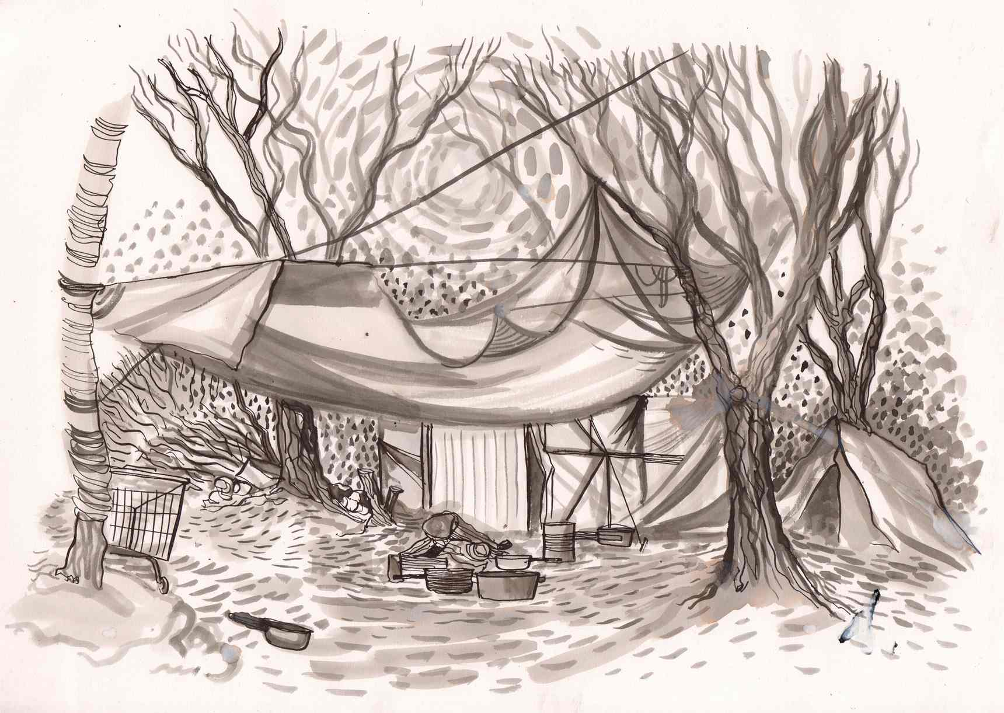
Figure 1: Nick Hayes’ elegant and soft depiction of the camp’s precarious shelters in ‘The End of the road: a sketchbook of refugees in Calais’ (The Guardian.com, 12 March 2016). https://www.theguardian.com/books/2016/mar/12/nick-hayes-graphic-artist-pictures-refugees-calais-camp-jungle (accessed 12 June 2019).

Often in the illustrations, as in Nick Hayes’s or Peter Blodau’s, figures are reduced to silhouettes standing in queues or crossing smudgy, virtually deserted landscapes: refugees are few and small in the outdoor images of the camp. Groups gather idle or, in rare displays of solidarity, build shelters. Usually isolated, they participate in the overwhelming prominence of the space over the figure. The camp stands as the refugee, a visual metaphor of their neglect. Rhetorical devices circumvent the need to explain who the refugees are; and though there might be a legitimate claim to associate the refugee with its ‘refuge’ (shelter), replacing the image of the person by one of a space is de facto dehumanising.

Inside, reportages offer a closer look through portraits of refugees in their living spaces. People are sometimes depicted in groups, and a feeling of solidarity is conveyed through different devices: close body postures (in Nick Ellwood’s drawings), or overlapping shapes (in Hannah Simpson’s drawings for KWCToday), whilst chiaroscuro and a warm colour scheme are also effective in creating a communal atmosphere (as in Pomès’s and Druelle’s reportages). Mundane items such as cooking utensils, coffee cups, packets of crisps and radios are given heightened visibility, with textual artist notations relating objects to specific anecdotes. Overlaid written commentary by the illustrators are prominent within the work of Kugler (‘Escaping Wars and Waves’) and Druelle (Figure 2). These texts point to the refugees’ actual situation and intentions: where they are, what they do, what they want. They depict them in the present of their needs in a very factual manner, describing their belongings and their daily chores, in the same manner as their aspirations and their failed attempts to cross the Channel. This emphasis on facts betrays the intention of the author to avoid emotional manipulation; however, this modesty belittles the human drama that takes place, and its carefulness does not allow much space for the humanity to get through. Overall, this visual focus on material aspects tends to reify the refugee, embedding him/her into his/her material circumstances at the expense of his/her personality, culture and experience.

The portraits of refugees typically focus on facial features and clothes – Peter Blodau’s characters, for instance, all appear smiling or emotionless (‘The Jungle Refugee Camp’), while Olivier Kugler sometimes only represents the refugee by a dress, or jeans and socks. Visual descriptions of faces and clothes alone amount to articulating a tautological statement: refugees come from afar, and they are in need. This way of representing results in defining the refugee through difference – through appearances, through experiences that are not shared by the majority of the readers.

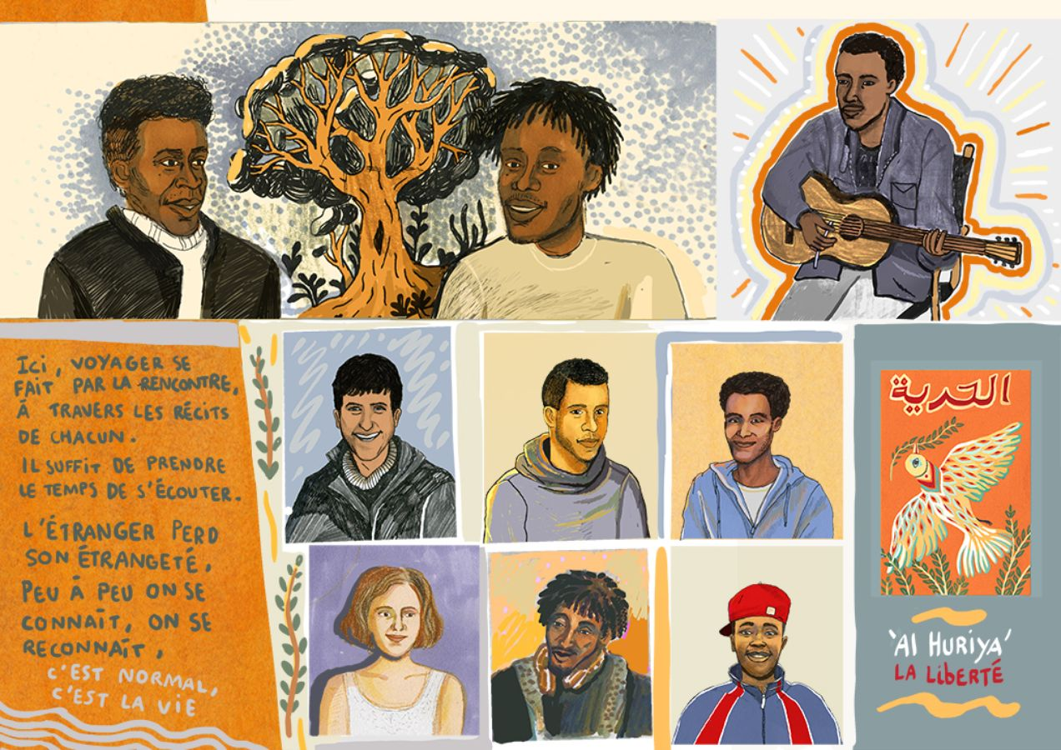
Figure 2: Louise Druelle’s refugees are positioned as potentially equal to the reader, yet they are defined by their difference. ‘Un an à Calais’ (Libération.fr, 28 October 2015). http://www.liberation.fr/voyages/2015/10/28/un-an-a-calais_1409399?utm_source=dlvr.it&utm_medium=twitter (accessed 16 June 2019).

A significant number of illustrations within the research sample exhibit hand-written text made by the illustrator. These take the form of observational notes, dialogue or narratives that accompany the image and in themselves operate at the visual level. Indeed, we may distinguish this textual information from the captioning accompanying photos in the same way that Barthes defines a distinction between ‘anchoring’ and ‘relay’ (Barthes, Image Music Text 41). The writing in these images is not necessarily a caption which is intended to define the content and limit potential alternate readings. Instead, the text works in relay with the image, marking snatched conversation, dialogue or the notes of the illustrator, which are to be read with and alongside the image, as a co-dependent exchange between two textual forms of the type which might be found in the speech or thought bubbles of comic book panels. The image and text direct meaning through a continual process of delegation and exchange, allowing each to resonate and enhance the other.

The textual information provided by the illustrator illuminates the status of the refugee as much with its insights as with its oversights. Refugees seem to have no opinion about the places they live in or the people they meet, nor do they articulate any critical evaluation of the situation they are in. Mentions of past (and respectable) occupations are the most recurrent comments, along with future plans to settle and resume normalcy. One of Kugler’s characters in the tent is an English teacher, while Pomès’s guide is a twenty-three-year-old English Literature student. The refugee is thus revealed in his equality to the reader through his occupational standing; he aspires to, and could become his neighbour, his equal, himself. Yet as Kurasawa contends, this is paradoxically denied by the rendered flatness of the subjects’ intellectual process, in which they are largely unable to assert their human qualities beyond their basic and immediate needs and circumstances. Though the end of Pomès’s reportage sees the emerging of a ‘refugee’ character of substance, it is mainly the locals who demonstrate much complexity and thoughtfulness (‘No Man’s Land’). Through these characters, a more nuanced rendering of the refugee as citizen is established. The potential equality of the refugee is clearly articulated by Mr. Nouchi, the Calais local declaring: ‘They are people like you and us, but who had to flee the horror. It is sad and terrible. If you think twice about it, it could happen to us tomorrow’ (Pomès, n.p.). Such renderings, however, reflect many existant tropes within media narratives that appeal to the aid worker, Western doctor or indeed journalist observer in order to assert the humanity of victims of humanitarian crisis rather than the voice of the subject of such crises.
It is thus largely an empty figure that is being defined in these reportages. An overemphasis on visual surroundings and the dominance of the present tense fix the refugee in an everlasting state of need, while the overuse of rhetorical devices, including the spectacularisation of these images, prioritise the form over the subject. The efficacy of such communicative strategies cannot be denied in terms of impact and might well be effective in rousing compassion within their audience. However, they thrive on the lack of substance in the refugees’ depictions, and end up reinforcing the reader’s pre-existing mental images. Even more so than the photographic image, the comparatively sparse renderings of the reportage image make more demands on the reader to fill in the gaps and assert pre-existing stereotypes over new understandings.
Moreover, Druelle’s insertion of photographs along with other evidential material, maps and texts points out to a high awareness on the part of the artist of the low modality of illustration, where visual modality stands for the extent to which a representation is considered as true – as defined by Gunther R. Kress and Theo van Leeuwen. This ‘low modality’ is a feature of drawn images, and in particular reportage images which, unlike photographic images, cannot assert themselves or their veracity without external markers of authenticity. Their failure to capture an unassailable verisimilitude to the subject, or definitively assert the ‘being there’ of the image due to its abundant signs of subjectivity, inevitably results in the reader doubting the evidence provided. Most illustrators in this study seem concerned with establishing the primacy of facts over fiction, of the real over the fake, and are confronted with the need to authenticate the text through an appeal to support higher modality forms (i.e. the photographic image, captioning, interviews or video testimony). As Kugler declares in a video featured by The Guardian,

[…] you have got text in the drawings, all my texts are from interviews of the people I met; and this will help to prove that all the drawings are real, that they are honest drawings. (Kugler, ‘Illustrator’ 1:25)
This statement highlights how concern over a discourse of truth might eclipse concern over the refugee’s identity. Since the power of these images relies significantly upon the trust bestowed on the author, the artist feels the need to strengthen his/her position through evidence. This is symptomatic of the shifting interest from the refugee’s identity to the image makers’.
In contrast to an expectation of such images to potentially dispel stereotypes, these reportages end up reducing the refugee to helpless figures of otherness, whilst paradoxically attempting to present them as figures of the same as articulated by Kurasawa. Overly concerned with the form and format of their visualisation, they primarily engage with the beautiful and the authentic. Whilst the phenomenological intensification advocated by Kurasawa might have been realised by exploiting illustration’s capacity to communicate understanding through a refinement and deepening of meaning within a selective ‘thick’ description, they ultimately present articulations of refugee identity that rarely penetrate the surface.
Overt, asserted authorship
Despite the anticipated assertion of migrant identities through reportage illustration, this article finds instead that what is asserted through these images is a more defined articulation of the European liberal identity. As suggested in early discussions about the potential of drawing, reportage illustrations re-assert the author through his/her very subjectivity – but to an unforeseen extent and with unexpected consequences. Through a range of symbolic acts (the inherent presence of the image-maker through their overt authorship; the artist’s own testimonies as visual notation within the visual plane; and the artist’s interview, which has begun to appear as a staple accompaniment to such imagery), the illustrator emerges as an intervener in humanitarian concerns. The ‘personal moral impulses of the artist’, demonstrated through an ‘overt form of “authorship” in the direction and representation of a “political point of view”’ (Minichiello 88) are held up in front of the viewer, not simply through the presentation and reading of the image, but also through the (celebrity) status that accompanies the publication of such images. It is to be noted that Pomès, Kugler, Hayes and others have featured in well publicised video or radio interviews, as have other artists ‘intervening’ through illustration in the popular press. No longer invisible behind the camera – which largely obliterates the author of the image through its perceived neutrality – the artist becomes central to the image and cannot be ignored in its reading. Dutch visual artist Jan Rothuizen, whose illustrated web-reportage ‘Refugee Republic’ about the Domiz camp in Iraq won many accolades, explains further in a video that focuses on his documentary practice:
It’s graphic storytelling, but also it’s highly personal. On one hand it’s about me, what I see, my thoughts but obviously I also use this to speak to the imagination of viewers as a narrative tool. (Rothuizen interviewed by van de Wetering, 04:17)
Indeed, in many examples of reportage, the author becomes not just an observer, but a central character appearing within the visual space – as interviewer in Kugler, through first-person commentary in Druelle, as character in Pomès, and finally, as photographic self-portrait in Druelle. Within this space, the illustrators, and in the same context the publishers, become concerned citizens whose moral drive is evidenced by their graphic intervention. Artist interviews and testimonials point to a conscious awareness of visiting the camp and drawing there as a humanitarian or political act. As Nick Ellwood recalls:
I wanted to explore and challenge prevailing attitudes towards migration and the scaremongering headlines presented in the media that seem to reinforce a fear of the ‘unknown’. (Ellwood, n.p.)

Yet these interventions are not merely naïve escapades or voyeuristic ventures:
I took a gap year at 18, so I’m well aware of the syndrome of ‘whitey-goes-to-help’, something to assuage guilt, or give him stories that make him look compassionate, so I’m under no illusions as to whether my going was pure and selfless, but with migration being the next big issue of humanity, I felt I had to be on the right side of the line. (Hayes cited by Hobbs, n.p.)

Hayes goes on to elaborate:
[w]ell, the white gaze was my problem. I was shy about going up to people and asking to draw them – because of the imbalance of our political polarity, it was hard for me to establish an equal footing between us as humans. I felt awkward about drawing people like they were animals in a media zoo, what with half of the volunteers in the camp taking photos to boost their prestige on Facebook. (Hobbs, n.p.)
Pervading guilt and the ultimate aveu d’impuissance
The latter’s concern with the white gaze points to a broader underlying discourse within the liberal Western media – a sense of pervading guilt that urges a need for interventions, and that justifies the existence of these reportage images, and finally consumes them. Ultimately, nearly all of these reportage images present a surrender to the inevitability of suffering which dominates both identities, but which elevates the morality of the Western interventionist whilst accepting the inescapable situation of the refugee, vis-à-vis both the latter’s identity as other, and their own literal presence within the camp. In the end, we return to Kurasawa’s conclusions, which point to the limitations of the European humanitarian discourse in articulating complex understandings of non-European identities. We would argue that the commissioning of these illustrations in effect limited the scope of the illustrators’ focus to that of the camp and its occupants, restricting their ability to communicate and render visible those structural relationships that may have allowed for a deeper understanding of cause and effect within the discourse of migration in Europe (as evidenced by artists’ testimonies). In essence, reportage illustrators were never in a situation where they could have any impact upon Kurasawa’s notion of a ‘structural expansion of visuality’ because those structures never entered into their field of view. However, where illustrations may have had a more pronounced impact was upon the notion of phenomenological intensification through a deeper engagement with its subject matter.
We conclude through this research, however, that the format of the travelogue / sketchbook, and to some extent the modality of reportage illustration – which foregrounds observation as a means of communicating, and which constitutes most of the reportage work examined – made it impossible to develop a phenomenological intensification because its processes and format are ultimately tied to and rarely transcend photographic reportage’s approach to representation. In the end, reportage’s clinging to reality dooms it to imitate photography’s perceived failings by presenting a surface level articulation of its subjects. The gaps left by the hand-made image, and its low modality in comparison to photography, could only be filled by a cognitive appeal to the plurality of pre-existing photographic imagery, operating within the collective conscience, as well as the broader media sphere, as reference points.
Despite this pessimism, we also note ways in which the reportage process may have begun to hint at thicker articulations of the real within processes of temporal expansion. For example, Kugler describes his ‘more elaborated process’ in these terms: ‘I always blend several scenes in a unique drawing, it allows to add context and thus reflection’ (Kugler cited by Stevan n.p.). By drawing upon narratives operating over extended periods that are subsequently re-composited within the image space, illustrations could fulfill their promise of more complex discourses (Figure 3). What Kugler’s process hints at is not merely an articulation of temporalities within the image through narrative, but a multiplication and enhancement of illustrations’ ability to tell greater truths through the manipulation of realities, i.e. the production of an artificial temporal / spatial construct in the form of illustration, and the potential of metaphoric and symbolic elements to play a more active role within the rendering and reading of such images. In Figure 3, for example, we not only see an overlaying of time periods within the visual plane, represented by varying levels of visual detail, but also more complex visual metaphors in operation. The figure of Muhamed, pictured as a transparent outline in contrast to the more fully rendered figures of Hamed and Issa, appears ghostly in comparison. In combination with the textual notes which accompany the figure and the speech bubble from Issa, we perceive a spectral figure whose presence is at once discernable, but whose relative incorporeality resonates with the notions of lost or incomplete ambitions and future, which haunt the image.
Indeed, alternative methods used in other illustrative medium such as comics and picture books, and other forms of editorial imagery (in which the illustrator can operate with greater freedom in the deployment of visual strategies) point at ways in which images could foster Kurasawa’s empathetic reading and contextualisation.
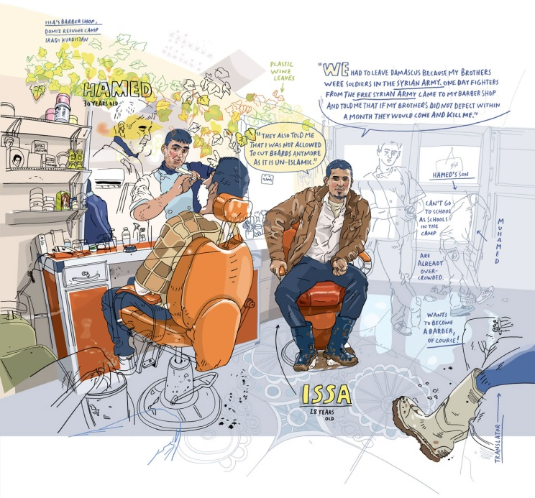
Figure 3: Olivier Kugler’s intensified narrative through editing and temporal manipulation in ‘Escaping Wars and Waves’ (Harper’s Magazine, February 2016). The image was originally published by Harper’s in 2016, and was subsequently re-printed by Myriad Editions in 2018.
Such examples can be found in the writings of Nina Mickwitz, which point to the potential of visual devices in comics and story books as means of relaying the narratives of refugees, migrants and the victims of global conflict and disaster. She considers the limitations and opportunities of travel narratives in Marjane Satrapi’s Persepolis, one of the most celebrated examples of autobiographical storytelling focused on a migrant story (107-14). Within this, she highlights the potential of compositional juxtaposition to convey tensions and contradictions, and of the linear sequence to articulate Satrapi’s complex identity, one that resists ‘dualist thinking’, so as to instead construct a culturally hybrid, ‘borderlands’ subjectivity (Anzaldúa cited in Mickwitz 109). Mickwitz’s examination of Epileptic, a comic book by David Beauchard, also highlights visual metaphor as an efficient communicative device within documentary narratives. She states that this text ‘undoes the separation between felt and seen, internal and external. This is not so much a question of the collapse between real and imagined as it is one between experience and expression. The text visually conjures as a means of communication in order to mediate aspects of the real that have no visible form’ (136).
Whilst it is unfair in many ways to compare a long-form graphic novel with a singular image, it is possible to locate ways in which the visual strategies of the former are not only compatible, but eminently achievable within the space (both physical and temporal) offered to reportage illustration. Moreover, the illustrator need not resort to sequential images operating over multiple panels in order to articulate notions of past and present, or their relationship to each other. As has been seen above, the overt overlaying of temporal spaces presents similar opportunities to relay time within a singular visual plane.
We would thus ultimately suggest that illustration still offers the potential to challenge existing discourses and provide more profound engagements with identity operating within a cosmopolitan global debate. We argue that the use of more fictional, narrative visual strategies may be instrumental in bringing forth more authentic and thicker representations of the real – whilst well aware of the aporetic aspect of the undertaking (Bruzzi 4, Mickwitz 23). However, this is predicated on a need for reportage illustration to challenge and critically engage with its own practices and methodologies in order to explore how it might define itself within a post-truth visual regime, and embrace its nature as a method for interrogating, interpreting and communicating a range of identities beyond those of the author themselves, primarily by embracing its subjectivity more fully.
Bibliography
Allan, Stuart. ‘Blurring Boundaries: Professional and Citizen Photojournalism in a Digital Age’. The Photographic Image in Digital Culture. Ed. Martin Lister. 2nd ed. Abingdon: Routledge, 2013. 183-200.
Barthes, Roland. Camera Lucida: Reflections on Photography. London: Vintage Classics, 1980.
— . Image Music Text: Rhetoric of the Image. London: Fontana Press, 1977.
Bingley, Ione. ‘Illustrators visit Calais Jungle’. KWCToday (13 September 2016). http://www.kcwtoday.co.uk/2016/09/calais-jungle/ (accessed 12 June 2019).

Blodau, Peter. ‘The Jungle Refugee Camp: A Reportage from Calais’. Reportager. Bristol: University of the West of England, 2015. http://reportager.uwe.ac.uk/projects16/peterblodau/index.htm (accessed 12 June 2019).
Boltanski, Luc. Distant Suffering: Morality, Media and Politics. Cambridge: Cambridge UP, 1999.
Bolton, Richard. The Contest of Meaning: Critical Histories of Photography. London: MIT Press, 1992.
Bruzzi, Stella. New Documentary. 2nd revised ed. London: Routledge, 2006.
Calis, Jules and David Oranje. ‘Dunkirk Refugee Camp: The Failure of our Humane Europe’. Drawing The Times (12 June 2016). http://drawingthetimes.com/story/duinkirk/ (accessed 12 June 2019).

Christafis, Angelique. ‘“At Night it’s Like a Horror Movie”: Inside Calais’s Official Shantytown’. The Guardian.com (6 April 2015). https://www.theguardian.com/world/2015/apr/06/at-night-its-like-a-horror-movie-inside-calaiss-official-shanty-town (accessed 12 June 2019).

Corner, John. The Art of Record: A Critical Introduction to Documentary. Manchester: Manchester UP, 1996.

Doane, Mary Ann. ‘Indexicality, Trace and Sign’. differences 18.1 (2007): 1-6.
Druelle, Louise. ‘Un an à Calais’. Libération.fr (28 October 2015). https://www.liberation.fr/voyages/2015/10/28/un-an-a-calais_1409399 (accessed 12 June 2019).
Ellwood, Nick. ‘Calais: Drawings from the Migration Crisis, December 2015’. http://www.nickellwood.co.uk/projects/calais-the-refugee-camps-winter-2015-i-can-see-england-2/ (accessed 12 June 2019).
Geertz, Clifford. The Interpretation of Cultures: Selected Essays. New York: Basic Books, 1973.
Gentz, Laura. ‘Les réfugiés à Paris vus par la dessinatrice Laura Genz’. Le Monde (10 September 2015). https://www.lemonde.fr/arts/portfolio/2015/09/10/dessins-de-refugies-par-laura-genz_4751690_1655012.html (accessed 12 June 2019).
— .‘Meet the Correspondents: Paris, Laura Genz’. Urban Sketchers (29 October 2008). http://www.urbansketchers.org/2008/10/meet-correspondents-paris-laura-genz.html (accessed 3 May 2019).
Gunning, Tom. ‘Moving Away from the Index: Cinema and the Impression of Reality’. differences 18.1 (2007): 29-52.
Hall, Stuart. ‘Encoding/Decoding’. Media Texts, Authors and Readers: A Reader. Eds. David Graddol and Oliver Boyd-Barrett. Clevedon: The Open UP, 1994. 200-11.
Hayes, Nick. ‘The End of the Road: A Sketchbook of Refugees in Calais’. The Guardian.com (12 March 2016). https://www.theguardian.com/books/2016/mar/12/nick-hayes-graphic-artist-pictures-refugees-calais-camp-jungle (accessed 12 June 2019).
Hobbs, James. ‘Calais: Inside the Refugee Camp through the Eyes of Nick Hayes’. Urban Sketchers (19 May 2016). http://www.urbansketchers.org/2016/05/calais-inside-refugee-camp-through-eyes.html (accessed 12 June 2019).
Kress, Gunther R. and Theo Van Leeuwen. Reading Images: The Grammar of Visual Design. London: Routledge, 2010.
Kugler, Olivier. ‘Escaping Wars and Waves’. Harper’s Magazine (February 2016). https://harpers.org/archive/2016/02/escaping-wars-and-waves/ (accessed 12 June 2019).
— . ‘Illustrator Olivier Kugler Visits Burkina Faso’. The Guardian (4 December 2012). https://www.theguardian.com/world/video/2012/dec/04/illustrator-olivier-kugler-burkina-faso-video (accessed 12 June 2019).
Kurasawa, Fuyuki. ‘Humanitarianism and the Representation of Alterity: The Aporias and Prospects of Cosmopolitan Visuality’. Democracy in Crisis. Ed. Stella Gaon. Manchester: Manchester UP, 2010. 133-54.
Lewis, Stephen. ‘DRAWN FROM LIFE: York Artist Nick’s Powerful Sketches of the Calais Camp Refugees’. York Press (28 October 2016). https://www.yorkpress.co.uk/news/14828287.drawn-from-life-york-artist-nicks-powerful-sketches-of-the-calais-camp-refugees/ (accessed 12 June 2019).
Lunenfeld, Peter. Snap to Grid. London: MIT Press, 2001.
Mickwitz, Nina. Documentary Comics. Basingstoke: Palgrave Macmillan, 2016.
Minichiello, Mario. ‘Political Illustration and Propaganda in a Mass Mediated World’. Varoomlab Journal 1 (2012): 71-94.
Pomès, Cyrille. ‘“No man’s land” de Cyrille Pomès’. ARTE Info. https://info.arte.tv/fr/no-mans-land-de-cyrille-pomes (accessed 12 June 2019).
Ruby, Jay. ‘Speaking for, Speaking about, Speaking with, or Speaking alongside: An Anthropological and Documentary Dilemma’. Journal of Film and Video 44.1/2 (1992): 42-66.
Salome M. and Sean Williams. ‘An Interview with Olivier Kugler’. Pear Drop Collective (29 January 2016). http://www.peardrop.net/portraits-of-hope-an-interview-with-olivier-kugler.html (accessed 30 November 2016).
Simpson, Hannah. ‘Illustrators visit Calais Jungle’. KWCToday (13 September 2016). http://www.kcwtoday.co.uk/2016/09/calais-jungle/ (accessed 12 June 2019).
Sontag, Susan. On Photography. London: Penguin Books, 1977.
Stevan, Caroline. ‘Lorsque j’ajoute des mots à mes dessins, ils deviennent plus puissants’. Le Temps online (6 March 2016). https://www.letemps.ch/culture/lorsque-jajoute-mots-dessins-deviennent-plus-puissants (accessed 12 June 2019).
Taher, Abul. ‘Pounds 200 Gets You into UK at The New Sangatte’. Sunday Times (8 April 2007): 10.
Van de Wetering, Geert. ‘The Making of Refugee Republic’. Submarine Channel. https://submarinechannel.com/profiles/profile-refugee-republic/ (accessed 12 June 2019).

