Gough, in Bud Young and Owen Manning, A Bedside Landscape Reader, 2019, LRG, Oxford

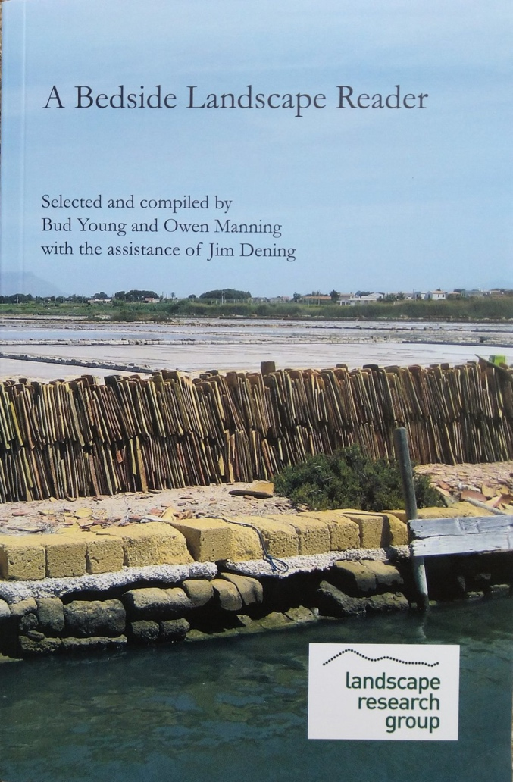

A Bedside Landscape Reader, Or Ten Aspects of Landscape: Forty Luminaries Shed Light on Landscape
Herein you will find a fascinating variety of material. The ways we perceive the landscape, and what it means to us, reflect the diversity of our humanity… From the slums of Beijing to the rich urban spaces of Barcelona, from the Malvern Hills to the Green Belt – landscape in poetry, planning and art – you will be captivated. Merrick Denton Thompson, OBE. Former President of the Landscape Institute
Paul Gough ‘Chicken Run: My Part in the Great Escape’, pp.223-224

Paul Gough ‘Perpetuation of the Picturesque’, pp.227-231

Title | A Bedside Landscape Reader, Or, Ten Aspects of Landscape: Forty Luminaries Shed Light on Landscape
Editors | Bud Young, Owen Manning, Jim Dening
Contributor | Landscape Research Group (Great Britain)
Edition | illustrated
Publisher | Landscape Research Group, 2019
ISBN | 0993122027, 9780993122026
Length | 334 pages

https://landscaperesearch.org/lre-book

