Paul Gough
A Commission for the Pentagon

2018-22

ART CONSIGNMENT AGREEMENT

“This Agreement contains terms between the representative of the art and the Office of the Secretary of Defense (OSD) Patriotic Rotating Art Exhibit Program, referred to hereafter in this paperwork as “OSDPAEP.” The art representative, may be the artist / agent /owner / dealer / benefactor, herein known and is hereafter referred to as “The Agent”.

“As part of gaining approval from the Pentagon Governance Council to institute the Pentagon's “Patriotic” Rotating Art Exhibit Program, it is agreed that exhibiting artists will not be officially promoted in any manner on part of the DoD/Pentagon and that art exhibited will represent America's military men and women with honor in keeping with the highest standards of military conduct. America’s military are considered to be the best, the bravest and the brightest the nation has to offer. They represent the best and highest in our nation's values and virtues. Therefore, artworks are accepted on the basis that they speak to and uphold military honor with the highest standards of selfless character, integrity, excellence, and service; reflecting dignity and respect for the nation’s military members as a whole.

- All art submissions and acceptance will be patriotic in nature: supportive of traditional Department of Defense missions and void of avant-garde genre (including political, social, satirical overtones, etc.) in both art form and descriptive literature. …”

2018 marked the centenary of the year when Australian and American troops first stood and fought side by side against a common enemy on the battlefield of the Western Front. This took place in the final months of the conflict during the Battle of Amiens.

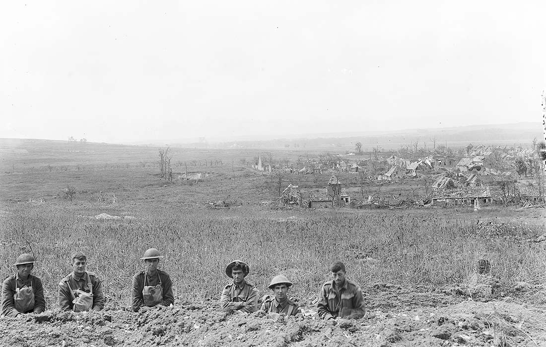

Photo: AWM E02844A-L

To commemorate this momentous occasion, a scheme was launched under the rubric “The Kangaroo and the Eagle: Allies in War and Peace 1908 – 2018”, which devised and funded several historical and creative projects. One such project involved an invitation to 6 artists in Australia and 6 in the USA, who were tasked with creating an artwork that reflected upon this unique moment in the two country’s history. The twelve selected artists each had experience of working with the military in a range of ways.

All artists were required to agree and sign a formal contract, an Art Consigment Agreement, of which an extract above.

The artists were invited to create an original artwork which would then be sent as an electronic file to be printed as glycee prints by the US authorities as a means of avoiding any security implications. No original pictures were shown, only digital reproductions. No opening events would take place and the artists were not invited to see the resulting exhibition. Extensive contracts were signed. Delayed by a change of US President, the work eventually went on show in the vast and pristine walls of The Pentagon, Washington.

The exhibition was significantly delayed, as the Australian organiser, Professor Martin Kerby wrote to PG in September 2022:

The end of a ten year war, a pandemic, a president impeached twice, an assault on the Capitol, and the largest land war in Europe since 1945 has not prevented us from showing our work in Washington. I just received news this morning that our show is now hanging in the Pentagon. Thank you very much for your contribution and your patience. As further news or photographs etc come to hand I will forward them to you immediately. The initial contact just conveyed the good news with the promise of details to follow.

Gough, Australian Corps memorial, Le Hamel , France

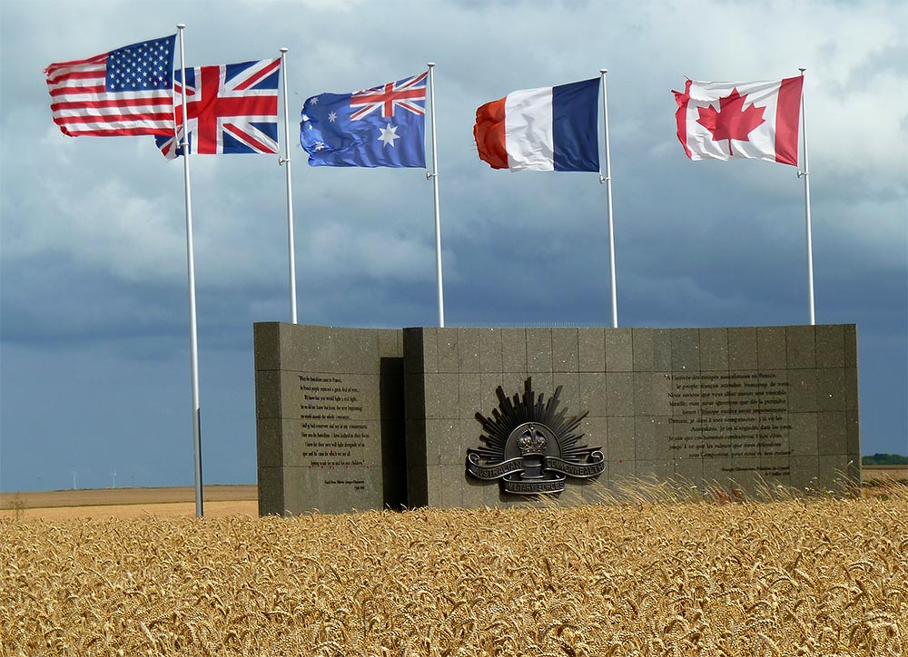

The Australian Corps Memorial Park is situated on the brow of a hill east of Le Hamel village to the south of the River Somme. The memorial park commemorates over 100,000 Australians who served with the Australian Corps in France during the First World War. The Australian Corps was formed in 1917. It comprised five Australian Divisions which saw service in Belgium and France from 1916-1918.
The memorial is located on the site of the final objective of the Battle of Hamel on 4th July 1918. This was the first attack planned and carried out by General Sir John Monash, commander of the Australian Corps.

Gough, study for Le Hamel Re-imagined, 1918-2018

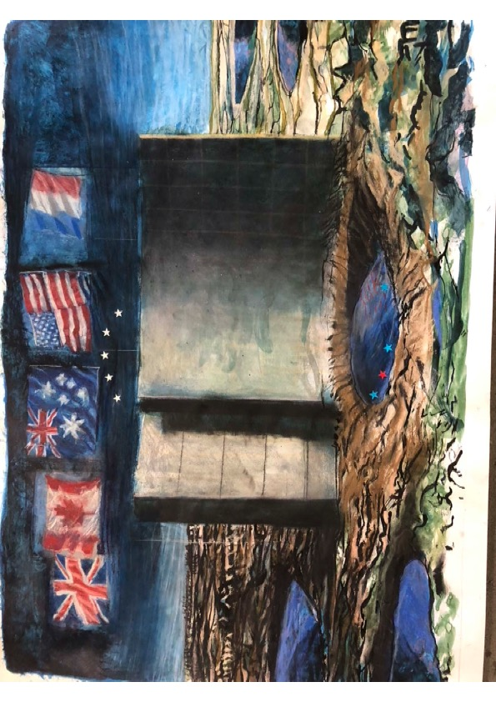

Title of Exhibition/Event | The Kangaroo and the Eagle: Allies in War and Peace
Type of Exhibition/Event | Exhibition/event
Creator/Contributor | Kerby, Martin (Curator), Jones, Albert Lee (Curator), Bywaters, Malcom (Curator) and Baguley, Margaret (Curator)
Place of Publication | Washington, D.C., United States
Event | The Kangaroo and the Eagle: Allies in War and Peace - exhibition
Event Details | The Kangaroo and the Eagle: Allies in War and Peace - exhibition  Aug 2022  Washington  The Pentagon
Description of Exhibition/Event | 'The Kangaroo and the Eagle: Allies in War and Peace' exhibition at the Pentagon in Washington, D.C., commemorates the enduring U.S./Australian security alliance and partnership between the United States and Australia through contemporary paintings, drawings and photographs.

https://research.usq.edu.au/item/q7x05/the-kangaroo-and-the-eagle-allies-in-war-and-peace
pgough@aub.ac.uk

